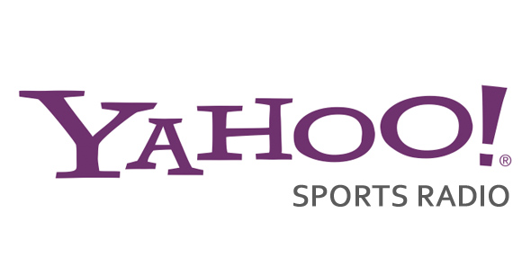

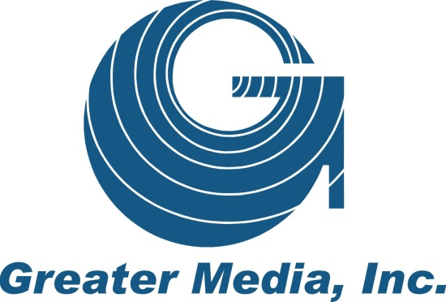

MARKET EVALUATION, BRANDING RECOMMENDATION, IMPLEMENTATION PLAN

PREPARED BY: YAHOO! SPORTS RADIO

PREPARED FOR: GREATER MEDIA NEW JERSEY

DATE: 29 MAY 2013

CONFIDENTIAL
Executive Summary

Objective
Yahoo! Sports Radio’s (YSR) sole objective is to assist Greater Media New Jersey in delivering compelling local and national sports programming that delivers an audience that will increase your sales and marketing opportunities.

Market Evaluation
YSR recommends positioning the station as an alternative to the WFAN & WEPN.

Branding Recommendation
Positioning of the station is important to create differentiation between your station and your competitors. We offer a few suggestions, including an out-of-the-box GOAT concept.

Designing your Logo
We’re including a few conceptual designs for a possible station logo; our fancy way of sketching on a napkin. Logo design is your responsibility, but we’re just tossing out a few concepts.

YSR’s National Sports Lineup
YSR’s national lineup begins with proven ratings-winner Steve Czaban in mornings. In addition, our lineup includes nationally-recognized writers Bob Ryan, Pat Forde, and Dan Wetzel.

Developing Local Talent
Success in sports-talk radio is largely dependent on the development of local talent. That’s why YSR will help your station identify and develop a local sports-talk show.

YSR Hosts & YSR Experts: Guests on your Local Shows
Once your local show has been launched, you can count of Yahoo! Sports Radio as a resource for help booking weekly guests from our on-air lineup and Yahoo! Sport Experts.

“The Sports Flash” powered by Yahoo! Sports Radio
Our customized, local sports reports will add a “local” voice to your national programming that will focus on your teams, your scores, your branding, and your sponsors.

Steve Czaban: Broadcasting Live from northern New Jersey
To celebrate the station launch and connect with your listeners, Yahoo! Sports Radio’s morning show host, Steve Czaban will host his show in northern New Jersey.

Play-by-Play Broadcasts
The development of local play-by-play broadcasts for high school sports, local colleges, and other schools creates another revenue stream for our station. In addition, we recommend adding a brand-name college football broadcast that would appeal to listeners in NYC.

Web Development
Our team can help develop your web site, and your geographically-targeted banner ads will direct visitors to our web page to listener to your station.

Sales & Marketing Support
Unlike other radio networks, YSR’s Chief Marketing Officer Graham McKernan is available to assist in developing winning sales strategies and packages for your station.

Market Evaluation
This is to briefly highlight other stations in the market with a sports format.

While many stations carry sports-related programming, there are only two all-sports radio stations in the market, but they are formidable brands in the nation’s first only all-sports radio station, Sports Radio 66 WFAN The Fan; and the brand of the self-proclaimed Worldwide Leader in Sports and programming from ESPN on WEPN-FM (98.7).

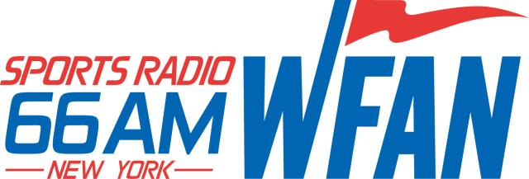

WFAN-AM (660) & WFAN-FM (101.9)
Sports Radio 66 WFAN is the pioneering sports talk station in the nation. There’s no need to go into depth in regards to this station. WFAN is home to the Mets; Giants; Nets; and Devils. The station is also now heard on 101.9-FM.

Boomer & Carton (6 A – 10 A)
Joe & Evan (10 A – 1 P)
Mike Francesa (1 P – 6:30 P)
Steve Somers (6:30 P – 10 P)
Joey McDonald (10 P – Midnight)
John Jastremski (Midnight – 2 AM)
Tony Paige (2A-6A)
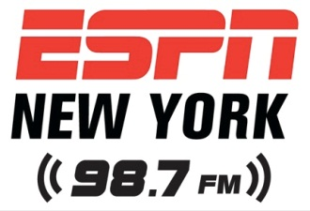

WEPN-FM (98.7)
This is ESPN New York 98.7 and features programming from ESPN’s Mike & Mike in the Morning and The Herd with Colin Cowherd. Local programming includes the following:

Mike & Mike in the Morning (6 A – 10 A)
The Herd with Colin Cowherd (10-Noon)
The Mike Lupica Show (Noon-1pm)
Stephen A. Smith & Ryan Ruocco (1p-3p)
The Michael Kay Show (3p-7p)
Dave Rothenburg (7PM-Midnight)
Robin Lundberg (3A-4A)
Maxed Out with Jared Max & Robin Lundberg (4A-6A)

It is important to acknowledge the strengths of the competition. WFAN is an iconic brand. It is THE sports-talk radio brand in New York City, if not the country. ESPN has the cache of the brand behind it with a competitive local lineup supporting the national programming.

Listening to the two stations, the programming is very similar, without a tremendous amount of distinction between the two brands. For listeners, WFAN is very similar to the station that launched as the nation’s first all-sports radio station in 1987. As you’d expect, WEPN is just another extension of the ESPN brand.

Lineup Comparison - WEPN vs. YSR vs. WFAN
YSR’s media kit documents our lineup of the best sport-talk hosts in the nation, including morning host Steve Czaban. For this document, our analysis concerns the comparison of our national lineup with those that are currently airing on your competition in New York City.

In addition to our weekly lineup, Yahoo! Sports Radio offers unique special programs, including:

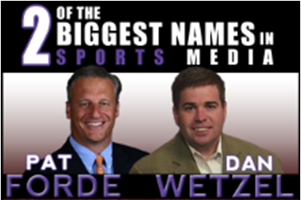

WTF: Wetzel to Forde
Thursdays 8-10 PM
This very popular show features two of the naiton’s biggest names in sports media in Yahoo! Sports writers Dan Wetzel and Pat Forde. Wetzel is the New York Times best-selling co-author of Death to the BCS while the Forde Yard Dash is one of the most read on YahooSports.com.

Fantasy Freaks
Fridays 8-10 PM; Sundays 9A-11A (August 2013)
More than 40-million play fantasy sports in the United States. Yahoo! Sports fantasy expert Brad Evans talks to that fan base about not only football, but all fantasy sports games.

Our Branding Recommendation

Ultimately, of course, the branding of the radio station is entirely at your discretion, but we have a few recommendations based on our analysis of the marketplace, with considerations that include:

-a heritage local brand (WFAN);
-a household name for sports (ESPN);
-positioning of your brand as the alternative;
-target demographic;
-marketing and promotional opportunities with existing corporate assets (WRAT & WDHA);
-and, signal disadvantages.

The Heritage Brand: WFAN
Launched in 1987, WFAN is the nation’s first all-sports radio station, starting on 1050 and eventually moving to the clear-channel signal at 660. This station is the trailblazing station for the sports-talk format across the country and an iconic brand locally and in our industry.

A Household Name for Sports: ESPN
For better or for worse, ESPN is indeed the Worldwide Leader in Sports and is a household brand name that transcends sports.

Positioning your brand as the Alternative
Yahoo! Sports Radio gives listeners an alternative to what they’ve come to expect from WFAN and WEPN, offering listeners a different perspective on the day’s events in the world of sports.

The audience is also somewhat younger than what you would expect from a traditional sports talk audience, offering marketing and promotional opportunities with Greater Media’s rock stations, WRAT-FM and WDHA-FM.

Target Demographic
Generally, sports-talk programming targets men, 25-49, with a particular interest in men 18-49, which aligns well with Greater Media’s sister stations, WRAT-FM & WDHA-FM.

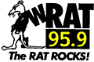 | 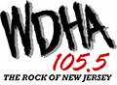
Promotional & Marketing Opportunities with Existing Corporate Assets
The positioning of your Yahoo! Sports Radio affiliate enables you to extend your rock-formatted brands into sports talk radio, expanding your reach into another format and offering your advertisers another method of reaching their target audience.

WRAT & WDHA also provide you with a built-in audience through which to promote your new sports station. As such, the “brand” of your sports-talk station should have a “rock” feel that would appeal to that audience.

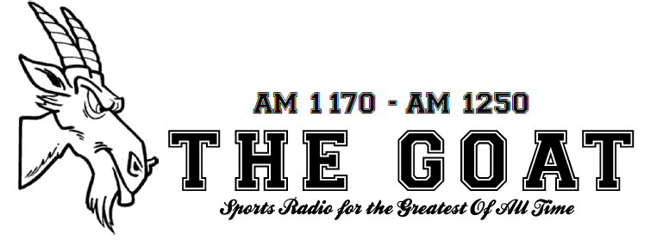
Sports Radio 1170 & 1250 - The GOAT (GREATEST OF ALL TIME)
In terms of positioning, THE GOAT is a unique and memorable name that creates a clear contrast with both WFAN and WEPN. The theme GREATEST OF ALL TIME also honors New York City as the greatest sports city in the world, home of the Yankees; Mets; Jets; Giants; Nets; Knicks; Devils Rangers; Islanders; Red Bulls; and more.

The Fan may be the sports station for the fanatic while WEPN is for those who cannot get enough of ESPN and similar content. The GOAT will be positioned as the station where the greatest sports fans in the world come together to talk about the greatest sports teams in the world that have combined for 44 World Championships.

Gotham Sports Radio 1170 & 1250 -or- Gotham1170 & 1250 powered by Yahoo! Sports Radio
This is another positioning effort designed to break away from the standard sports-talk formatted stations in the market. Gotham delivers an edgier, darker theme in the positioning of the brand that may appeal to a younger audience.
Yahoo! Sports Radio - New York
While we’re all for the prominence of Yahoo! Sports Radio branding, this is a much more conservative approach to branding the station. This conservative approach could cause some brand confusion with ESPN New York’s branding. This is not a recommended branding due to its lack of differentiation with the other sports brands in the market.


New Jersey’s Sports Radio 1170 & 1250
Positioning your station as the “sports voice” of northern New Jersey has its advantages. This branding (a) acknowledges your signal disadvantage when going head-to-head with WFAN & WEPN; (b) enables you to carve out a niche market for your sales and marketing efforts in northern New Jersey; and (c) positions your stations as the local voice for northern New Jersey sports.

Of course, New York City teams will be predominant on your local talk shows, but what radio does best is serve the local market, and this positions your station as the sports voice of northern New Jersey. This will ultimately lead to ratings in New York City, as evidenced by the ratings success of WDHA, which is positioned as the Rock of New Jersey.

Development of your Local Show
Regardless of your branding, we recommend including a weekday show focusing on local sports. Afternoons is often the best time for local shows, although early afternoon or lunchtime shows can be very popular on stations with otherwise national programming.

Yahoo! Sports Radio’s programming department can assist your station with the development of a local show, including:

-identification, development of local talent;
-creation of show “clock” for maximum ratings results;
-implementation of show prep techniques for maximum impact;
-implementation of topic development techniques for maximum caller interaction; and,
-monthly air-checking of local talent to assist in the improvement of on-air performance.

If the show development goes well, then the air talent could have an opportunity to host a nationwide weekend show based from your studios on Yahoo! Sports Radio.

Many stations have had success with an air talent who is interested in selling the show locally. This ensures that you have a person with a vested interest involved with hosting and selling the show locally. Of course, this is dependent upon the person’s ability to sell and adequately host the show.

Another possible source of local talent is the current on-air staff of your sister stations. Perhaps one of your morning personalities has an interest in expanding their skill set into the world of sports-talk radio. This could be an opportunity for that person to also a one-hour show at lunchtime. Of course, the goal here is to hold down costs, so finding someone who is interested in expanding their skill set without increasing their paycheck is important. Although a revenue sharing agreement with the host could be a possible method of compensation or the potential for talent fees for live show appearances.

JERSEY’S GOT SPORTS-TALK TALENT
A promotional method of finding a local on-air talent that would be effective in generating buzz for the station is to conduct an “American Idol” type of search for a local on-air talent. The “Jersey’s Got Sports Talk Talent” (or something similar) contest would include the submission of air checks, on-air tryouts, and listeners voting online for the first-ever sports-talk host on the new station. This is an opportunity to generate a tremendous amount of buzz for the station.

YSR can assist with the implementation of this campaign.

Yahoo! Sports Radio hosts available for your local shows
As an affiliate, your station will have access to Yahoo! Sports contributors Dan Wetzel, Pat Forde, Adrian Wojnarowski, among others. The award-winning writers could be available to your station for weekly call-ins to your local shows and provide your station with breaking news as it happens.

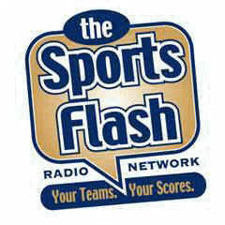


“The Sports Flash” powered by Yahoo! Sports Radio
YSR will provide all of your stations with “local” sports anchors that are dedicated to providing your stations with the best in local sports updates that focus on your teams, your scores. We’ll use your branding and even include your local sponsors.

Our team of update anchors will be responsible for providing your station each weekday with local sports content. The updates can also be used as a method of promoting your local shows, play-by-play broadcasts, live broadcasts, and as additional inventory for your station. All you have to do is send us the copy and we’ll include your local sponsors in the opening/closing billboards of our “Sports Flash” updates for your station.

In addition, we recommend including our “Sports Flash” updates on WRAT-FM & WDHA-FM in an effort to cross-promote your sports station to their audiences. As an example:

OPENING BILLBOARD:
Jersey City Ford Service Center presents “The Sports Flash” powered by
New Jersey’s Sports Radio on 95-9 The Rat.

CLOSING BILLBOARD:
When you buy three tires, get the fourth tire free at Jersey City Ford Service.
Online at Jersey City Ford Service – dot – com. From the New Jersey’s Sports Radio
1170 & 1250 Sports Desk, I’m __________ on 95-9 The RAT.

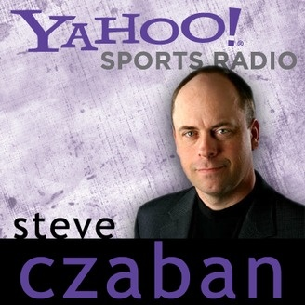

Yahoo! Sports Radio – Broadcasting Live from northern New Jersey
Unlike other sports-radio networks, Yahoo! Sports Radio’s will host a live broadcast in your community, featuring morning show host Steve Czaban. This is another buzz-generating event for your station that provides another opportunity for a strong launch for your brand.

The live broadcast would be on a Friday morning before a big football weekend. A few weekends make the most sense for the YSR live broadcast, including:

SEPT 7 - RUTGERS home opener vs. NORFOLK STATE
SEPT 8 – NY JETS home opener vs. TAMPA BAY BUCCANEERS

SEPT 14 – EASTERN MICHIGAN @ RUTGERS
SEPT 15 – NY GIANTS home opener vs. DENVER BRONCOS

Of course, this is also dependent upon Steve’s availability for those weekends and other factors but at some point early in the launch of the format, we recommend a live show in your market featuring Steve Czaban.

YSR can help to develop potential sales packages for this local event.

Sales & Marketing
Yahoo! Sports Radio’s programming reaches the same audience as your rock-formatted stations, WRAT-FM & WDHA-FM, giving Greater Media of New Jersey a lock on the male demographic in northern New Jersey.

With successful radio stations, we all know the delicate balance between content and inventory. Too much inventory, not enough content, the listener flees. Yet, without additional inventory and a limited ability to increase audience size, it is nearly impossible to increase revenue.

For your current local advertisers, this is an opportunity for you to incrementally increase their advertising placement. Imagine the impact to your revenues if advertising increased 2%-5% for each of your current WRAT-FM & WDHA-FM advertisers.

This station would reach the same target audience, but offers an expansion of your sales opportunities, including:

-studio naming rights;
-phone naming rights;
-live reads;
-live broadcasts;
-coaches shows;
-play-by-play broadcasts; and,
-specialty content and shows.

Yahoo! Sports Radio can assist Greater Media in generating sales packages that have proven successful in other markets, including YSR owned & operated properties in Houston.

Play-by-Play Broadcasts
High school football play-by-play broadcasts are a revenue-generating opportunity, especially when you partner with the right schools with strong athletic booster clubs. Often, these booster clubs sell sponsorships to generate revenue to support the student-athletes, including: selling advertisements in game programs; public address announcements during games; and signage at the venue. If you could partner with the right athletic booster club, they’ll essentially sell the advertising for your broadcasts.

With two signals, there’s an opportunity for you to broadcast two high schools in the community, one on each signal.

Time-brdokered play-by-play broadcasts are an opportunity for the station to generate additional revenue. For your stations, there are a number of schools in the area that might be a good fit for a time-brokered play-by-play arrangement, including: New Jersey Institute of Technology; Bloomfield College; and Felician College. Whether a full-season commitment or a partial schedule, you can create play-by-play radio broadcast schedules for the schools.

The Play-by-Play Home of the …
…ALABAMA CRIMSON TIDE
…OHIO STATE BUCKEYES
…NOTRE DAME FIGTING IRISH
…OREGON DUCKS

Sister-station WCTC airs Rutgers football. Syracuse football is carried on WNYM-AM in New York City, so that might be out as an option for your stations. If possible, we recommend adding the play-by-play broadcasts of a national brand-name college football program as a unique listening opportunity for your audience on Saturdays. Our first recommendation is Notre Dame, but that is carried on WBBR-AM in New York City. This still might be an option if we position your stations as Notre Dame’s northern New Jersey affiliate. Other unique play-by-play opportunities include Alabama, Ohio State, Southern Cal, and Oregon.

Our recommendation is to investigate the number of “out of town” alumni that reside in the northern New Jersey, New York metropolitan area. Alumni organizations are particularly active in the large metro areas, and could create a built-in audience for the broadcasts.

Another option would be to carry the play-by-play of a former high school football player who is currently starring in the college ranks. This would be a “hometown connection” type of affiliate, so local listeners can keep tabs on the local kid who is making it big at the next level.

Specialty Content & Shows
These time-brokered specialty shows open up another revenue-stream opportunity for your station to sell specialty programming that includes golfing shows; fitness clubs; sports medicine providers; automotive enthusiasts; and many others.

Web Site Development
As you might expect, Yahoo! Sports Radio utilizes the best digital assets possible to promote our radio network, and we can assist your station in doing the same. This includes assisting in the development of your web page. YSR’s sports module is also very popular with our affiliates, providing a running updates of the latest sports headlines and links to stories. There is a possibility of developing a module for your web site that is specifically dedicated to New York City sports news and stories.

YahooSportsRadio.com
At our web site, we’ll include geographically-target banner ads that link to your station web site and encourage people in northern New Jersey and New York City to listen to your radio station.

IMPLEMENTATION TIMELINE
This is an implementation timeline for the transition of your stations to Yahoo! Sports Radio in time for the 2013 football season. Rather than just flipping a switch to YSR and hoping that people listen to the station, we’ll work with you to develop a game plan to slowly build momentum for your station as we approach the fall of 2013.

JUNE 2013
Brand Development
Logo Design
Web Site Development
Development of Sales Packages
Securing of Play-by-Play Rights (High School, College)

MID-JULY 2013
Launch of the Stations to Yahoo! Sports Radio with new branding
Launch of “The Sports Flash” powered by Yahoo! Sports Radio on new YSR affiliates
Launch of “The Sports Flash” powered by Yahoo! Sports Radio on sister-stations (WRAT; WDHA)
Announcement of Jersey’s Got Sports-Talent Contest to identify local show host

AUGUST 2013 – WEEK ONE
Preliminary Rounds of Jersey’s Got Talent Contest (Air Checks On-Air & Online for Fan Vote)
Announcement of upcoming Play-by-Play broadcasts on stations

AUGUST 2013 – WEEK TWO
Announcement of Steve Czaban Appearance & VIP Contest
On-Air Tryouts for Jersey’s Got Sports-Talk Talent Contest

AUGUST 2013 – WEEK THREE
Finalists announced for Jersey’s Got Sports-Talk Talent Contest
On-Air Tryouts for Jersey’s Got Sports-Talk Talent Contest

SEPTEMBER 2013
Winner of Jersey’s Got Sports-Talk Talent Contest announced during Czabe appearance
Launch of Play-by-Play Broadcasts

