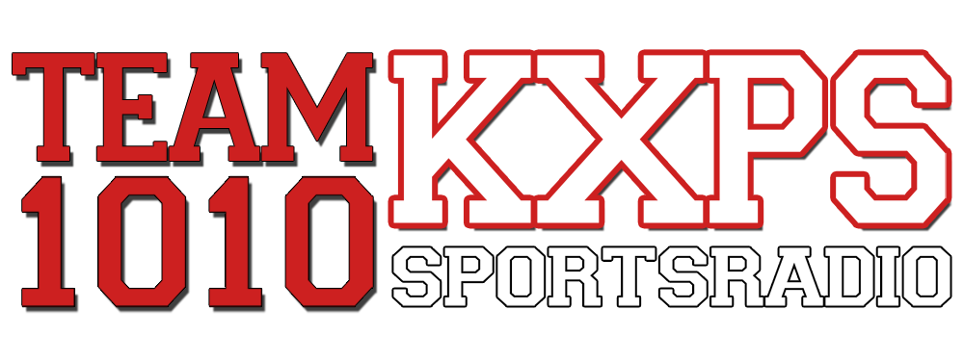
TEAM 1010 KXPS in Palm Springs has added “The Sports Flash” powered by Yahoo! Sports Radio.

Our updates deliver the following: Your teams. Your scores. Your branding. Your sponsors.

We’re 100% barter, affiliate-friendly, and easy to use. In a matter of hours, we can have you up and running.

Ask for a customized demo, and we’ll get one to you in 24 hours.

Thanks for your time,
Mike Sinnott
“The Sports Flash”
Your teams. Your scores.
Vice President, Yahoo! Sports Radio
(517) 927-4570
www.TheSportsFlash.com
www.YahooSportsRadio.com

