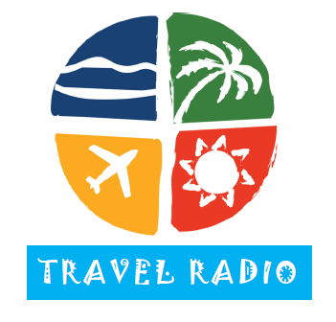

December 5, 2013

I am writing to introduce you to Travel Radio, a network of more than 400 radio stations nationwide, including 40 affiliates in North Carolina and South Carolina. Our network offers affordable radio advertising to travel and tourism groups across the country. I have enclosed a rate card for your state and a list of our affiliates.

Radio is most effective when advertisers can consistently repeat their message. We deliver the affordable frequency you need to reach and influence your target audience. In terms of targeting, we can deliver your message regionally, locally, or on a station-by-station basis. Our flexibility enables you to quickly and easily change your advertising message to promote seasonal attractions and special events. We can also target specific audiences with specific messages.

For as little $500/week, we offer affordable frequency, micro-targeting, and the flexibility you need to reach your target audience. This is a limited-time offer for 2014 that ends on December 20, 2013.

Let’s talk soon.

Thanks for your time,

Mike Sinnott
Travel Radio
(517) 927-4570

