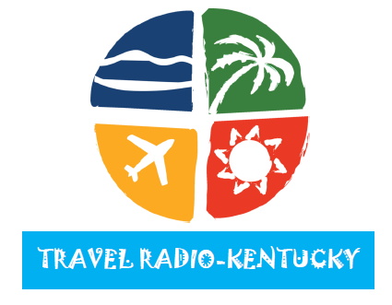
WLVK-FM (105.5) Elizabethtown Country
WAKY-FM (103.5) Elizabethtown Oldies
WQXQ-FM (101.9) Central City Top 40
WNES-AM (1050) Central City Sports
WMJL-FM (102.7) Marion Oldies
WMJL-AM (1500) Marion Oldies
WBGN-AM (1340) Bowling Green Sports
WZAQ-FM (92.3) Louisa Country
WOMI-AM (1490) Owensboro News/Talk
WKWC-FM (98.3) Owensboro Rock
WHAY-FM (98.3) Whitley City Country
WCBR-AM (1110) Richmond Gospel
WKXQ-FM (103.9) Mayking Country
WKYH-AM (600) Paintsville News/Talk
WHOP-FM (98.7) Hopkinsville Lite Rock
WHOP-AM (1230) Hopkinsville News/Talk
WBFC-AM/FM (1470/103.7) Stanton Gospel
WEKC-AM (710) Williamsburg Gospel
WSIP-AM (1490) Paintsville News/Talk
WSIP-FM (98.9) Paintsville Country
WAIN-AM/FM (1270/93.5) Columbia Country
WKHG-FM (104.9) Leitchfield Hot AC
WMTL-AM (870) Leitchfield Bluegrass
WTLO-AM (1480) Somerset Nostalgia
WYWY-AM (950) Barbourville Gospel
WKKQ-FM (96.1) Barbourville AC
WYMC-AM/FM (1430/93.9) Mayfield Nostalgia
WMIK-AM/FM (560/92.7) Middleboro Christian
WMMG-AM (1140) Brandenburg Country
WMMG-FM (93.5) Brandenburg Country
WRIL-FM (106.3) Pineville Hot AC
WNTC-FM (103.9) Drakesboro Sports
WDGG-FM (93.7) Huntington Country
WRVC-FM (92.7 & 98.5) Huntington Classic Rock
WRVC-AM (930) Huntington News/Talk
WCMI-AM (1340) Huntington Sports

2014 TRAVEL RADIO – RATE CARD
CAMPAIGN | COMMERCIALS (60-SEC) | INVESTMENT/WEEK | TOTAL INVESTMENT
13-WEEKS | 5 @ $100/EACH | $500/WEEK | $6,500.00
26-WEEKS | 5 @ $100/EACH | $500/WEEK | $13,000.00
52-WEEKS | 5 @ $100/EACH | $500/WEEK | $26,000.00
TRAVEL RADIO requires a minimum investment of $6,500. Offer ends December 20, 2013.

