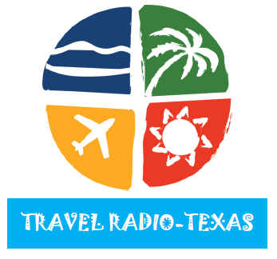
KAND-AM (1340) Corsicana Country
KATX-FM (97.7) Eastland Classic Rock
KBST-FM (95.7) Big Springs Country
KBST-AM (1490) Big Springs Talk
KCCT-AM (1150) Corpus Christi Country
KCKM-AM (1330) Monahans Country
KCKM-FM (98.7) Odessa Country
KCTX-AM (92.1 & 1510) Childress Top 40
KCTX-FM (96.1) Childress Country
KDCD-FM (92.9) San Angelo Country
KEYJ-FM (107.9) Abilene Rock
KEYE-FM (93.7) Perryton Classic Hits
KEYE-AM (1440) Perryton News/Talk
KFNC-FM (97.5) Houston Sports
KGOW-FM (1560) Houston Sports
KLTD-FM (101.7) Temple-Killeen Sports
KLTR-FM (94.1) Brenham AC
KLVT-AM (1230) Lubbock-Levelland Country
KMDX-FM (106.1) San Angelo Rhythmic CHR
KMIL-FM (105.1) Cameron Country
KNNK-FM (100.5) Hereford Christian
KNUZ-FM (106.1) San Saba Country
KNGR-AM (1560) Daingerfield Gospel
KNVR-AM (1400) San Saba Nostalgia
KPET-AM (690) Lamesa Country
KQBZ-FM (96.9) Brownwood AC
KQQB-AM (1520) San Antonio Business Talk
KSEY-AM (1230) Seymour Sports
KSEY-FM (94.3) Seymour Country
KSHN-FM (99.9) Liberty Full Service
KSLI-AM (1240) Abilene Classic Country
KSML-AM (1260) Lufkin Sports
KSTA-AM (1000) Brownwood Country
KTWL-FM (105.3) Brenham Country
KTXJ-FM (102.7) Jasper Southern Gospel
KULL-FM (100.7) Abilene Classic Hits
KWRW-FM (97.7) Rusk Oldies
KXYL-FM (102.3) Brownwood News/Talk
KXYL-AM (1240) Brownwood News/Talk
KZZN-AM (1490) Lubbock-Littlefield Country

2014 TRAVEL RADIO – RATE CARD
CAMPAIGN | COMMERCIALS (60-SEC) | INVESTMENT/WEEK | TOTAL INVESTMENT
13-WEEKS | 5 @ $100/EACH | $500/WEEK | $6,500.00
26-WEEKS | 5 @ $100/EACH | $500/WEEK | $13,000.00
52-WEEKS | 5 @ $100/EACH | $500/WEEK | $26,000.00
TRAVEL RADIO requires a minimum investment of $6,500.

