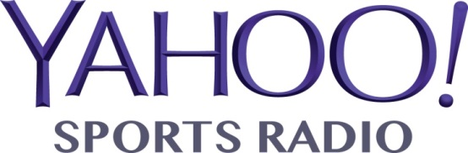 | 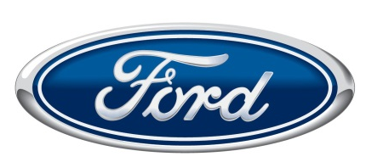
HOMETOWN HEROES
powered by your neighborhood FORD dealers
OVERVIEW
Nothing brings a community together like high school football. Yahoo! Sports Radio (YSR) proposes an integrated marketing campaign that targets local high school football fans, their peers, parents, and the community. High school football coaches, athletic directors, and the media will nominate players for the weekly honor. From Monday through Thursday, fans will vote online to select the weekly winner, who will be announced each Friday. The weekly winners will be eligible for the player of the year honor that will also be determined by a vote of the fans. Weekly winners will receive a certificate and/or a tee-shirt with the player of the year will receive a plaque or trophy during a presentation at the high school or the local Ford dealer.

INTEGRATED SPORTS MARKETING
Our campaign combines radio advertising, earned media, interactive, and event marketing to engage, energize your target audience, drive traffic to your dealer web sites, and generate leads for your dealers. YSR has experience executing successful integrated sports marketing campaigns for a variety of clients, including: North Carolina Spit Tobacco Education Program; U.S. Army; U.S. Marine Corps; U.S. Air Force; Wyoming Through With Chew, and others.

RADIO ADVERTISING
“The Sports Flash” Radio Network powered by Yahoo! Sports Radio delivers radio advertising to 104 network affiliates in your territory, including: Illinois (6); Indiana (14); Kentucky (29); Michigan (9); Ohio (3); Pennsylvania (3); Tennessee (9); West Virginia (30); and Wisconsin (1). In addition to a standard radio advertising campaign, we will air promotional spots that highlight the weekly nominees, weekly winners, and drive traffic to local dealer web sites.

EARNED MEDIA
Our media efforts have generated tremendous free media coverage in many of the major publications across the country, including: The Columbus Dispatch; The Cincinnati Enquirer; The Cleveland Plain Dealer; The Kansas City Star; The Baltimore Sun; The Indianapolis Star; The Washington Post; and hundreds of daily community newspapers across the country. Press releases each week will announce the nominees and winners.

INTERACTIVE
Each week during the campaign, fans will drive traffic to the web sites of your local Ford dealers to vote for the weekly winner of the campaign. We will also geo-target web banners that will drive traffic from our web site to your local dealer web sites. Yahoo! Sports Radio is powered by the world’s #1 sports site – Yahoo! Sports. Since November 2012, there have been more than 2.5-million unique visitors to www.yahoosportsradio.com. Each month, we deliver 250,000 unique visitors; 250,000 streaming listeners; and 500,000 on-demand listeners.

EVENT MARKETING
The weekly winners will be honored at a presentation ceremony at their high school, during an assembly, pep rally, at another sporting event at the school, or during a presentation ceremony at the dealer location.

INVESTMENT
For each region, we require an investment of $12,500 for this integrated marketing campaign. For a campaign that targets our three areas of significant affiliate concentration (Indiana, Kentucky, West Virginia), we require an investment of $37,500. The investment covers the cost of our time for campaign management, radio advertising, and any materials associated with the campaign, including certificates, tee-shirts, or plaques for all regions.

