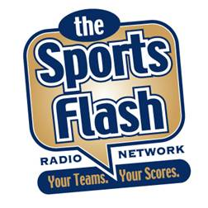 | 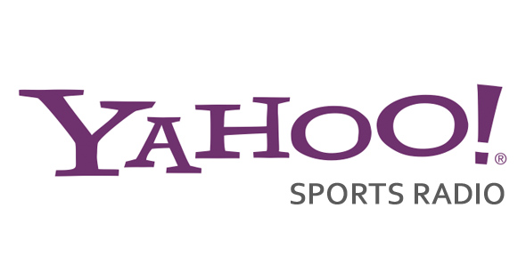
“The (YOUR BRAND) Sports Flash”
powered by Yahoo! Sports Radio

Overview
“The Sports Flash” Radio Network powered by Yahoo! Sports Radio delivers customized, local sports reports to196 network affiliates across the country, including affiliates in Chicago; Seattle; Miami; Tampa; Denver; and Nashville, among others.

Effective
Our award-winning sports broadcasters deliver updates that wrap your advertising message around content that the listener wants to hear, cutting through the clutter, and ensuring a greater impact for your advertising message.

Consistent
Each year, we deliver more than 160,000 “Sports Flash” updates to our network affiliates around the country and we’ll include your advertising in every single one of them.

Affordable
As the title sponsor of “The Sports Flash” powered by Yahoo! Sports, we will brand our updates with your advertising message.

Flexible
While our updates will be branded exclusively with your advertising message, you will have the opportunity to change your advertising message daily, weekly, or monthly. In fact, you can even change your copy station-by-station to micro-target our audience.

Billboards & Commercials
For just $5 per update, we’ll brand all 160,000 updates in the next year with your advertising message. In addition, we’ll provide you with as many as 400 network commercials on all of our 196 affiliates at no additional cost, a value of $120,000.

Investment
The title sponsor of “The Sports Flash” Radio Network powered by Yahoo! Sports Radio requires an annual investment of $850,000.

