 | 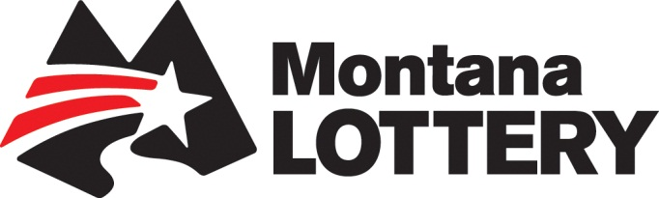 | 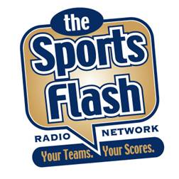
Montana Lottery “Sports Flash” powered by YAHOO! Sports Radio

Overview:
“The Sports Flash” (TSF) Radio Network is now part of Yahoo! Sports Radio with 382 network affiliates nationwide, including 14 network affiliates throughout Montana.

Commercials:
TSF Radio Network has 30-second and 60-second commercials available on our network affiliates throughout the state. Our “Sports Flash” programs powered by Yahoo! Sports Radio airs during morning drive on all stations with some stations extending air play of our updates throughout the day.

Billboards:
For the Montana Lottery, TSF Radio Network will open and close our “Sports Flash” updates with your advertising message, wrapping your message around content that the listener wants to hear, creating a greater impact for your message. This could be particularly effective in promoting your Jackpot Alerts, MSA Fantasy Racing, or MSA Fantasy Football.

Investment:
There is no difference in price between a 60-second and 30-second commercial on our network. Both are just $5 each or $70 for one network wide commercial in Montana. Our billboards are $2.50 or $35 for one network wide billboard message.

 | FEB 13 | MARCH 13 | APRIL 13 | MAY 13 | JUNE 13 | JULY 13 | AUG 13 | SEPT 13 | OCT 13 | NOV 13 | DEC 13 | TOTAL
B: $35.00 | 20/$700.00 | 25/$875.00 | 20/$700.00 | 20/$700.00 | 25/$875.00 | 20/$700.00 | 20/$700.00 | 25/$875.00 | 20/$700.00 | 20/$700.00 | 25/$875.00 | 240 @ $35.00
C: $70.00 | 20/$1,400.00 | 25/$1,750.00 | 20/$1,400.00 | 20/$1,400.00 | 25/$1,750.00 | 20/$1,400.00 | 20/$1,400.00 | 25/$1,750.00 | 20/$1,400.00 | 20/$1,400.00 | 25/$1,750.00 | 240 @ $70.00
TOTAL | $2,100.00 | $2,625.00 | $2,100.00 | $2,100.00 | $2,625.00 | $2,100.00 | $2,100.00 | $2,625.00 | $2,100.00 | $2,100.00 | $2,625.00 | $25,200.00

