 | 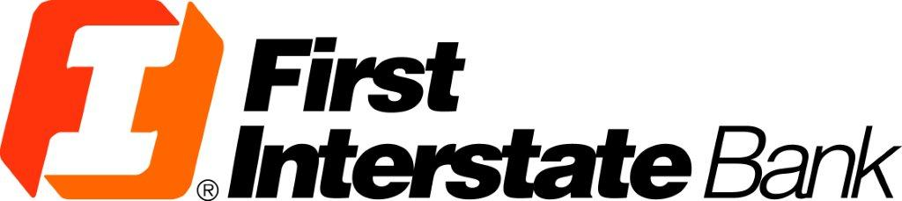 | 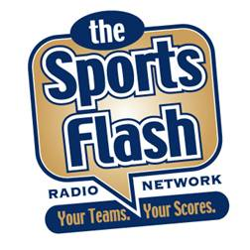
FIRST INTERSTATE BANK “Sports Flash” powered by YAHOO! Sports Radio

Overview:
“The Sports Flash” (TSF) Radio Network is now part of Yahoo! Sports Radio with 382 network affiliates nationwide, including 24 network affiliates in Montana, South Dakota, and Wyoming.

Commercials:
TSF Radio Network has 30-second and 60-second commercials available on our network affiliates throughout the state. Our “Sports Flash” programs powered by Yahoo! Sports Radio airs during morning drive on all stations with some stations extending air play of our updates throughout the day.

Billboards:
For Interstate Bank, TSF Radio Network will open and close our “Sports Flash” updates with your advertising message, wrapping your message around content that the listener wants to hear, creating a greater impact for your message.

Investment:
There is no difference in price between a 60-second and 30-second commercial on our network. Both are just $5 each or $120 for one network commercial that airs on all of our 24 affiliates in Montana, South Dakota, and Wyoming. Our billboards are $2.50 or $35 for one network wide billboard message.

 | APRIL 13 | MAY 13 | JUNE 13 | JULY 13 | AUG 13 | SEPT 13 | OCT 13 | NOV 13 | DEC 13 | TOTAL
B: $35.00 | 20/$700.00 | 20/$700.00 | 25/$875.00 | 20/$700.00 | 20/$700.00 | 25/$875.00 | 20/$700.00 | 20/$700.00 | 25/$875.00 | 195 @ $35.00
C: $120.00 | 20/$2,400.00 | 20/$2,400.00 | 25/$3,000.00 | 20/$2,400.00 | 20/$2,400.00 | 25/$3,000.00 | 20/$2,400.00 | 20/$2,400.00 | 25/$3,000.00 | 195 @ $120.00
TOTAL | $3,100.00 | $3,100.00 | $3,875.00 | $3,100.00 | $3,100.00 | $3,875.00 | $3,100.00 | $3,100.00 | $3,875.00 | $30,225.00

