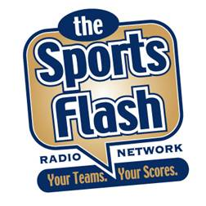 | 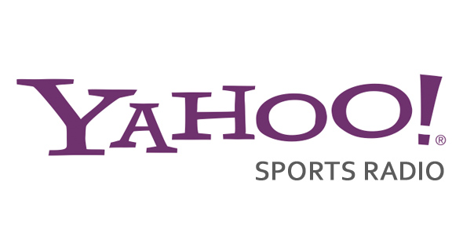

“The Sports Flash” powered by Yahoo! Sports Radio - Montana

KATQ-FM (100.1) Plentywood Country
KATQ-AM (1070) Plentywood News/Talk
KBSR-AM (1490) Laurel/Billings News/Talk
KHDN-AM (1230) Hardin News/Talk
KMTX-FM (105.3) Helena Hot AC
KMXE-FM (99.3) Red Lodge/Billings Classic Rock
KXGN-AM (1400) Glendive News/Talk
KDZN-FM (96.5) Glendive Country
KIKC-AM (1250) Forsyth Country
KIKC-FM (101.3) Forsyth Country
KYUS-FM (92.3) Miles City Hot AC
KMTA-AM (1050) Miles City Oldies
KGCX-FM (93.1) Sidney Classic Rock
KXTL-AM (1370) Butte Oldies

“The Sports Flash” powered by Yahoo! Sports Radio - Wyoming

KPOW-AM (1290) Powell News/Talk
KRKK-AM (1360) Rock Springs News/Talk
KEVA-AM (1240) Evanston Classic Hits
KNYN-FM (99.1) Evanston Country
KYDT-FM (103.1) Sundance Country
KBFS-AM (1450) Sundance Country

BILLBOARDS: $25.00 EACH
Our billboards are 10-15 second advertising messages that we include in our opening/closing billboards of our “Sports Flash” updates. This advertising method wraps your advertising message around content that the listener wants to hear.

COMMERCIALS: $50.00 EACH
Our commercials are 60-second advertising messages that air immediately after our “Sports Flash” updates.

 | APR | MAY | JUNE | JULY | AUG | SEPT | OCT | NOV | DEC | TOTAL
BILLBOARD | 20/$500 | 20/$500 | 20/$500 | 20/$500 | 20/$500 | 20/$500 | 20/$500 | 20/$500 | 20/$500 | $4,500.00
COMMERCIAL | 20/$1000 | 20/$1000 | 20/$1000 | 20/$1000 | 20/$1000 | 20/$1000 | 20/$1000 | 20/$1000 | 20/$1000 | $9,000.00
 | $1,500 | $1,500 | $1,500 | $1,500 | $1,500 | $1,500 | $1,500 | $1,500 | $1,500 | $13,500.00

