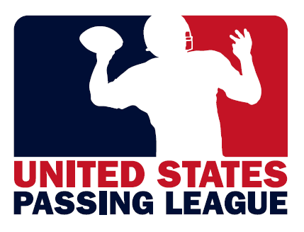

USPL Title Sponsorship - $5,500/event
As the title sponsor of a USPL regional event, your company will receive the following:

-event branded with your corporate identity, featuring 16-20 high school football teams;
-inclusion of your brand identity in the event logo;
-primary signage locations throughout the event’s facility;
-booth space in the highest-profile location of the event’s facility;
-opportunity to make one-on-one presentations to participating teams;
-brand identity included on tee-shirts provided to student-athletes;
-corporate branding included in all communications materials to promote event;
-posting of your click through web banner at primary location at event’s official web site;
-access to database of all participating student-athletes; and,
-presentation of trophy to tournament champion.

USPL Presenting Sponsors - $2,500/event
As the presenting sponsor of a USPL regional event, your company will receive the following:

-participation in event featuring 16-20 high school football teams;
-secondary signage locations throughout the event’s facility;
-booth space in the secondary location of the event’s facility;
-posting of your click-through web banner at secondary location at official web site;
-opportunity to distribute information to participating teams,

USPL Associate Sponsors - $1,250/event
As an associate sponsor of a USPL regional event, your company will receive the following:

-participation in event featuring 16-20 high school football teams;
-signage locations, where available, throughout facility; and,
-booth space at facility to distribute information, products to participants.

For more information on the sponsorship packages available with the United States Passing League, please contact Mike Sinnott at (517) 927-4570.

