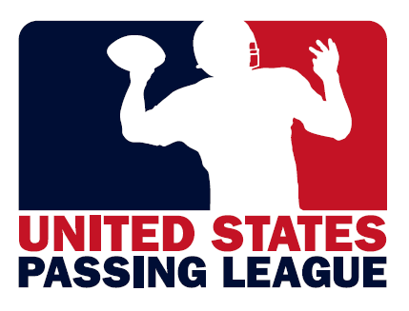

United State Passing League
Executive Summary

Overview
The United States Passing League (USPL) is a seven-on-seven spring/summer passing league that features high school football teams from across the country.

What is a Passing League?
A passing league is a non-contact game played on a shortened field that features seven players on each side. Passing leagues are popular with high school football teams as a method of keeping their teams in shape during the summer months.

Eligible Participants
USPL teams feature high school student-athletes between the ages of 13-19 who have not yet graduated from high school. High school graduates are prohibited from participating.

Local Teams, No “All Star” or “Elite” Teams
The USPL is designed as a skill-building, team-building event for local teams, not a showcase event for the all-star or elite teams. All participating teams are loosely associated with the high schools in their community.

Sponsors ensure that USPL events are FREE for participating teams
Usually, teams are charged $300-$400 or more to participate in passing league tournaments. With sponsor support, USPL is a free event for all participating teams.

Season
The USPL season is a spring/summer league that runs roughly June-July each year, during the high school football off-season.

Host Sites
High schools or regional athletic facilities serve as host sites for USPL events. A general requirement is for each host site to have two (2) 100-yard fields, with at least one turf field.

Earned Media
USPL events have successfully generated free media coverage in media outlets throughout the country.

Passing Leagues for the U.S. Army & U.S. Marine Corps
Since 2010, USPL executives have managed passing leagues for the U.S. Army and the United States Marine Corps in Maryland, Pennsylvania, and South Carolina.

Generating Leads
USPL events are an opportunity to generate personal information about potential customers, including: name; address; phone numbers; e-mail; and much more.

Distributing Products, Information
Each USPL event will be an opportunity to distribute product samples and information to participating student-athletes, coaches, and spectators.

Building Relationships
A marketing partnership with a USPL event enables you to build relationships with high school student-athletes, their peers, parents, coaches, administrators, and the community.

USPL Events: A marketing opportunity too good to pass up
The USPL offers affordable event marketing opportunities to engage our target audience of high school student-athletes, ages 13-19 years of age.

Overview
The United States Passing League (USPL) manages seven-on-seven passing leagues throughout the country. USPL events are excellent opportunities for sponsors to generate leads; distribute products, information; and build relationships.

What is a passing league?
Passing league football is a non-contact seven-on-seven game played on a shortened field that features only the passing game. Many state associations prohibit contact during off-season drills, so passing leagues are very popular with high school football teams as a method of keeping their teams sharp and in shape during the off-season.

While high school basketball has AAU competition and high school baseball has traveling teams or American Legion, there is nothing for high school football players who want to remain at peak condition and sharpen their skills during the off season. The USPL provides that opportunity.

Recently, negative publicity has hurt the image of the summer passing leagues. Those questionable events are “showcase” events that feature “all-star” teams of “elite” players who travel around the country. Since college coaches cannot attend these passing league events, the “showcase” seven-on-seven events involve a number of individuals who do not have the student-athletes best interests in mind.

USPL events prohibit “all-star” and “elite” teams from competition. Instead, we require teams to have an affiliation with sanctioned high schools in the state and coached by their high school head coaches or assistant coaches.

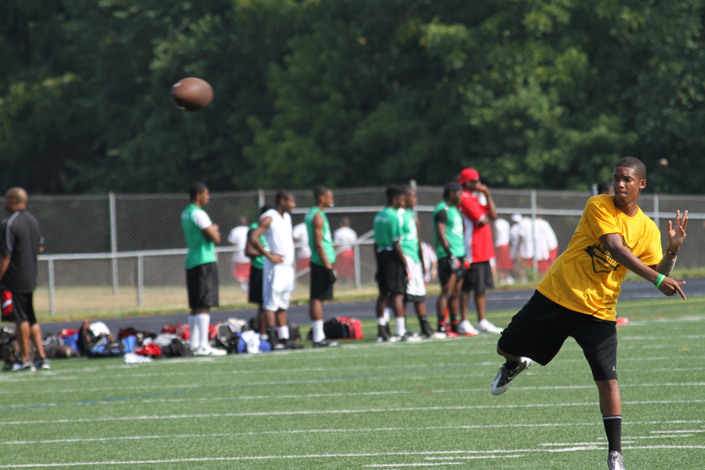
What is a passing league? This is a non-contact 7-on-7 game played on a shortened field that features only the passing game. Many state associations prohibit contact during off-season drills, so passing leagues are very popular with high school football teams as a method of keeping their teams in shape during the summer.
Since 2010, the USPL has founded three regional passing leagues; the Palmetto Passing League in South Carolina; the Pennsylvania Passing League; and the U.S. Marine Corps – Passing League Maryland.
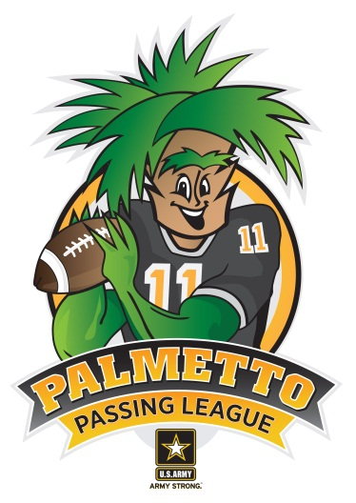

Palmetto Passing League presented by the U.S. Army
In June 2011, the U.S. Army Florence Recruiting Company hosted the first-ever Palmetto Passing League (PPL) at the Freedom Florence Recreation Center with 20 teams, 525 student-athletes. After 49 games of competition, South Florence won the inaugural PPL title with a 21-14 win over Cheraw in the championship game.

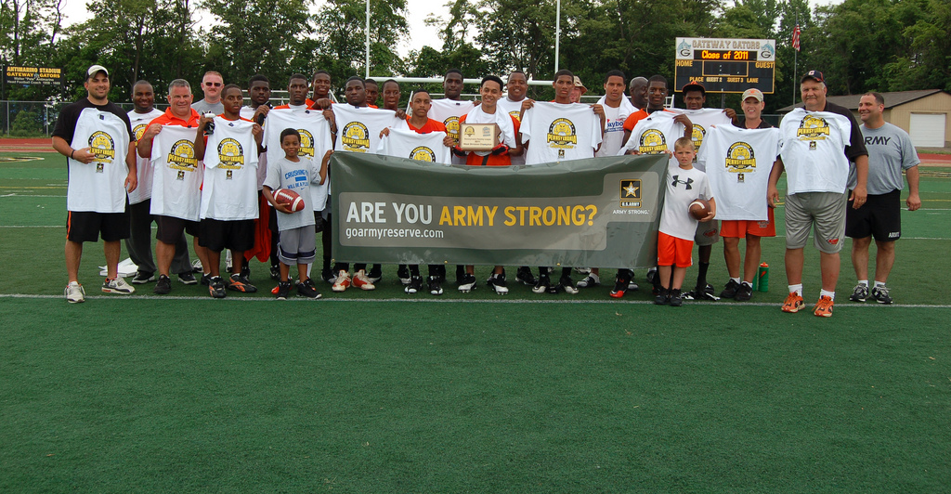
Pennsylvania Passing League presented by the U.S. Army
In 2012, the Pennsylvania Passing League (PPL) begins its third season of competition with events in Pittsburgh and Harrisburg. Since 2010, the PPL has hosted 64 teams and as many as 1,280 student-athletes at our PPL events. In our inaugural season, the PPL EAST & PPL WEST champions were scheduled to play at half-time of a Pittsburgh Steelers preseason game.

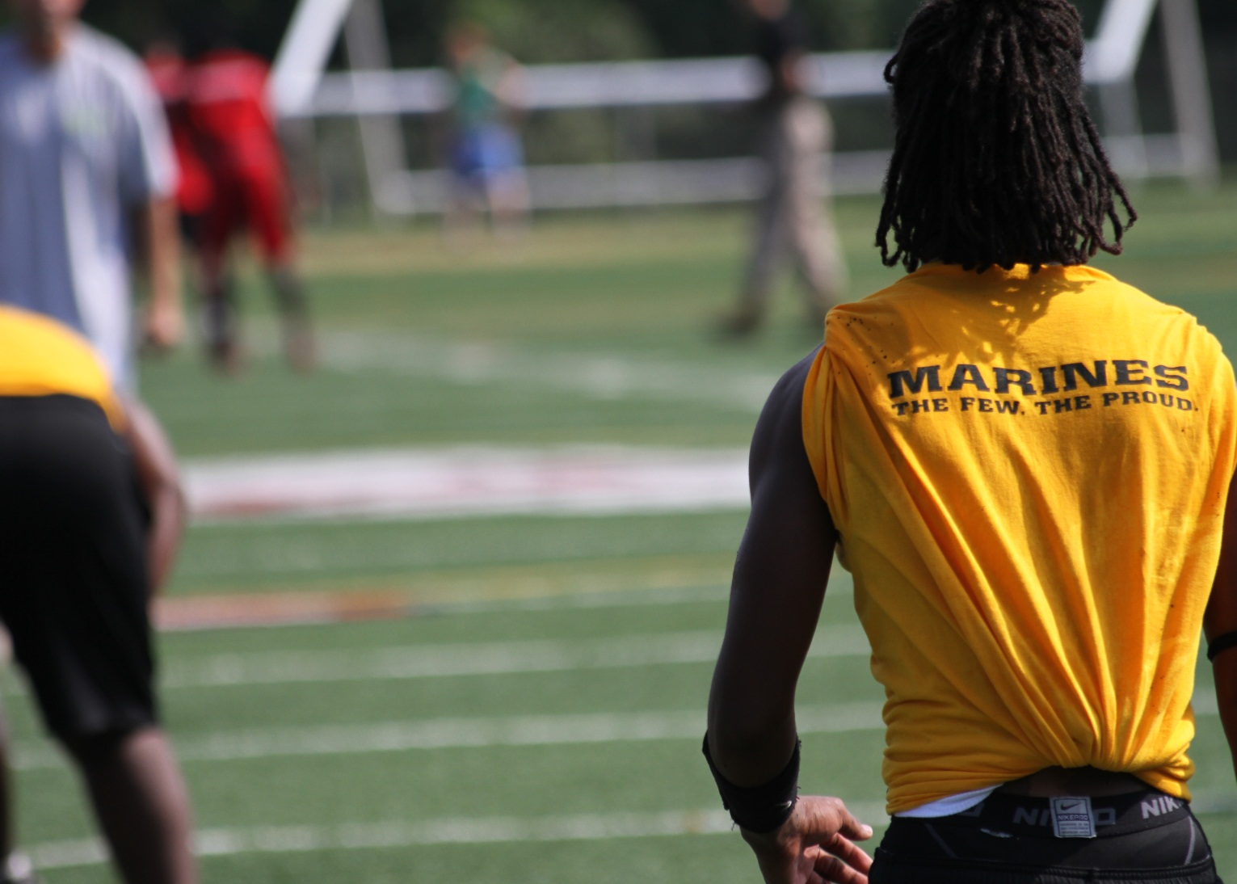

U.S. Marine Corps — Passing League Maryland hosted the first-ever event at Woodlawn High School in Baltimore. The event featured 475 student-athletes playing on 19 teams from throughout the state. Marine recruiters had the opportunity to interact with the student-athletes, coaches, and fans throughout the event.

United States Passing League – 2012 Tentative Events
The USPL is working on securing regional events throughout the United States in 2012. As of December 2011, USPL has tentative passing league events scheduled in the following states:

Asheville Sevens presented by the U.S. Army
Palmetto Passing League presented by the U.S. Army
Pennsylvania Passing League presented by the U.S. Army
U.S. Marine Corps – Passing League Maryland
U.S. Marine Corps – Passing League Delaware

United States Passing League – Structure
Each USPL event is a single-day tournament with pool play determining the seeding for the single-elimination championship round. All participating teams are guaranteed to play four games with at least three games in pool play and one game in the championship round.

USPL events are self-contained, singular regional events that feature local high school football teams. Think of the USPL as a sanctioning body for regional, statewide events that are branded as a local event as in the Pennsylvania Passing League.

Direct Contact
USPL handles the securing of the participating teams in our events, creating a database of all of the schools in the region. In securing the participating teams, TSF Radio Network engages the head football coaches, athletic directors, and principals in the region, using a variety of methods, including:

-introductory letter;
-press releases;
-e-mail contact, updates;
-faxed flyer; and
-phone calls.

We distribute an introductory letter, a flyer, and registration forms to all of the high school football coaches and athletic directors in a region. Information is also faxed to the head football coaches in the region.

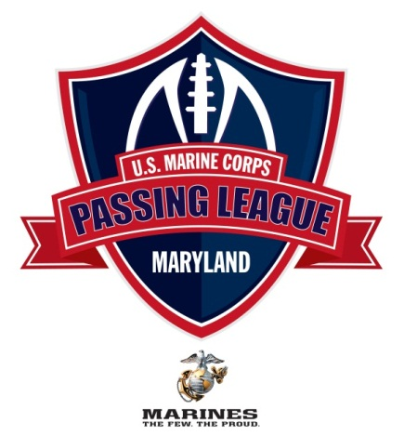

July 12, 2011

I want to thank you for your participation in the U.S. Marine Corps Passing League – Maryland (USMC-PLM). The event is scheduled for Saturday, July 23 at Woodlawn High School. At this time, we’re scheduling the coaches meeting to begin at 8:10 AM at the 50-yard-line with the first game of the day beginning at 8:30 AM. I have enclosed release forms for each of your participating student-athletes, a team information form, and an abridged version of the USMC-PLM rules and penalties.

I have enclosed 15 release forms for your student-athletes. The student-athlete needs to fill out the form completely, and we need the signature of each participant’s parent or guardian. If you need more than 15 release forms, please make a copy of one of the enclosed release forms, or download a release form from the PPL web site, which you can access by visiting www.TheSportsFlash.com.

We must have a signed participant release from every student-athlete competing in the event, or they will not be allowed to compete. The release forms can be turned in when your team checks in on the day of the event, or you can send them to us via e-mail, fax, or regular mail.

To remain in compliance with Maryland Public Secondary Schools Athletic Association rules, we will assign you with a team name and provide you with a USMC-PLM tee-shirt for your players to wear during competition. Please have your players wear a white or gray shirt that day, so we’ll have an “alternate” shirt should you get matched up with a team that has the same shirt color as your team.

The tee-shirts will be distributed the day of the event. Each team will receive 15 tee-shirts for the event, so we’re restricting the rosters to 15 players. If you’d like to bring more than 15 players, that’s fine. Please be advised that we’ll need to purchase a tee-shirt for them or share the shirts during the event. We will offer additional tee-shirts at cost, which should not be more than $10 each, but they’ll need to be purchase before the event. I will send along an order form and a deadline for pre-tournament purchase before the end of June.

If you have any questions, please feel free to contact me at your convenience. I’m available at (517) 927-4570 or by e-mail at TheSportsFlash@aol.com or mike@TheSportsFlash.com. Woodlawn’s DaVaughn Mellerson is serving as our tournament coordinator and is available at (443) 850-5251 or via e-mail at d.mellerson@live.com.

Thanks for your participation,

Mike Sinnott
U.S. Marine Corps – Passing League Maryland

U.S. Marine Corps – Passing League Maryland - “The Sports Flash” Radio Network
Mike Sinnott - 517-927-4570 - TheSportsFlash@aol.com - www.TheSportsFlash.com
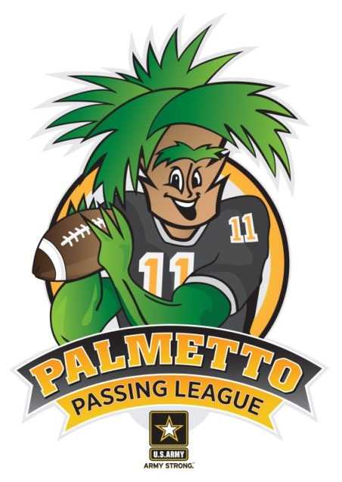
Introducing the 2011
Palmetto Passing League

FREE registration is now available for the first 16 schools that participate in the PPL.

The U.S. Army Florence Recruiting Company and “The Sports Flash” (TSF) Radio Network are teaming up for the 2011 Palmetto Passing League. This 7-on-7 passing tournament will feature high school football players from across the Pee Dee & Grand Strand region. The 2011 Palmetto Passing League will be held on June 18 at the Freedom Florence Recreation Complex.

Registration is now underway and we’re offering FREE registration to the first 16 teams that register for the PPL.

For additional information, go online to www.TheSportsFlash.com and click on the Palmetto Passing League logo to visit the league’s official web site.

If you have any questions, please contact TSF Radio Network’s Mike Sinnott at
(517) 927-4570 or West Florence head football coach Trey Woodberry at (843) 616-1928. E-mail your questions to ArmySTRONG.SC@TheSportsFlash.com or TheSportsFlash@aol.com.

Register now – for FREE – for the 2011 Palmetto Passing League!
 |  | 

Event Management
The United States Passing League (USPL), along with the on-site partner school, handles the management of all USPL events. The event management includes:

-registering teams upon arrival;
-setting up, breaking down of tables, tents, chairs;
-providing water for all competitors;
-coordinating with food vendors, concessions staff;
-assigning officiating crews to particular games;
-interpreting rules;
-scheduling of games;
-ensuring a high-level of sportsmanship, fair play; and
-providing security for the venue, along with a variety of other duties.

Field Managers
The field manager is responsible for ensuring that everything runs smoothly on each field, answers any questions regarding the game rules, keeps an accurate score of each game, and reports the final scores to the tournament score coordinator. In addition, the field manager is responsible for settling any disputes regarding the enforcement of the rules.

Game Managers
The game managers were responsible for keeping the “official” score of each game, running the four-second clock for the quarterback, and ensuring the prompt placement of the ball marker at the line of scrimmage.

Drafting USPL Rules
The United States Passing League drafted the rules, based on a composite of several different passing leagues from throughout the country. During the process, our goal was to draft rules that ensured a fair, safe competition for the participating student-athletes while setting a high standard of sportsmanship among the competitors that aligned itself with USPL values and the values of our sponsors.

USPL officials actively sought the feedback of high school football coaches and athletic directors from throughout the country in helping to create the rules for USPL events.

The rules are distributed to all of the participating schools via e-mail and made the rules available for download at the “official” USPL event web site. In addition, a one-page document that included an abridged version of the rules and penalties were distributed to the coaches on the day of the event.

The abridged version of the rules was drafted from a more extensive rules document that outlined the rules of play; conduct of coaches, athletes; and tournament procedures. The tournament procedures included the rules for determining the field for the single-elimination tournament.

United States Passing League - Rules Overview
1. Field is 40-yards (1.a); a first-down is 20-yards and two first-downs without a penalty results in a touchdown for the offense (5.b).
2. All offensive plays must be forward passes. No shovel passes; no double passes; and no tailback screens (5.a). No running plays are allowed.
3. Participants must wear mouth pieces at all times during competition (2.d – 2.d.4).
4. The quarterback must release the ball in four (4) seconds, or the play would be blown dead, resulting in an incomplete pass (5.f.1-5.f.2).
5. On each down, seven players per team; on offense, a center, quarterback, and five eligible receivers; on defense, seven defenders for each down. (2.f – 2.f.1b)
6. One hand or two-hand touch required to “tackle” the ball carrier. (6.a)
7. No blocking. (5.i)
8. All games are 25-minutes with a running clock. (3.a)
9. Six (6) points are scored on a touchdown. (9.a)
10. Point After Attempt is a PASSING PLAY, no kicking. (9.a) One (1) point is scored on a PAT from the 5-yard-line and two (2) points scored on a PAT from the 10-yard-line. (9.b.1-9.b.2). An intercepted pass during a PAT is a dead ball and no points are scored.
11. An interception returned by the defense beyond the 40-yard-line is a touchdown (6) with the extra-point to follow. (7.c.2 – 7.c.3) SEE ALSO (9.e – 9.d.2)
12. A safety is recorded when a legal pass is completed to an eligible receiver and the defensive player “tackles” the ball carrier behind the 40-yard-line. Two points awarded to the defensive team, and the defensive team will take possession at the 40-yard-line. (9.c)
13. Overtime is three plays from the 15-yard-line (9.f.2) and teams are required to go for two-points on all conversions in overtime (9.f.4).
14. Fumbles which hit the ground are dead balls at the spot of the fumble. (8.a) Muffed snap that hits the ground is a dead ball and a loss of down. (8.c) Fumbles may be recovered in the air before the ball hits the ground. (8.a.1)
United States Passing League - Penalities
1. Defensive pass interference is an automatic first-down at the spot of the foul. (7.a)
2. Offensive pass interference is a five-yard penalty and a loss of down. (7.b)
3. Defensive holding is a 10-yard penalty and repeat the down.
4. Taunting or “trash talking” will not be tolerated. First unsportsmanlike offense is a five (5) yard penalty; second offense is 15-yards and automatic first down; and third unsportsmanlike penalty results in the automatic ejection from the game. (10.j – 10.k.2)
5. Unnecessary roughness or excessive force by shoving, pushing, or striking a blow is a penalty, resulting in an automatic first-down at the spot of the foul. (6.a.1) Officials have the discretion to eject any player from the game. Decision to eject a player is entirely at the discretion of the game official and cannot be appealed (6.a.2)
6. Illegal procedure results in a five-yard penalty (5.j)
7. No offensive foul can take the ball beyond the 40-yard-line.
8. Offense has 25 seconds to put the ball in play once it has been marked for play. Failure to snap the ball in 25-seconds is a 5-yard delay of game penalty with two delay of game penalties on the same possession resulting in a turnover with no points awarded to the defense. (3.i – 3.i.2)

Host Site
During the process of determining the host site, a central location in preferred to ensure a reasonable travel distance for all participating teams. In addition, USPL has minimum requirements for a facility to host an event, including:

-two (2) 100-yard fields;
-one (1) artificial turf field, if possible;
-registration tables;
-access to field house/locker room facilities;
-restrooms;
-concession stands;
-public address system;
-scoreboard; and,
-stadium lights.

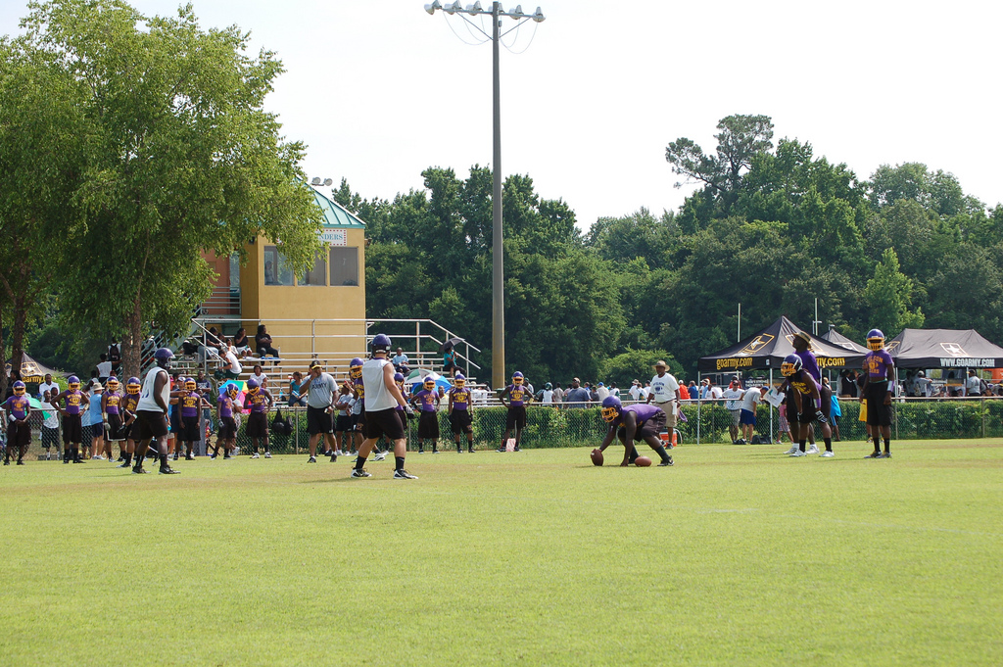
“If anyone ever questions the validity of the passing league, you can let them know that we had four guys come in to enlist within a business day of the event. Three of them were from South Florence High School and they all qualified pending the ASVAB test. Now, that’s awesome.”
CPT Shawn Fitzgerald
Company Commander
Florence Recruiting Company

 |  | 
 |  | 
 |  | 
 |  | 
 |  | 
 | 

Earned Media
Press releases are distributed to our statewide media database that includes newspaper, Internet, radio, and television media outlets. Our earned media efforts have been successful in generating “free media” coverage in a plethora of publications, including:

-Baltimore Sun;  -The Florence Morning News;  -PennLive.com;  -Pittsburgh Post-Gazette;  -Pittsburgh Tribune-Review;  -The Myrtle Beach Sun News;  -The Patriot-News;  -WBTW-TV (Florence, SC);  -WPMT-TV (Harrisburg, PA); and  -York Daily Record. | 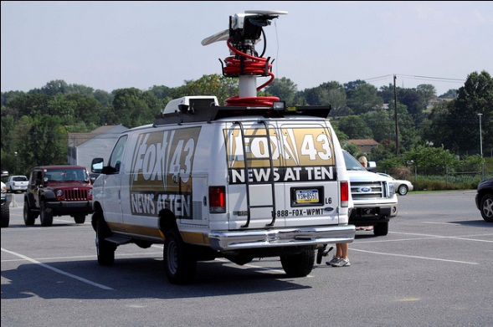
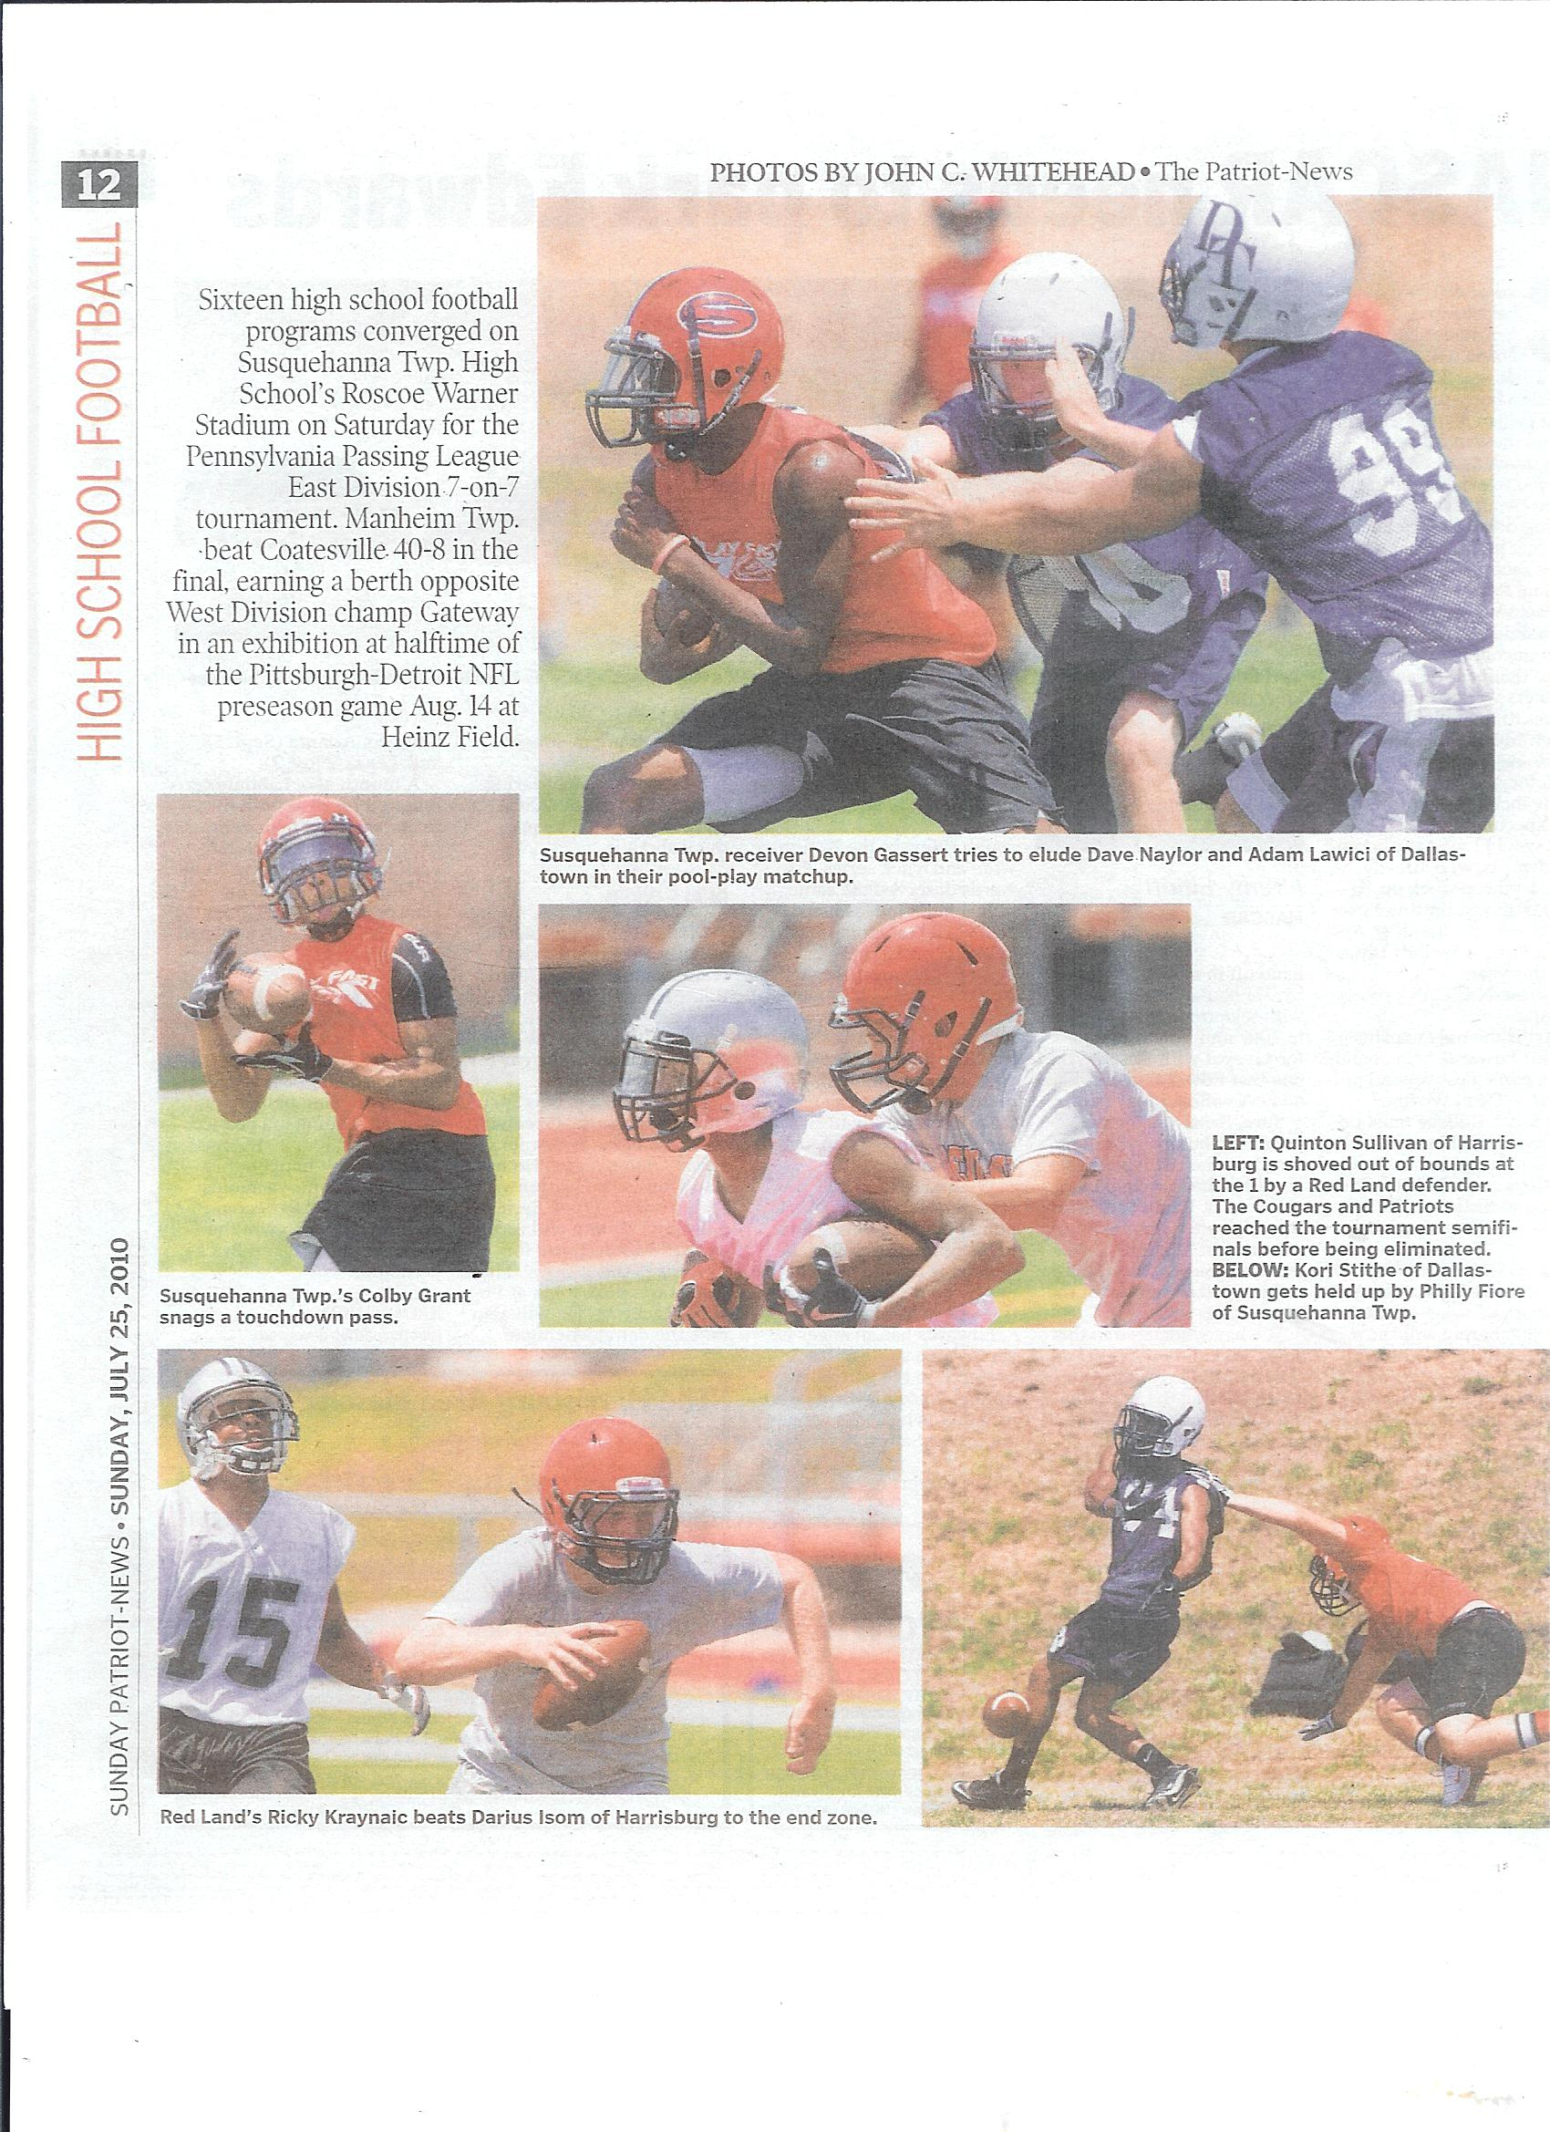
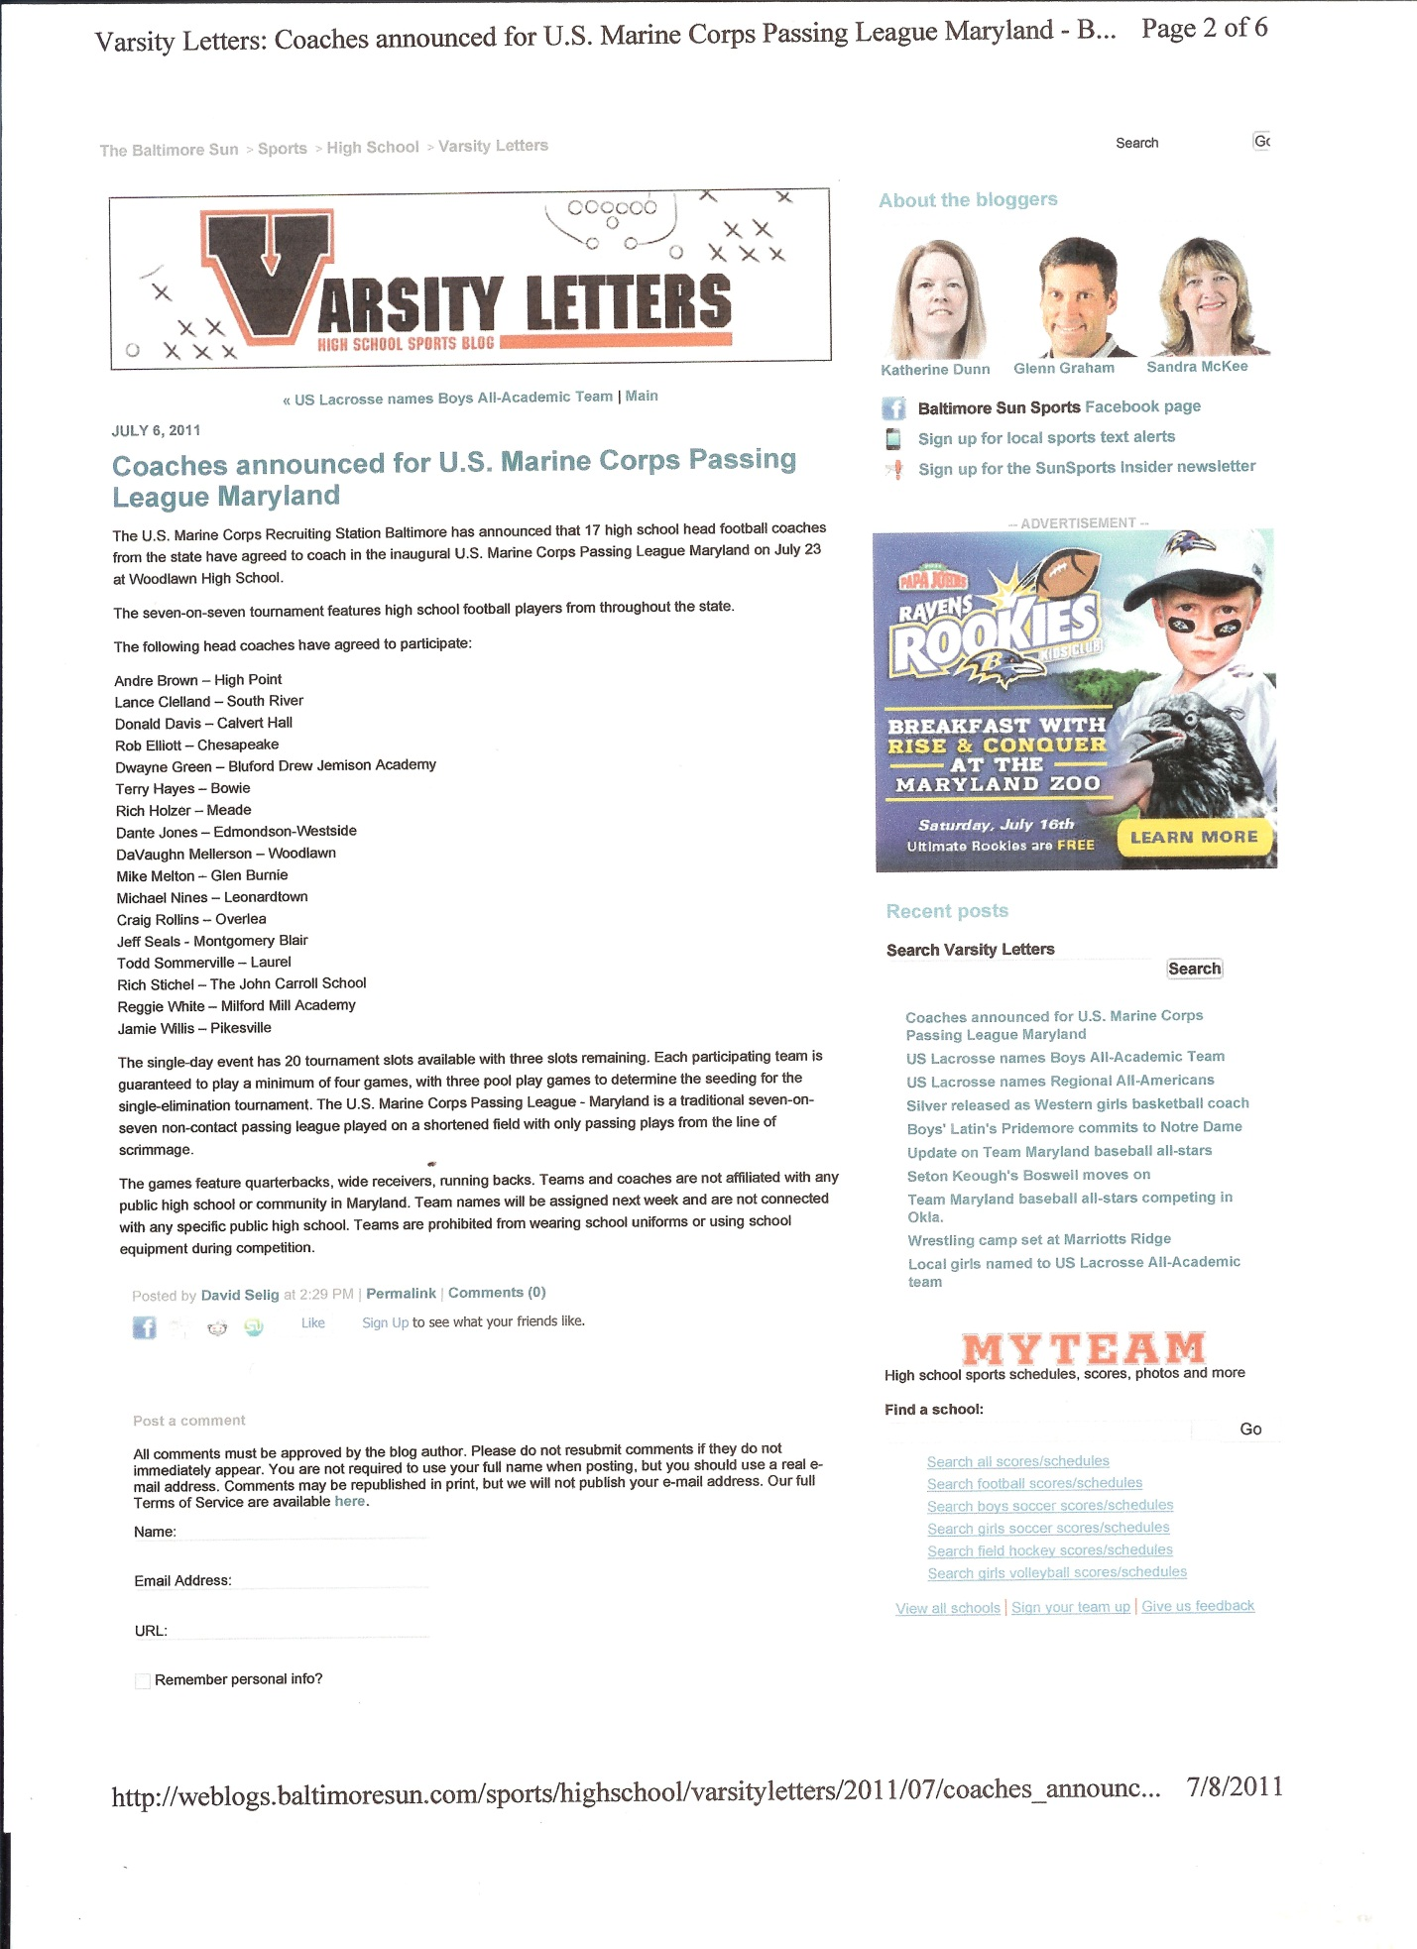
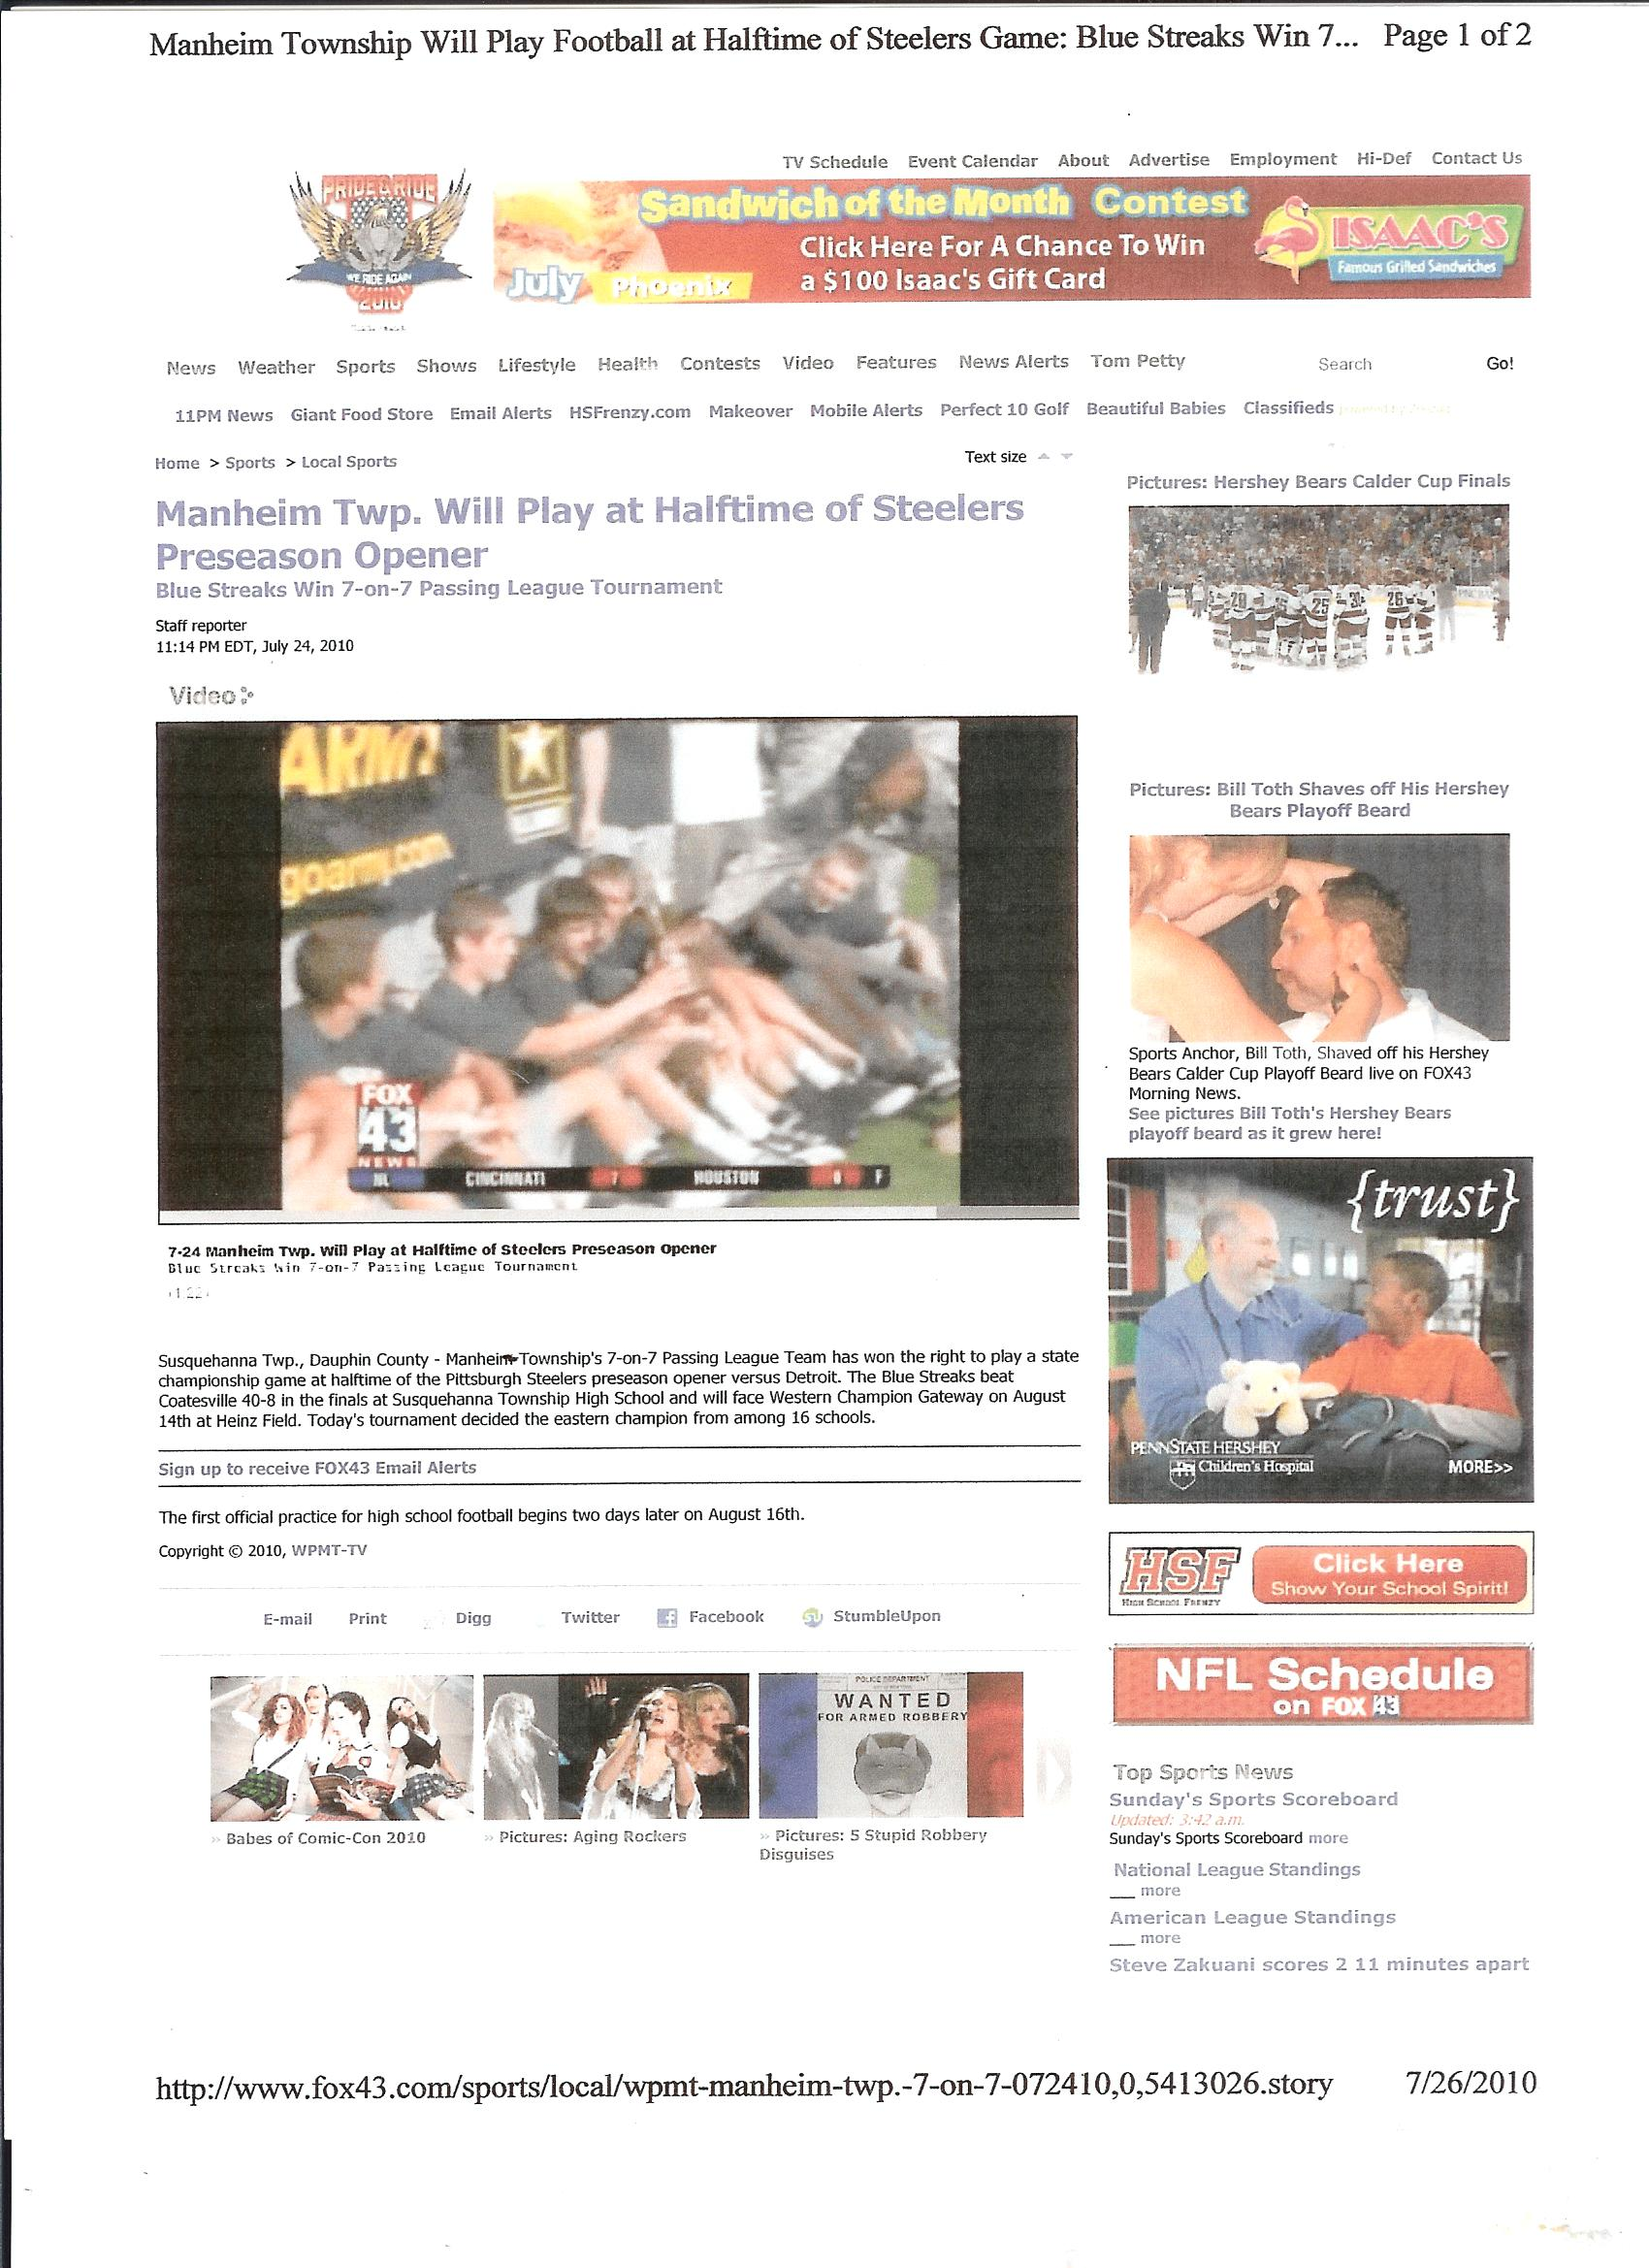
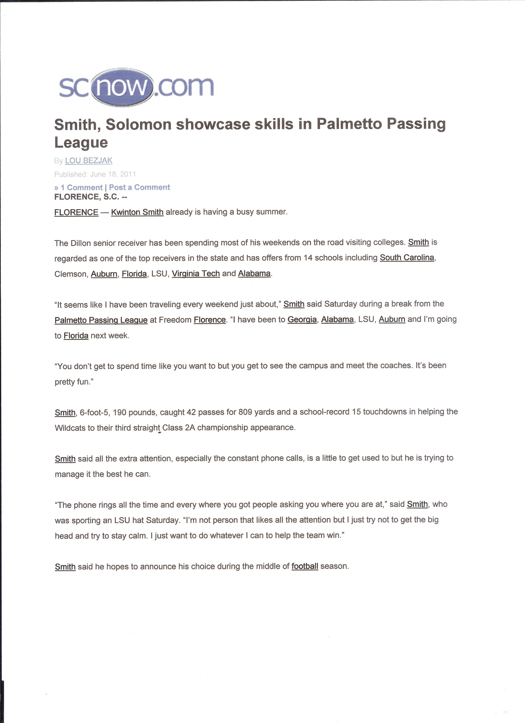

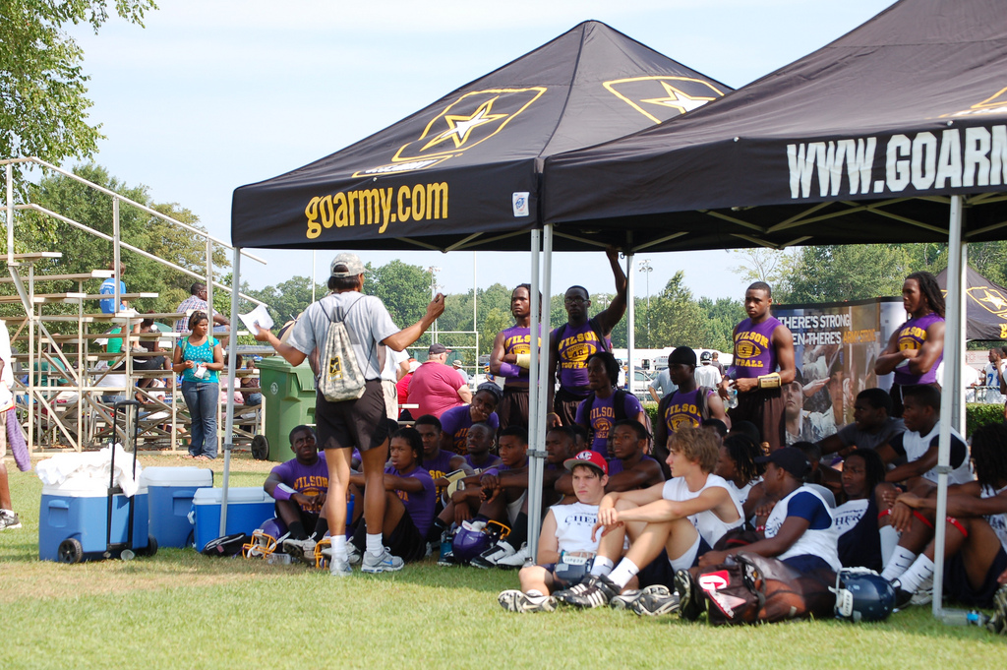
Generating Leads
USPL events are an opportunity to generate personal information about potential customers, including: name; address; phone numbers; e-mail; and much more.


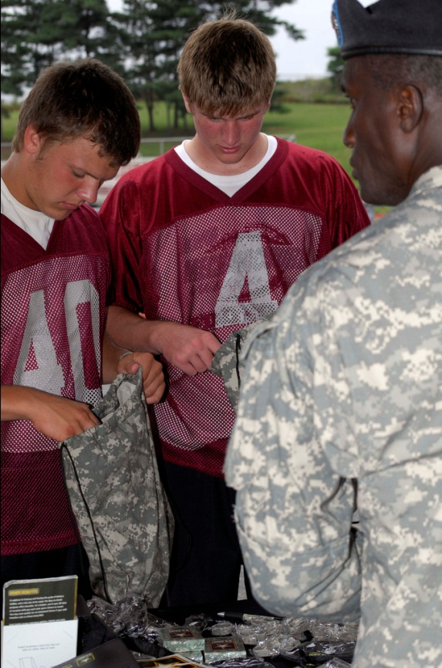
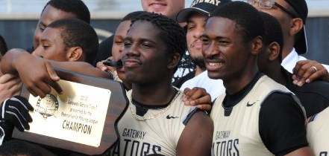
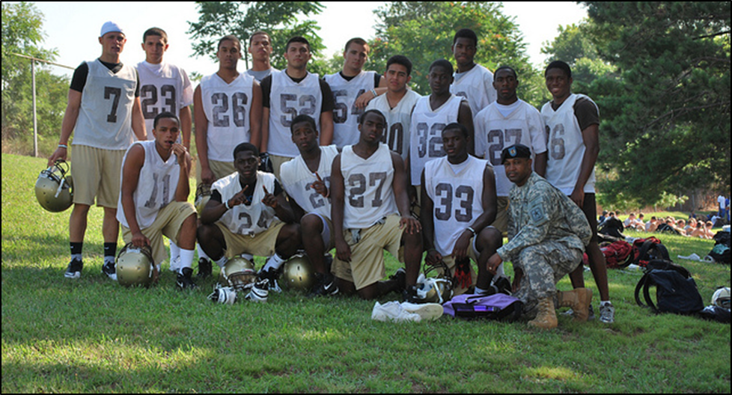

Distributing Products, Information
Each USPL event will be an opportunity to distribute product samples and information to participating student-athletes, coaches, and spectators.

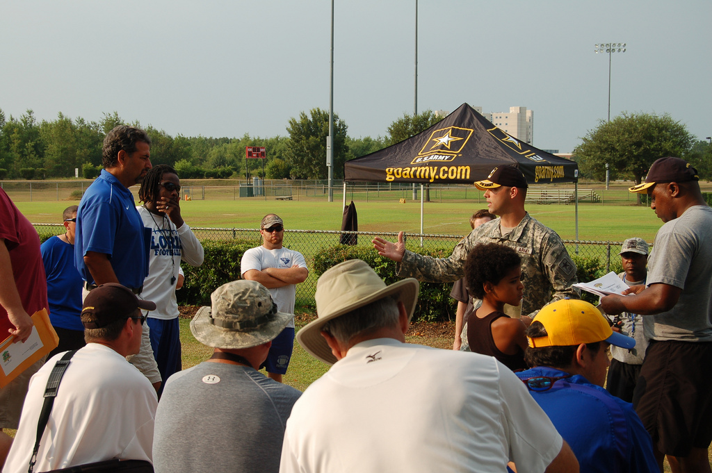
Building Relationships
A marketing partnership with a USPL event enables you to build relationships with high school student-athletes, their peers, parents, coaches, administrators, and the community.

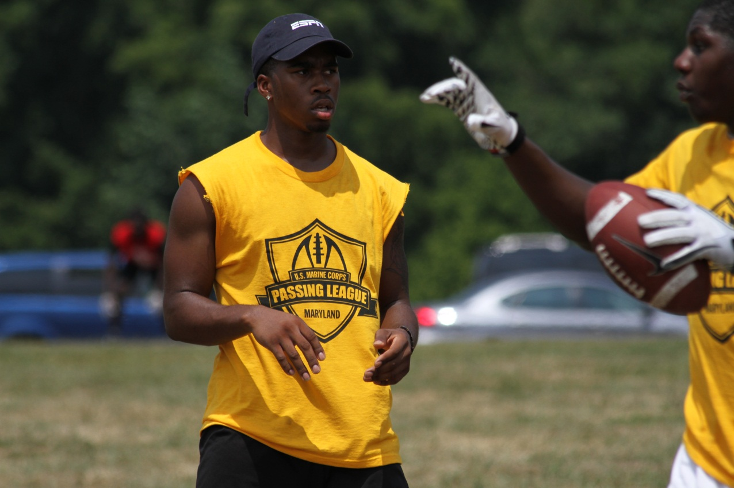

USPL Target Demographic: Student-Athletes (MALES, 13-19), their peers, parents, and community
USPL events reach a target demographic of male student-athletes who are between the ages of 13 and 19 years of age. Since the USPL features “skill” position players, these student-athletes are more than likely to play another sport at their high school, especially basketball and track & field. These student-athletes work out regularly and are concerned with improving their performance. This group of student-athletes is extremely likely to have an interest in work-out equipment; dietary supplements; healthy sports drinks; and functional sports-related clothing and accessories.

In addition, these student-athletes perform above-average academically when compared with students who do not compete in sports, and are leaders in their respective high schools. These student-athletes are admired by their peer group and qualify as influencers in that community.

Their parents are more than likely to be actively involved in their lives, especially with the decision-making process for their life after high school. These student-athletes, however, do influence their parents buying decisions, especially in households in which these computer-savvy young adults advise their parents in regards to purchases both large and small.

Clothing, including shoes, tops the list of this target audience’s most recent purchases and what they plan to purchase in the near future and constitutes their most consistent and annually their largest expenditure. Entertainment, including downloaded music and video games, constitute the second largest recently purchased category. A close third for this group includes food, candy, salty snacks, soda, and sports/energy drinks.

This target audience is particularly interested in purchasing an automobile.

USPL Title Sponsorship - $5,500/event
As the title sponsor of a USPL regional event, your company will receive the following:

-event branded with your corporate identity, featuring 16-20 high school football teams;
-inclusion of your brand identity in the event logo;
-primary signage locations throughout the event’s facility;
-booth space in the highest-profile location of the event’s facility;
-opportunity to make one-on-one presentations to participating teams;
-brand identity included on tee-shirts provided to student-athletes;
-corporate branding included in all communications materials to promote event;
-posting of your click through web banner at primary location at event’s official web site;
-access to database of all participating student-athletes; and,
-presentation of trophy to tournament champion.

USPL Presenting Sponsors - $2,500/event
As the presenting sponsor of a USPL regional event, your company will receive the following:

-participation in event featuring 16-20 high school football teams;
-secondary signage locations throughout the event’s facility;
-booth space in the secondary location of the event’s facility;
-posting of your click-through web banner at secondary location at official web site;
-opportunity to distribute information to participating teams,

USPL Associate Sponsors - $1,250/event
As an associate sponsor of a USPL regional event, your company will receive the following:

-participation in event featuring 16-20 high school football teams;
-signage locations, where available, throughout facility; and,
-booth space at facility to distribute information, products to participants.

For more information on the sponsorship packages available with the United States Passing League, please contact Mike Sinnott at (517) 927-4570.

