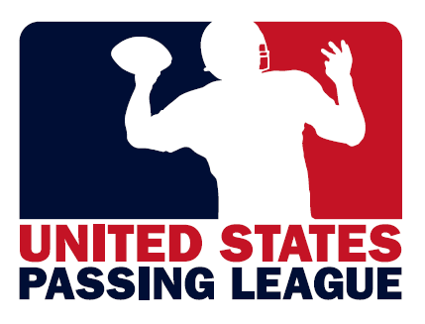 | 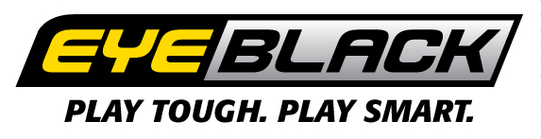

EYEBLACK named the “Official EYEBLACK of the Student-Athletes and Fans” of the USPL
USPL to host as many as 180 teams, 4,500 student-athletes at nine events this summer

FOR IMMEDIATE RELEASE CONTACT: Mike Sinnott; USPL; (517) 927-4570
MAY 25, 2012 Peter Beveridge; EYEBLACK; (877) 393-2522

WILLIAMSTON, MI - The United States Passing League (USPL) is proud to announce an exclusive partnership with patent-protected EYEBLACK. This partnership names EYEBLACK the “Official EYEBLACK of Student-Athletes and Fans of the USPL.” At each USPL event, the participating student-athletes will receive USPL-branded EYEBLACK product to wear during competition.

EYEBLACK will have a presence at all nine USPL events this summer, and student-athletes will have an opportunity to test the patent-protected product in game conditions. In addition, EYEBLACK will be the presenting sponsor of the U.S. Marine Corps – Passing League Maryland SOUTH that will be held at Coolidge High School in Washington, D.C. on Friday, July 13. As the presenting sponsor, each student-athlete will wear an EYEBLACK-branded tee-shirt during the event.

Based in Rockville, Maryland, EyeBlack.com produces innovative sports products that are used worldwide by athletes to enhance their on-field performance, while enabling fans to express their support of a team or a specific athlete. The company offers five main products, manufactured solely in the United States, and made from latex-free medical grade tape that is safe, tested and can breathe on the skin. EyeBlack.com is an official licensee of Major League Baseball (MLB) and Major League Lacrosse (MLL), and has partnerships with National Football League players Marshawn Lynch (Seattle Seahawks), Stevie Johnson (Buffalo Bills), Adrian Wilson (Arizona Cardinals) and LaMarr Woodley (Pittsburgh Steelers), along with World Tennis Association female athlete Bethanie Mattek-Sands and Olympic Gold Medal softball star Jennie Finch. Additionally, more than 400 collegiate programs across the nation wear custom EyeBlack.com products.

Away from the athletic field, EyeBlack.com collaborates with a number of nonprofits, corporations and others to create customized EyeBlack for their respective events, charitable causes, etc.

The United States Passing League begins its 2012 season with the U.S. Army’s Pennsylvania Passing League – WEST in Pittsburgh on June 16. In addition, the USPL will host events in Asheville, NC; Baltimore; Florence/Myrtle Beach, SC; Harrisburg, PA; Kansas City; Philadelphia; St. Louis; and Washington, D.C. The USPL is a seven-on-seven, non-contact passing league played on a shortened field with only passing plays from the line of scrimmage. The games feature quarterbacks, wide receivers, running backs, and defensive backs, giving these skill players an opportunity to sharpen their skills in a fun, competitive atmosphere. Each USPL events features 16-20 teams with each team guaranteed to play four games with three pool play games and at least one game in the single-elimination championship round.

Since 2010, the United States Passing League has managed passing league campaigns in Maryland; North Carolina; Pennsylvania; and South Carolina. The USPL is a marketing platform managed by “The Sports Flash” (TSF) Radio Network. TSF Radio Network provides local, customized sports updates to 179 network affiliates in 13 different states while managing unique sports marketing campaigns for many organizations, including Bluegrass Cellular; Kentucky’s Tobacco Quitline; Montana’s Tobacco Use Prevention Program; the North Carolina Spit Tobacco Education Program; South Carolina Department of Health and Environmental Control; U.S. Army; U.S. Marine Corps; and Wyoming Through With Chew.

For more information about the USPL or other marketing campaigns managed by TSF Radio Network, contact Mike Sinnott at (517) 927-4570.

###

