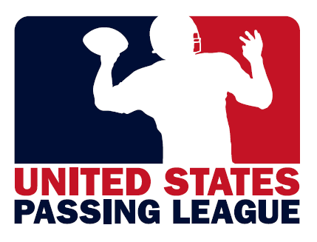 | 

EYEBLACK.com: “Official Eye Black” of the athletes & fans of United States Passing League

The United States Passing League (USPL) hosts seven-on-seven high school football events at a variety of sites throughout the country. Here’s the 2012 United States Passing League schedule as of May 24:

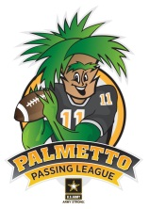 |  | 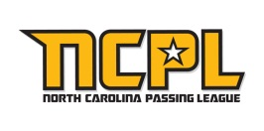 |  | 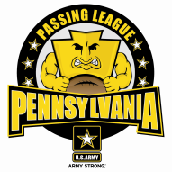 | 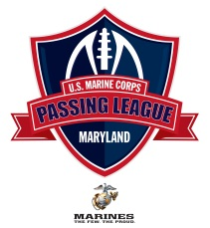
 |  | 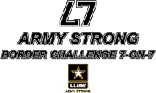 |  | 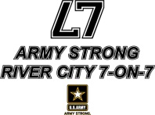
 | DATE |  | USPL EVENT
 | June 16 |  | Pennsylvania Passing League – Pittsburgh
 | June 23 |  | ARMY STRONG River City 7-on-7 – Saint Louis
 | June 23 |  | Palmetto Passing League – Myrtle Beach/Florence, SC
 | June 30 |  | North Carolina Passing League - Asheville
 | June 30 |  | ARMY STRONG BORDER CHALLENGE 7-on-7 – Kansas City
 | July 13 |  | U.S. Marine Corps Passing League – Washington, D.C.
 | July 15 |  | Pennsylvania Passing League – Harrisburg
 | July 21 |  | Pennsylvania Passing League – Philadelphia
 | July 28 |  | U.S. Marine Corps Passing League – Baltimore

EYEBLACK.com will provide the USPL with 4,000 pairs of product customized with USPL logo. The USPL will distribute that product for FREE to the participating student athletes at each of our nine events. In addition, EYEBLACK.com will provide the USPL with 1,000 retail sets (2-pair) of the product that the USPL can sell for approximately $3.00 each. The USPL will share any revenue generated from the on-site sales of EYEBLACK.com product with the host school.

In exchange for this product, the USPL will provide EYEBLACK.com with the following marketing considerations:

-distribution of FREE product, information to our 4,500+ participating student-athletes;
-distribution of coupons, at your discretion, for a percentage off on team or individual purchases;
-secondary signage locations (banners/posters) throughout each USPL venue;
-access to booth space at each USPL venue and the right to distribute information to participating teams;
-public address announcements during each event that highlights the EYEBLACK.com brand;
-web banners at each USPL event-specific web site that clicks-through to the EYEBLACK.com web site;
-inclusion of EYEBLACK.com in all marketing materials to promote each event; and,
-inclusion of EYEBLACK.com in all press releases to promote the event.

In addition, EYEBLACK.com will be the presenting sponsor of our event in Washington, D.C. at Coolidge High School on Friday, July 13. The event will be known as the U.S. Marine Corps – Passing League Maryland SOUTH presented by EYEBLACK.com. We will include the EYEBLACK.com logo on all of the tee-shirts worn by the competitors at that event, and promote that tournament as a Marine Corps, EYEBLACK.com partnership to bring a FREE football tournament to Coolidge High School.

This is a mutually beneficial partnership that will enable EYEBLACK.com to introduce its products to nearly 200 high school and 4,500 student-athletes at events around the country in 2012.

United States Passing League
1516 Lytell Johne’s Path – Williamston, MI - 48895
Mike Sinnott – (517) 927-4570 – www.TheSportsFlash.com – TheSportsFlash@aol.com – mike@thesportsflash.com.

