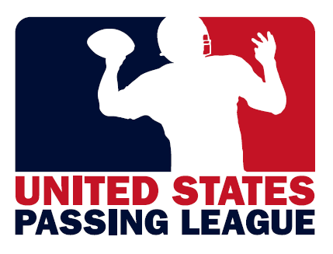 | 

GTM SPORTSWEAR:
“Official Outfitter” of the U.S. Marine Corps - Passing League Maryland

The United States Passing League (USPL) hosts seven-on-seven high school football events at a variety of sites throughout the country, including two events in Maryland in Baltimore and in the Washington, D.C. area.

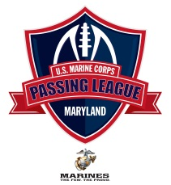
U.S. Marine Corps – Passing League Maryland
2012 Schedule
July 14 – Washington, D.C.
July 28 – Baltimore, Maryland

Our events are an opportunity for GTM SPORTSWEAR to introduce your products to high school football coaches, athletic directors, and administrators at our events in Maryland. These are the decision makers who make the purchasing decisions for their respective high schools, including a multitude of sports teams and organizations at each school.

As the “Official Outfitter” of the U.S. Marine Corps-Passing League Maryland, GTM SPORTSWEAR will receive marketing considerations that are valued at $2,500 per event or $5,000 for two events. In Maryland, the high school athletic association rules require that teams participating in our USMC-PLM events wear tee-shirts provided by our organization. For our Maryland event, GTM SPORTSWEAR will provide each competitor in Maryland with a tee-shirt that includes the GTM SPORTSWEAR logo in the center of the shirt.

For the first 16 teams at each event, the USMC-PLM will provide each team with 15 FREE shirts from GTM SPORTSWEAR. For additional tee-shirts, the teams will be required to purchase the shirts from GTM SPORTSWEAR.

In exchange for 480 tee-shirts in four distinct colors, the USPL will provide GTM SPORTSWEAR with the following marketing considerations:

-GTM SPORTSWEAR tee-shirts will be worn by all competitors at our two Maryland events;
-GTM SPORTSWEAR logo will be prominently included on the front of the tee-shirts worn by our student-athletes;
-secondary signage locations (banners/posters) throughout each venue;
-access to booth space at each USPL venue and right to distribute information to participating teams;
-right to conduct apparel seminar for coaches, athletic directors at each event;
-public address announcements during each event that highlights the GTM SPORTSWEAR brand;
-web banners the USPL’s event-specific web site that clicks-through to GTM SPORTSWEAR web site;
-inclusion of GTM SPORTSWEAR in all marketing materials to promote each event; and,
-distribution of GTM SPORTSWEAR catalogs to decision makers for each of the participating schools.

For more information on the sponsorship packages available with the United States Passing League, please contact Mike Sinnott at (517) 927-4570.

