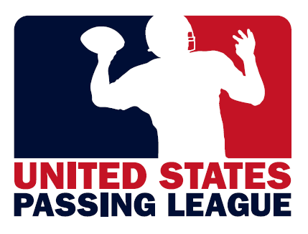

2012 Market Analysis
Miami, Florida, USA

Prepared by the United States Passing League for:



Objective
The United States Passing League (USPL) has prepared this market analysis for CytoSport’s brand Muscle Milk. Please consider this a working document that provides you with insight into our thought process as we determine the viability of a passing league event as a marketing vehicle for your brand in the Miami market.

Ultimately, our goal is to create a showcase event for the best high school football players in South Florida. This will be a fun event for your target audience and will help with Muscle Milk’s branding with the target audience in the Miami market.

This marketing “game plan” will be duplicated for each Muscle Milk passing league market.

Branding each event for Muscle Milk
Muscle Milk will own the branding for each event, starting with the name of the event. In general terms, we can brand all events under the MUSCLE MILK Passing League banner or create a unique identity for each local event.

Here are a few suggested names for the Miami event:

-Muscle Milk Passing League;
-Muscle Milk Passing League – Miami;
-Muscle Milk Seven-On-Seven;
-Muscle Milk Seven-On-Seven – Miami;
-Miami’s Seven-On-Seven Invitational engineered by Muscle Milk;
-Miami’s Muscle Milk Passing League; and,
-South Florida’s Seven-On-Seven powered by Muscle Milk.

Although the goal is national in scope, keeping a “local” feel for each event is important. This helps to give the local schools ownership of the event.

Designing the campaign logo
The USPL will work with our design partner, Image Creative Group, to create an image for your passing league campaign. We can either design one general logo for all events, or design separate logos for each market, incorporating design elements that would be unique to the market. For Miami, a logo that incorporates tropical imagery, palm trees, water, light, breezy colors may be appropriate for the campaign logo.

Muscle Milk will be a key design element of any passing league logo. In addition, we will work to ensure that the logo conveys the following through its design elements:

-strength;
-vitality;
-enthusiasm;
-athleticism;
-fun, youthful exuberance;

Of course, the campaign logo will be used in all materials to promote the campaign, including the web site, direct mail, press releases, etc.

As the title sponsor of the Miami event, Muscle Milk will give final approval on the logo design. In addition, although not necessary, Muscle Milk will have the opportunity to have its design team design the passing league logos for each market.

Securing Host Sites
As the passing league logo is being designed, the USPL will work to secure a host site that meets our requirements for hosting an event. The hosting requirements cover all aspects of the event, including:

-number of available fields, including availability of a turf field;
-restroom facilities;
-locker room facilities;
-press box facilities;
-parking; and,
-concessions, among others.

The USPL has a host site application that details all of the requirements of hosting an event and goes into detail regarding the host site’s facilities.

In addition, the USPL considers proximity from major highways in the area, travel distance for a majority of the teams, the safety of the neighborhoods surrounding the venue, and the demographics of the school, community that is hosting the event.

The cost to rent the facility is also a consideration. With a limited budget and our commitment to keeping this a free event for the participating teams, the USPL works to find venues that are affordable.

Most importantly, UPSL ensures that there are little or no restrictions on our ability to help market your products to the target audience.

For Muscle Milk’s Miami event, the USPL recommends considering the following facilities:

  - Central Broward Regional Park
  - Gerry Curtis Park Sports Complex
  - Miramar Regional Park
  - Nathaniel Traz Powell Stadium
  - Christopher Columbus High School
  - North Broward Prep School
  - Ransom Everglades School
  - St. Thomas Aquinas High School
Parks & Recreation Facilities

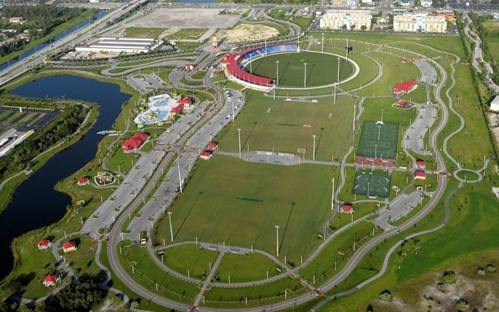

Central Broward Regional Park 3700 North West 11 Place, Lauderhill, FL

This is a 110-acre multi-purpose facility and includes the only cricket stadium certified by the International Cricket Council in the United States. The circular, multipurpose cricket stadium has covered seating for 5,000 spectators. There are four lighted fields, spectator seating, a field house, concessions, plenty of parking and much more. The venue is also fairly reasonable to rent for a single-day event. The facility is located northwest of Fort Lauderdale-Hollywood International Airport, west of Interstate 95, and is approximately 30 miles north of Miami International Airport.

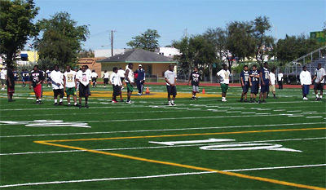

Gerry Curtis Park Sports Complex 1901 NW 24th Avenue, Miami

This City of Miami Park is centrally located to the east of the Miami International Airport and north of the Dolphin Expressway. The facility has a lighted, turf-field with a secondary field possible on the outfield of an adjacent baseball stadium.

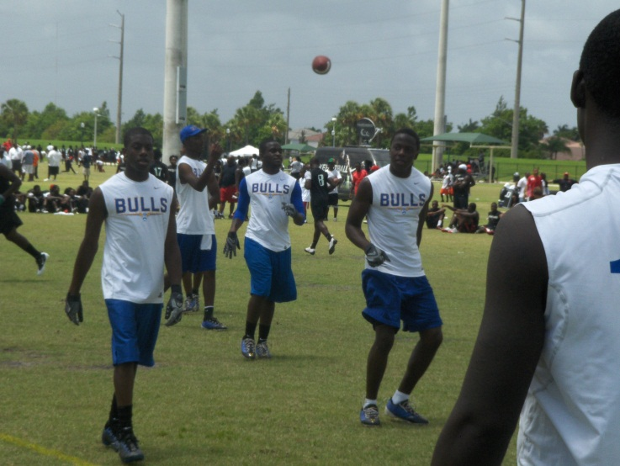

Miramar Regional Park 16801 Miramar Parkway, Miramar

This 173-acre multi-purpose facility is located one mile west of I-75 on Miramar Parkway. The facility has four football fields along with a large corporate pavilion, plenty of bathroom facilities, and parking. The facility does not have an artificial turf field available, but it does have eight fields available for games. This facility is located on the far western edge of the Miami metropolitan area, but is located near many high-traffic expressways, which makes for reasonable travel from both Miami and Fort Lauderdale to the facility. This facility has previously hosted Nike 7-on-7 events.

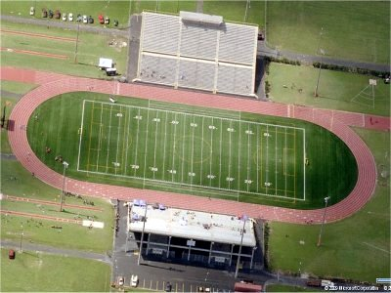

Nathaniel Traz Powell Stadium 11380 Northwest 27th Avenue, Miami

This stadium is the home field for Miami’s Booker T. Washington & Miami Northwestern High School. The facility is located north of Miami International Airport, west of Interstate 95. The facility has an artificial turf field with two possible secondary fields of play, within walking distance of the facility.
High School

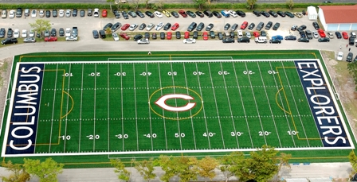

Christopher Columbus High School 3000 Southwest 87th Avenue, Miami

The school has one turf field along with potentially three other fields for use during the tournament. The secondary fields could potentially become a problem due to space concerns, but the games could be played on the outfields of two baseball diamonds.
Columbus High School’s location is reasonable for travel. The school is located between the Palmetto Expressway and the Florida 921 Toll Road, south of Miami International Airport and southeast of the FIU campus.

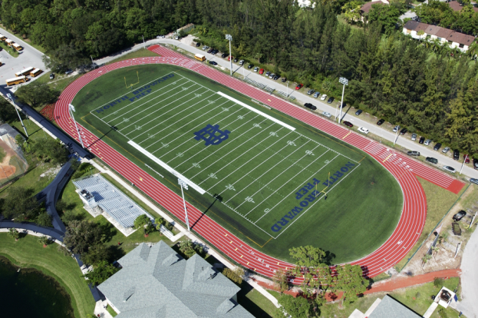

North Broward Prep School 7600 Lyons Road, Coconut Creek

North Broward has one turf field available and another two fields available for play within a short walk of the main stadium. If necessary, the outfield of a baseball stadium is available for play. There’s plenty of parking for teams, spectators. This venue is 44-miles north of downtown Miami.

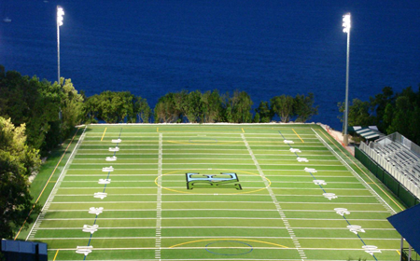 | 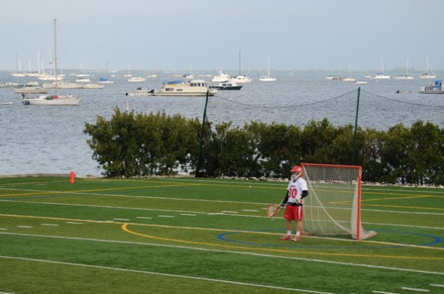

Ransom Everglades School 2045 South Bayshore Drive, Miami

This could be one of the more unique venues in all of high school sports. Walker Athletics Field at Ransom Everglades School overlooks the Biscayne Bay. In fact, notice that there are no goal posts at the end overlooking the bay since a simple extra-point would end in a splash down of the football. Even if the venue were available at an affordable price, the location presents many logistical problems that may be too much to overcome.

Parking is at a premium, and, after 16 school buses have found parking, there’s the problem of parking for spectators. In addition, there’s just the one field at Ransom Everglades. While we could change the format of the tournament to make that work, we would have to limit the field to 16-team, and consider playing some of the games at night. Now, the middle school has a field available, but that is 2.2-miles from the high school.

The school itself is located to the east of Coral Gables, and, while somewhat southeast of many of the possible schools, it is located close enough to U.S. 1 to be a reasonable travel distance for most of the participating schools.

This is a charming venue, but one that may not be a feasible host site for our event. I am, however, intrigued by the possibilities.

St. Thomas Aquinas 2801 SW 12th Street, Ft. Lauderdale

This school is located northwest of the Ft. Lauderdale-Hollywood International Airport, one block west of Interstate 95, just off of Davie Boulevard. The northern location of this venue has its drawbacks. In addition, a secondary field of play may be difficult to find. One field may be available in the outfield of the baseball field, but it may be a tight fit.

In ranking the possible host facilities, we rank them in the following order of preference:

- Central Broward Sports Complex
- Miramar Regional Park
- Traz Powell Stadium
- Gerry Curtis Park Sports Complex
- Columbus High School
- St. Thomas Aquinas
- North Broward Prep
- Ransom Everglades

This recommendation is based solely on our analysis of each venue’s ability to put on a “showcase” event for Muscle Milk. As with every aspect of this campaign, we will make our recommendations, but Muscle Milk will have the final approval.

Ultimately, a variety of factors will determine the host site, including the availability of the venue on the preferred date, cost to rent facility, and restrictions, if any, that are placed on our ability to actively engage the target audience.

High schools who host the event can use the event as a fundraiser for the school’s athletic booster club or football program. Each school is allowed to sell concessions and keep the proceeds from the concession sales.

If possible, since we are not charging teams to participate and the host school is using the event as a fundraiser, the USPL prefers facilities that do not charge a rental fee. Often, when high schools host events, there is no charge for the facility as the host school is likely to waive the rental fee.

Since this is a large metropolitan area, we will also work to ensure that the event is held in a safe community in a desirable neighborhood. The securing of all participating teams is of the utmost concern. USPL will research the surrounding neighborhoods and community for any crime patterns that could be of reasonable concern for the safety of our event.

Establishing Date for Event
After the host facility has been secured, the USPL will establish the date for the event. We’ll work to avoid significant conflicts that will hamper teams from participating, working to avoid conflicts with existing events, including team camps and combines. We’re find the best possible date to increase participation in the event.

Typically, USPL events are held during the spring, summer, but, for Miami, we’re open to a winter date, especially with the favorable weather in the region.

On-site Tournament Coordinator
For each market, the USPL will work with a head football coach or athletic director who will be the on-the-ground representative of our event. The on-site coordinator helps to lend credibility to the event, helps to secure participating teams, and helps guide us through the process of establishing an event in the community.

As we get closer to the event, the on-site coordinator will take a much more active role in coordinating the game-day activities. We’ll often work with the head football coach, athletic director of the host school or a school in the community.

Contacting, Securing Teams
After we’ve secured the host facility, we’ll begin the process of securing the participating teams for the event. The USPL will target the high schools that match Muscle Milk’s socioeconomic profile. The USPL will create a database of all high schools that match Muscle Milk’s target audience that includes contact information for school administrators, athletic directors, and football coaches.

In securing the participating teams for your event, the USPL will engage head football coaches, athletic directors, and principals in a variety of methods, including:

-introductory letter to the head coaches, athletic directors;
-press releases, notices sent via e-mail;
-faxed flyer introducing the event; and
-follow up via telephone.

We’ll also include our partner school in the in securing schools for our event. Usually, our in-state coordinator is a head football coach, athletic director who can help us to establish credibility with the schools in the community, help secure the schools, and provide guidance in regards to rules, officials, and on-site logistics.

With Muscle Milk’s sponsorship, teams will not be charged to participate in the event. From our experience, this will make your event very attractive to participating schools. This will save schools $300-$400 for the event.

The USPL cannot guarantee the participation of any school in our events. Participation is a school-by-school decision and can be based on a variety of factors, including: a team’s style of play; injuries; conflicts with other events; and coaching philosophy. We cannot control whether or not a particular team participates in a USPL event, but we can make the event as attractive as possible for the schools.

Targeting schools
Our goal is to create an event for Muscle Milk that involves the best high school football teams in the region, creating an event with student-athletes that are a “cut above the rest.” In South Florida, Muscle Milk will associate its brand with some of the best high school football players from not only the state, but the nation. South Florida is fertile territory for college recruiters who are looking for the best football talent in the nation.

There are 105 football playing schools in Broward and Dade Counties. Based on their on-field performance from the 2011 football season, we’ve broken down the groups by priority schools (8-15 wins); secondary targets (6-7 wins); and tertiary targets (5 wins or fewer).

PRIORITY SCHOOLS (22)

We have identified 22 priority schools that won a minimum of eight games in 2011. This group includes the defending Florida High School Athletic Association (FHSAA) Class 5A state champions from Norland and three teams that finished second in their respective classifications during the 2011 playoffs. In addition, St. Thomas Aquinas, was a mythical high school national champion in 2010.

- Norland (15-0) – FHSAA Class 5A - Champion
- Miramar (13-1) – FHSAA Class 8A – Runner Up
- Central (13-1) – FHSAA Class 6A – Runner Up
- Booker T. Washington (12-2) – FHSAA Class 4A – Runner Up
- University Prep (11-1)
- Cooper City(10-2)
- Columbus (10-3)
- St. Thomas Aquinas (10-3) – 6 x STATE CHAMPION (’92, ’97, ’99, ’07, ’08, ’10)
- American Heritage (9-2)
- Belen Jesuit (9-2)
- Chaminde Prep (9-2)
- Taravella (9-2)
- Coral Reef (9-3)
- South Miami (9-3)
- Boyd Anderson (8-2)
- Dade Christian (8-2)
- North Broward Prep (8-2)
- Cardinal Gibbons (8-3)
- Gulliver Prep (8-3)
- Miami Beach (8-3)
- Cypress Bay (8-4)
- Jackson (8-4)

SECONDARY TARGETS (26)

There are 26 secondary targets that could participate in the Muscle Milk Passing League event. The secondary targets won a minimum of six games in the 2011 football season. The list includes Nothwestern, a four-time state champion, whose most recent state title was in 2008.

- Calvary Christian (7-2)
- Coral Springs Charter (7-2)
- Coral Springs (7-3)
- Goleman (7-3)
- Northwestern (7-3) – 4 x STATE CHAMPION (’95, ’98, ’06, ’08)
- Westminster Academy (7-3)
- Westminster Christian (7-2)
- South Plantation (7-4)
- Blanche Ely (7-4)
- Northeast (7-5)
- Palmer Trinity (6-3)
- Archbishop Carroll (6-4)
- Edison (6-4)
- Flanagan (6-4)
- Hialeah-Miami Lakes (6-4)
- Highlands Christian (6-4)
- Killian (6-4)
- Miami High (6-4)
- MacArthur (6-4)
- Ronald Reagan (6-4)
- American (6-5)
- Pembroke Pines Charter (6-5)
- Southwest (6-5)
- Southridge (6-6)
- Western (5-4)
- Hillel (4-2-1)

TERTIARY TARGETS (57)

The tertiary targets have five wins or fewer, but include two schools that have a history of playing in the FHSAA playoffs, including four-time state champion Carol City and Monsignor Pace who had a streak of 18-consecutive appearances in the playoffs end in 2008.

- Braddock (5-5)
- Ferguson (5-5)
- Hallandale (5-5)
- Planation (5-5)
- South Dade (5-5)
- Stranahan (5-5)
- Monsignor Pace (4-4) – STREAK of 18-sraight tourney appearance ended in 2008
- South Florida HEAT (4-4)
- Carol City (4-5) – 4 x STATE CHAMPION (’77, ’96, ’97, ’03)
- Palmetto (4-5)
- Archbishop McCarty (4-6)
- Everglades (4-6)
- Homestead (4-6)
- South Broward (4-6)
- Varela (4-6)
- Westland Hialeah (4-6)
- Krop (4-6-1)
- Hialeah (4-7)
- Northwest Christian (3-3)
- Champagnat (3-6)
- Deerfield Beach (3-6)
- Doral Academy (3-6)
- Florida Christian (3-6)
- Mater Academy Charter (3-6)
- Pine Crest (3-6)
- Miami Country Day (3-7)
- Monarch (3-7)
- Nova (3-7)
- Pine Crest (3-6)
- Barrington Christian (2-4)
- Miami Christian (2-5)
- Somerset Academy (2-5)
- Coral Springs Christian (2-6)
- Dillard (2-6)
- Coral Gables (2-7)
- Douglas (2-7)
- Archbishop Curley (2-8)
- Fort Lauderdale (2-8)
- Hollywood Hills (2-8)
- North Miami (2-8)
- Piper (2-8)
- Pompano Beach (2-8)
- Westwood Christian (1-7)
- Zion Lutheran (1-7)
- Coral Glades (1-8)
- LaSalle (1-9)
- Mourning (1-9)
- Sunset (1-9)
- West Broward (1-9)
- Posnack Day School (0-4)
- Sheridan hills Christian (0-6)
- Calusa Prep (0-9)
- Hialeah Gardens (0-9)
- Coconut Creek (0-10)
- Coral Park (0-10)
- Miami Springs (0-10)
- North Miami Beach (0-10)

Demographic Data
Muscle Milk is a business with a product to sell to its target audience. That’s why on-field performance alone is not the only criteria to be considered when inviting teams to your USPL event. We understand that. It is also clear that Muscle Milk is an expert at its own target audience’s demographics.

From our superficial understanding of your target audience, you’re seeking active, athletic males who are concerned with their performance with a reasonable amount of discretionary income. Since Muscle Milk is a product that approaches $3.00 per unit, some of the more economically disadvantaged schools might not fit your criteria.

For each possible participating school, we’ve secured relevant demographic data for your analysis. This is to determine which of these high schools fit your demographic criteria.

The following school demographic information was gathered from the U.S. Department of Education’s “No Child Left Behind” Act School Public Accountability Reports for each of the public schools. While it is not representative to the specific demographics of each particular team, it stands to reason that each team will consist of student-athletes that fall into these demographic categories.

For example, it stands to reason that a hypothetical Miami Central team of 25-players in your USPL event will consists of approximately 20 African-American and five Hispanic student-athletes while nearly 21 of those student-athletes will be economically disadvantaged.

MIAMI CENTRAL (13-1) |  |  | TOTAL STUDENTS: 1,849
 | WHITE: 0.4% | BLACK: 78.8% |  | ASIAN: 0.1% |  | HISPANIC: 20.5%
 | ECONOMICALLY DISADVANTAGED: |  |  |  | 79.1%

Based on the available data, we can extrapolate a reasonable demographic of the participating student-athletes for your event.

The relevant data is not available for the private schools, but, when available, we’ve found the tuition for each private school. It is reasonable to assume that private school student-athletes will have more discretionary income than student-athletes who attend a public school where a majority of the students are economically disadvantaged.

For the USPL, this is a marketing event for Muscle Milk. Ultimately, the goal is to sell your product. The best way to do that is to expose your product to those members of your target audience with enough discretionary income to purchase your product. All you need to do is establish the demographic parameters for your target audience and we’ll work to create an event the delivers that audience.

The following information is the data that we’ve compiled for the priority schools and secondary targets. These are the 48 top-tier football programs in South Florida, and we’ll initially target those schools. If necessary, we’ll engage the 57 tertiary targets, but that’s unlikely to happen. If it does become necessary, we’ll compile the relevant demographic data for those schools as well.

PRIORITY SCHOOLS (22)

- NORLAND (15-0) |  |  | TOTAL STUDENTS: 1,458
 | WHITE: 0.4% | BLACK: 95.2 % |  | ASIAN: 0.3% |  | HISPANIC: 0.1 %
 | ECONOMICALLY DISADVANTAGED: |  |  |  | 69.2%
- MIRAMAR |  |  | TOTAL STUDENTS: 2,748
 | WHITE: 3.1% | BLACK: 76.5% |  | ASIAN: 4.4% |  | HISPANIC: 14.2%
 | ECONOMICALLY DISADVANTAGED: |  |  |  | 63.0%
- MIAMI CENTRAL (13-1) |  |  | TOTAL STUDENTS: 1,849
 | WHITE: 0.4% | BLACK: 78.8% |  | ASIAN: 0.1% |  | HISPANIC: 20.5%
 | ECONOMICALLY DISADVANTAGED: |  |  |  | 79.1%
- BOOKER T. WASHINGTON (12-2) |  |  | TOTAL STUDENTS: 1,045
 | WHITE: 2.0% | BLACK: 50.3% |  | ASIAN: 0.6% |  | HISPANIC: 47.0%
 | ECONOMICALLY DISADVANTAGED: |  |  |  | 69.2%
- UNIVERSITY PREP (11-1) |  |  | TOTAL STUDENTS: N/A
 | WHITE: N/A | BLACK: N/A |  | ASIAN: N/A |  | HISPANIC: N/A
 | TUITION: |  |  |  | N/A
- COOPER CITY (10-2) |  |  | TOTAL STUDENTS: 2,249
 | WHITE: 63.5% | BLACK: 5.2% |  | ASIAN: 5.0% |  | HISPANIC: 23.3%
 | ECONOMICALLY DISADVANTAGED: |  |  |  | 17.9%
- COLUMBUS (10-3) |  |  | TOTAL STUDENTS: N/A
 | WHITE: N/A | BLACK: N/A |  | ASIAN: N/A |  | HISPANIC: N/A
 | TUITION: |  |  |  | $8,100/YEAR
- ST THOMAS AQUINAS (10-3) |  |  | TOTAL STUDENTS: N/A
 | WHITE: N/A | BLACK: N/A |  | ASIAN: N/A |  | HISPANIC: N/A
 | TUITION: |  |  |  | $8,200-$10,200/YEAR
- AMERICAN HERITAGE (9-2) |  |  | TOTAL STUDENTS: N/A
 | WHITE: N/A | BLACK: N/A |  | ASIAN: N/A |  | HISPANIC: N/A
 | TUITION: |  |  |  | $21,946 - $22,954/YEAR
- BELEN JESUIT (9-2) |  |  | TOTAL STUDENTS: N/A
 | WHITE: N/A | BLACK: N/A |  | ASIAN: N/A |  | HISPANIC: N/A
 | TUITION: |  |  |  | $12,500/YEAR
- CHAMINADE PREP (9-2) |  |  | TOTAL STUDENTS: N/A
 | WHITE: N/A | BLACK: N/A |  | ASIAN: N/A |  | HISPANIC: N/A
 | TUITION: |  |  |  | $8,200-$9,700
- TARAVELLA (9-2) |  |  | TOTAL STUDENTS: 2,982
 | WHITE: 42.7% | BLACK: 19.1% |  | ASIAN: 3.3% |  | HISPANIC: 32.0%
 | ECONOMICALLY DISADVANTAGED: |  |  |  | 37.1%
- CORAL REEF (9-3) |  |  | TOTAL STUDENTS: 3,090
 | WHITE: 18.9% | BLACK: 16.9% |  | ASIAN: 3.9% |  | HISPANIC: 58.8%
 | ECONOMICALLY DISADVANTAGED: |  |  |  | 41.7%
- SOUTH MIAMI (9-3) |  |  | TOTAL STUDENTS: 2,355
 | WHITE: 6.8% | BLACK: 7.1% |  | ASIAN: 0.5% |  | HISPANIC: 85.5%
 | ECONOMICALLY DISADVANTAGED: |  |  |  | 73.2%
- BOYD ANDERSON (8-2) |  |  | TOTAL STUDENTS: 2,070
 | WHITE: 1.7% | BLACK: 89.6% |  | ASIAN: 1.9% |  | HISPANIC: 5.6%
 | ECONOMICALLY DISADVANTAGED: |  |  |  | 71.3%

- DADE CHRISTIAN (8-2) |  |  | TOTAL STUDENTS: N/A
 | WHITE: N/A | BLACK: N/A |  | ASIAN: N/A |  | HISPANIC: N/A
 | ECONOMICALLY DISADVANTAGED: |  |  |  | $11,148/YEAR
- NORTH BROWARD PREP (8-2) |  |  | TOTAL STUDENTS: N/A
 | WHITE: N/A | BLACK: N/A |  | ASIAN: N/A |  | HISPANIC: N/A
 | TUITION: |  |  |  | $24,500/YEAR
- CARDINAL GIBBONS (8-3) |  |  | TOTAL STUDENTS: N/A
 | WHITE: N/A | BLACK: N/A |  | ASIAN: N/A |  | HISPANIC: N/A
 | TUITION: |  |  |  | $7.900-$9,700
- GULLIVER PREP (8-3) |  |  | TOTAL STUDENTS: N/A
 | WHITE: N/A | BLACK: N/A |  | ASIAN: N/A |  | HISPANIC: N/A
 | TUITION: |  |  |  | $26,900/YEAR
- MIAMI BEACH (8-3) |  |  | TOTAL STUDENTS: 2,273
 | WHITE: 20.8% | BLACK: 9.2% |  | ASIAN: 1.9% |  | HISPANIC: 67.7%
 | ECONOMICALLY DISADVANTAGED: |  |  |  | 61.0%
- CYPRESS BAY (8-4) |  |  | TOTAL STUDENTS: 4,085
 | WHITE: 37.4% | BLACK: 3.8% |  | ASIAN: 3.5% |  | HISPANIC: 52.9%
 | ECONOMICALLY DISADVANTAGED: |  |  |  | 15.0%
- JACKSON (8-4) |  |  | TOTAL STUDENTS: 1,208
 | WHITE: 0.6% | BLACK: 36.3% |  | ASIAN: 0.1% |  | HISPANIC: 63.0%
 | ECONOMICALLY DISADVANTAGED: |  |  |  | 91.3%

SECONDARY TARGETS (26)

- CALVARY CHRISTIAN (7-2) |  |  | TOTAL STUDENTS: N/A
 | WHITE: N/A | BLACK: N/A |  | ASIAN: N/A |  | HISPANIC: N/A
 | TUITION: |  |  |  | $9,900/YEAR
- CORAL SPRINGS CHARTER (7-2) |  |  | TOTAL STUDENTS: 1,640
 | WHITE: 54.8% | BLACK: 12.0% |  | ASIAN: 3.5% |  | HISPANIC: 27.5%
 | ECONOMICALLY DISADVANTAGED: |  |  |  | 31.0%
- CORAL SPRINGS (7-3) |  |  | TOTAL STUDENTS: 2,293
 | WHITE: 35.1% | BLACK: 33.7% |  | ASIAN: 4.5% |  | HISPANIC: 23.9%
 | ECONOMICALLY DISADVANTAGED: |  |  |  | 51.0%
- GOLEMAN (7-3) |  |  | TOTAL STUDENTS: 1,972
 | WHITE: 7.5% | BLACK: 6.5% |  | ASIAN: 0.9% |  | HISPANIC: 84.8%
 | ECONOMICALLY DISADVANTAGED: |  |  |  | 51.0%
- NORTHWESTERN (7-3) |  |  | TOTAL STUDENTS: 1,774
 | WHITE: 0.3% | BLACK: 92.3% |  | ASIAN: 0.0% |  | HISPANIC: 7.4%
 | ECONOMICALLY DISADVANTAGED: |  |  |  | 77.4%
- WESTMINSTER ACADEMY (7-3) |  |  | TOTAL STUDENTS: N/A
 | WHITE: N/A | BLACK: N/A |  | ASIAN: N/A |  | HISPANIC: N/A
 | TUITION: |  |  |  | $13,500/YEAR
- WESTMINSTER CHRISTIAN (7-2) |  |  | TOTAL STUDENTS: N/A
 | WHITE: N/A | BLACK: N/A |  | ASIAN: N/A |  | HISPANIC: N/A
 | TUITION: |  |  |  | $16,300/YEAR
- SOUTH PLANTATION (7-4) |  |  | TOTAL STUDENTS: 2,351
 | WHITE: 29.5% | BLACK: 41.9% |  | ASIAN: 3.0% |  | HISPANIC: 23.3%
 | ECONOMICALLY DISADVANTAGED: |  |  |  | 53.8%
- BLANCHE ELY(7-4) |  |  | TOTAL STUDENTS: 1,927
 | WHITE: 3.9% | BLACK: 86.6% |  | ASIAN: 1.5% |  | HISPANIC: 7.0%
 | ECONOMICALLY DISADVANTAGED: |  |  |  | 74.9%
- NORTHEAST (7-5) |  |  | TOTAL STUDENTS: 2,177
 | WHITE: 32.2% | BLACK: 34.1% |  | ASIAN: 1.5% |  | HISPANIC: 30.2%
 | ECONOMICALLY DISADVANTAGED: |  |  |  | 59.5%
- PALMER TRINITY (6-3) |  |  | TOTAL STUDENTS: N/A
 | WHITE: N/A | BLACK: N/A |  | ASIAN: N/A |  | HISPANIC: N/A
 | TUITION: |  |  |  | $25,000-$26,000/YEAR
- ARCHBISHOP CARROLL (6-4) |  |  | TOTAL STUDENTS: N/A
 | WHITE: N/A | BLACK: N/A |  | ASIAN: N/A |  | HISPANIC: N/A
 | TUITION: |  |  |  | $8,900-$10,735/YEAR
- EDISON (6-4) |  |  | TOTAL STUDENTS: 892
 | WHITE: 0.0% | BLACK: 91.5% |  | ASIAN: 0.0% |  | HISPANIC: 8.4%
 | ECONOMICALLY DISADVANTAGED: |  |  |  | 87.3%
- FLANGAN (6-4) |  |  | TOTAL STUDENTS: 3,235
 | WHITE: 20.1% | BLACK: 25.2% |  | ASIAN: 4.7% |  | HISPANIC: 47.0%
 | ECONOMICALLY DISADVANTAGED: |  |  |  | 41.7%
- HIALEAH-MIAMI LEAKS (6-4) |  |  | TOTAL STUDENTS: 1,852
 | WHITE: 3.5% | BLACK: 23.2% |  | ASIAN: 1.2% |  | HISPANIC: 71.8%
 | ECONOMICALLY DISADVANTAGED: |  |  |  | 78.5%
- HIGHLANDS CHRISTIAN (6-4) |  |  | TOTAL STUDENTS: N/A
 | WHITE: N/A | BLACK: N/A |  | ASIAN: N/A |  | HISPANIC: N/A
 | TUITION: |  |  |  | $7.995/YEAR
- KILLIAN (6-4) |  |  | TOTAL STUDENTS: 2,941
 | WHITE: 19.0% | BLACK: 20.8% |  | ASIAN: 1.8% |  | HISPANIC: 57.6%
 | ECONOMICALLY DISADVANTAGED: |  |  |  | 49.9%

- MIAMI HIGH (6-4) |  |  | TOTAL STUDENTS: 2,804
 | WHITE: 2.4% | BLACK: 3.3% |  | ASIAN: 0.6% |  | HISPANIC: 93.6%
 | ECONOMICALLY DISADVANTAGED: |  |  |  | 85.2%
- MACARTHUR (6-4) |  |  | TOTAL STUDENTS: 2,105
 | WHITE: 21.9% | BLACK: 24.3% |  | ASIAN: 4.0% |  | HISPANIC: 47.4%
 | ECONOMICALLY DISADVANTAGED: |  |  |  | 64.3%
- RONALD REAGAN (6-4) |  |  | TOTAL STUDENTS: 2,302
 | WHITE: 9.5% | BLACK: 1.1% |  | ASIAN: 1.6% |  | HISPANIC: 87.4%
 | ECONOMICALLY DISADVANTAGED: |  |  |  | 38.0%
- AMERICAN (6-5) |  |  | TOTAL STUDENTS: 2,076
 | WHITE 4.0% | BLACK: 28.2% |  | ASIAN: 1.0% |  | HISPANIC: 66.3%
 | ECONOMICALLY DISADVANTAGED: |  |  |  | 72.1%
- PEMBROKE PINES CHARTER (6-5) |  |  | TOTAL STUDENTS: 1,929
 | WHITE: 23.4% | BLACK: 22.0% |  | ASIAN: 0.8% |  | HISPANIC: 45.2%
 | ECONOMICALLY DISADVANTAGED: |  |  |  | 27.2%
- SOUTHWEST (6-5) |  |  | TOTAL STUDENTS: 2,959
 | WHITE: 6.8% | BLACK: 1.3% |  | ASIAN: 0.8% |  | HISPANIC: 91.0%
 | ECONOMICALLY DISADVANTAGED: |  |  |  | 69.2%
- SOUTHRIDGE (6-6) |  |  | TOTAL STUDENTS: 2,261
 | WHITE: 7.3% | BLACK: 38.8% |  | ASIAN: 1.6% |  | HISPANIC: 51.3%
 | ECONOMICALLY DISADVANTAGED: |  |  |  | 76.6%

- WESTERN |  |  | TOTAL STUDENTS: 2,991
 | WHITE: 53.4% | BLACK: 5.3% |  | ASIAN: 3.4% |  | HISPANIC: 31.4%
 | ECONOMICALLY DISADVANTAGED: |  |  |  | 29.1%

- HILLEL |  |  | TOTAL STUDENTS: N/A
 | WHITE: N/A | BLACK: N/A |  | ASIAN: N/A |  | HISPANIC: N/A
 | TUITION: |  |  |  | $22,175/YEAR

Tournament Field – Our Recommendation
As you know, for the reasons already stated, we cannot guarantee any particular team’s participation in your event. We are confident, however, that we can secure 16-20 schools for your event from among the top 48 schools.

For Muscle Milk, we recommend a tournament field that consists of 10-12 teams that are reflective of your target audience while inviting 6-8 schools that might not necessarily reflect your target demographic, but can help establish the credibility of your event as the “showcase” passing league event in the region.

Again, this is your passing league and we’ll follow your recommendations on the tournament field.

Media Relations
Throughout your passing league campaign, the USPL will work to generate free media coverage of your event and the Muscle Milk brand. The USPL will generate press releases throughout the process and distribute the press releases to our media database.

For most events, our standard press release schedule includes:

-USPL announcement of passing league event in the market;
-USPL announcement of Muscle Milk’s title sponsorship of Miami event;
-USPL, Muscle Milk’s “unveiling” of Miami passing league logo;
-USPL, Muscle Milk announcement of host site, date for the event;
-USPL, Muscle Milk announcement of first five participating teams;
-USPL, Muscle Milk announcement of significant schools who agree to participate;
-USPL, Muscle Milk’s “unveiling” of the tournament field;
-USPL, Muscle Milk’s “unveiling” of the tournament pool play schedule;
-USPL, Muscle Milk’s media advisories, reminding media outlets to cover the event;
-USPL, Muscle Milk’s press release, announcing the results, winner of the event.

The USPL could also work with Muscle Milk to coordinate story placement about your product in the sports section, recreation, or lifestyle section of the major daily, community newspapers throughout the market. The article could be a business section article about the Muscle Milk brand and the future of the company, or a lifestyle piece about how elite athletes are using your product to maintain their bodies during their tough training regimens.

Since our events begin early in the morning, we could pitch the local news, sports, or weather personality about doing a “live” broadcast the morning of our event from the host facility. The football in the summer on a hot day usually plays well with the local television folks.

We’ll also look for a local high school football show that might be interested in taping the event to show online or show the game on a tape-delayed basis.

Miami Media
We will create a media database for the Miami-Fort Lauderdale media market that will target all of the market’s major media outlets, including: newspaper; radio; television; and Internet media outlets. We’ll target the major media outlets with the “big picture” stories while micro-targeting the media outlets that are specific to each participating team.

This following is just a sampling of the media outlets in the Miami market. If we move forward with this passing league campaign, we’ll develop a more comprehensive list.

Newspaper
Miami Herald
Sun-Sentinel (Fort Lauderdale)
Miami Community Newspapers
South Dade News Leader
Coral Gables Gazette

Television
WFOR-TV – Miami - CBS – CBS 4 Miami
WPLG-TV – Miami - ABC – Local 10
WSVN-TV – Miami - FOX – 7 News
WTVJ-TV – Miami - NBC – NBC 6 Miami
WLTV-TV – Miami-Fort Lauderdale - Univision 23

Radio
WAXY-AM – Miami – 790 The Ticket
WFTL-AM - Miami-Fort Lauderdale – 850 WFTL
WIOD-AM - Miami – News Radio 610 & 100.3 FM
WIMZ-AM - Miami – 940 WIMZ The Sports Animal
WMEN-AM - Fort Lauderdale – 640 First in Sports
WQAM-AM – Sports Radio 560 WQAM
WWNN-AM - Boca Raton – Health & Wealth Network

Drafting Tournament Rules
The USPL has a standard rules package for all of our passing league events. We will, however, consult with our on-site coordinator and other participating coaches for suggested rules changes and revisions. Furthermore, we will review all of the rules for off-season practice, games for all of the relevant governing bodies, in this case, the Florida High School Athletic Association. Our goal is to ensure that our event is in compliance with all off-season rules for high school student-athletes in Florida.

That’s why our rules packages changes from state-to-state, due to the different rules governing high school athletics in each state. For example, some states require the use of helmets during competition while other states prohibit the use of helmets during off-season games, practices.

USPL Concussion Policy
Our concussion policy follows the most stringent national guidelines to protect the health and safety of our competitors. Basically, our policy is that any student-athlete suspected of having a concussion is to be removed from competition immediately and transported to an authorized health-care provider for diagnosis and treatment.

In addition, USPL officials will contact the student-athlete’s parental guardians and official notify his head coach, athletic director, and principal that the student-athlete has suffered a concussion during our event. This ensures that the school is informed that the student-athlete has suffered a concussion and that the appropriate measures and follow up in regards to the student-athlete’s diagnosis and treatment.

USPL Inclement Weather Policy
This is a standard inclement weather policy for all outdoor, sporting events. Essentially, the policy clears the playing field of all activity whenever lightning is seen or thunder is heard. All on-field activities are suspended for 30 minutes after the last moment that lightning is seen or thunder is heard. The 30-minute delay clock begins again whenever any subsequent lightning is seen or thunder is heard.

In regards to severe heat, we have a policy for that as well. Teams are advised to monitor their student-athletes and ensure that they are properly hydrated throughout the day. Trainers are also trained to monitor the weather conditions and have the authority to delay or stop play if conditions become too dangerous for competition.

Game Day Management
The USPL will provide the game day management of your passing league event. The event management includes:

-registering teams upon arrival;
-setting up, breaking down of tables, tents, chairs;
-providing water for all competitors;
-coordinating with food vendors, concessions staff;
-hiring officials, assigning officials to games;
-interpreting rules;
-scheduling of games;
-ensuing a high-level of sportsmanship, fair play; and,
-providing security for the venue, along with a variety of other duties.

Field Managers
The field manager is responsible for ensuring that everything runs smoothly on each field, answers any questions regarding the game rules, keeps an accurate score of each game, and reports the final scores to the tournament score coordinator. In addition, the field manager is responsible for settling any disputes regarding the enforcement of the rules.

Game Managers
The game managers were responsible for keeping the “official” score of each game, running the four-second clock for the quarterback, and ensuring the prompt placement of the ball marker at the line of scrimmage.

Officials
The USPL will hire FHSAA-certified officials to officiate the games. The officials will call the game based on our official rules.

Athletic Trainer, Medical Personnel
While many teams will bring a certified athletic trainer to the event, the USPL will have medical personnel on-site to handle any medical issues during competition. If athletic trainers are not available for game day, then the USPL will have an ambulance with certified EMTs on site for the game.

Security
There is not usually a need for security presence at our events, but, depending upon the location of the event, the USPL will consider hiring security personnel for the event.

Muscle Milk “Game Day” Branding
As the event’s title sponsor, Muscle Milk will have the right to engage spectators and fans throughout the event. Muscle Milk branding can include the following:

-banners;
-pop up tents;
-razor banners;
-flags; and,
-signs, among others.

Muscle Milk will have the opportunity to distribute your product to our target audience, register participants, fans for free products or merchandise, and provide information to those in attendance.

Muscle Milk-branded shirts will be provided to all competitors. The shirts will likely be used for competition and will include the Muscle Milk Logo on the chest; another event specific logo; and the apparel sponsor’s logo. On the back, between the shoulder blades, we will include a small USPL logo.
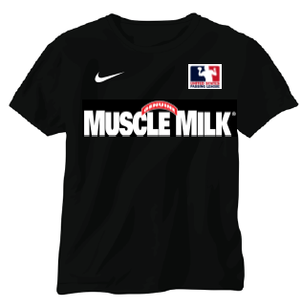 | 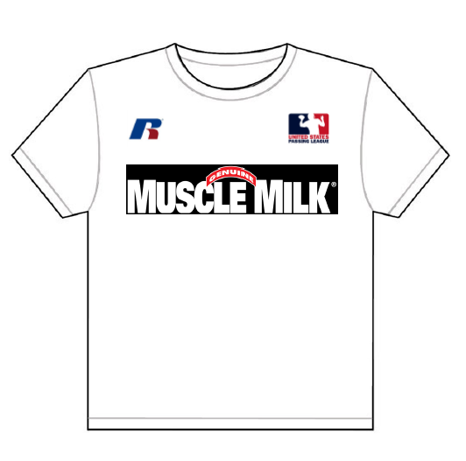
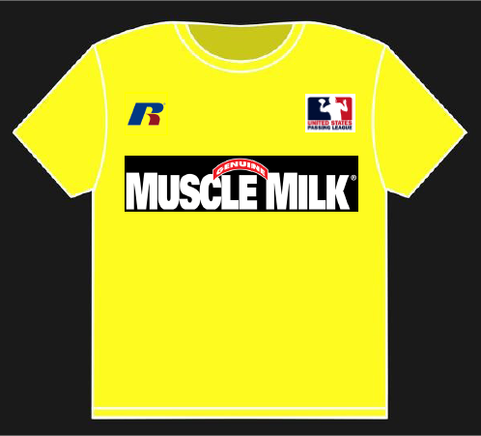
 | 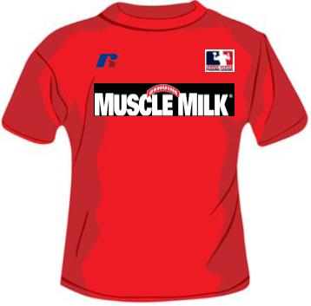

Muscle Milk’s exclusivity of sponsorship
With this partnership, the USPL grants Muscle Milk exclusivity to its category and beyond. In general, Muscle Milk’s sponsorship excludes any other product that goes into a person’s body, including, but not limited to: soft drinks; sports drinks; energy drinks; candy; chips; fast-food restaurants; and others.

The USPL will have the right to sell secondary sponsorships to Muscle Milk events. We understand that CytoSport has an obligation to protect its Muscle Milk brand. That’s why CytoSport will have the right of refusal for any secondary sponsor of a Muscle Milk event. This will ensure that CytoSport will have the opportunity to protect Muscle Milk’s brand integrity.

USPL’s sponsorship efforts for any Muscle Milk events would concentrate on the following sponsorship categories:

-military recruitment;
-cellular communications;
-insurance;
-sporting goods;
-gaming; and,
-automotive.

All secondary sponsors will be secondary to Muscle Milk in every regard. As the title sponsor, Muscle Milk will have the opportunity to restrict the activities of the secondary sponsors at each event. As detailed on our rate card, the presenting and associate sponsors of the event are limited to on-site event marketing activities with secondary signage locations.

For the Miami market, our goals are to secure a few secondary sponsors in the categories of: military recruitment; cellular communications; and sporting goods.

Participation
From our experience, teams will bring 20-25 players to each event. For each USPL event, we anticipate 320-500 participating student-athletes. If Muscle Milk title sponsors four events in 2012, then we can reasonably expect 1,280-2,000 participating student-athletes. That total does not include coaches, administrators, or fans in attendance at each event.

A marketing partnership with the United States Passing League
The United States Passing League views our relationship with Muscle Milk as a partnership. Our only goal will be in creating a “showcase” event for Muscle Milk, one that engages the target audience with a fun event that helps brand your product with the target audience in the Miami market and beyond.

