w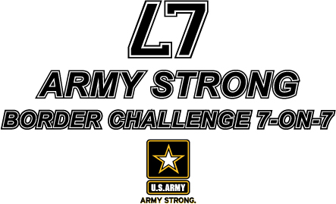

REGISTER NOW FOR FREE !!

FREE registration is now available for the first 16 teams that sign-up for the ARMY STRONG BORDER CHALLENGE 7-on-7 at Shawnee Mission West.

WHEN: | June 30, 2012
WHERE: | SHAWNEE MISSION WEST  8800 West 85th STREET  Overland Park, KS 66212

Teams are guaranteed to play four games with three games in pool play and at least one game in the single-elimination championship round.

For more information, go online to www.TheSportsFlash.com and click on the ARMY STRONG BORDER CHALLENGE 7-on-7 logo.

To register, contact Mike Sinnott at (517) 927-4570 or by e-mail at TheSportsFlash@aol.com or mike@TheSportsFlash.com. For more information, please contact Shawnee Mission West head football coach Tim Callaghan at (913) 271-6791.

Register now – for FREE – for the ARMY STRONG Border Challenge 7-on-7.



United States Passing League - ARMY STRONG BORDER CHALLENGE 7-on-7
1516 Lytell Johne’s Path – Williamston, MI - 48895
Mike Sinnott – (517) 927-4570 – www.TheSportsFlash.com – TheSportsFlash@aol.com – mike@thesportsflash.com.

