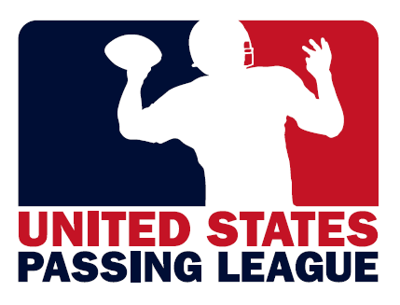 | 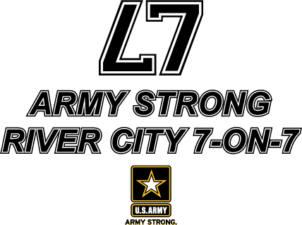

U.S. Army’s Kansas City Recruiting Battalion to host the ARMY STRONG River City 7-on-7 on June 23
Francis Howell High School will host 16-20 high school teams in the first-ever ARMYSTRONG River City 7-on-7
FOR IMMEDIATE RELEASE | CONTACT: Mike Sinnott, U.S. Passing League (517) 927-4570
15 MAY 2012 | Rich Beckett, U.S. Army, (816) 877-8608

KANSAS CITY, MO – The U.S. Army Kansas City Recruiting Battalion will host the ARMY STRONG River City 7-on-7 at Francis Howell High School on Saturday, June 23. The event will feature 16-20 high school football teams from throughout the St. Louis area. This non-contact seven-on-seven, single-day tournament will feature teams from throughout the battalion’s recruiting territory. The U.S. Army’s sponsorship of the event ensures that this will be a FREE event for the first 16 teams that sign-up to participate.

The format of the ARMY STRONG River City 7-on-7 ensures that each team will play at least four games. Each team will play three games in pool play. The results from pool play will determine the seeding for the single-elimination championship round. In all, as many as 49 games will be played during the single-day event.

The ARMY STRONG River City 7-on-7 is a traditional seven-on-seven, non-contact passing league played on a shortened field with only passing plays from the line of scrimmage. The game features quarterbacks, wide receivers, running backs, and defensive backs. The event is an opportunity for the student-athletes to sharpen their skills in a fun, yet competitive atmosphere.
For more information about the ARMY STRONG River City 7-on-7, go online to www.TheSportsFlash.com and click on the event logo. High schools that are interested in participating in the event should contact Mike Sinnott at (517) 927-4570 or via e-mail at TheSportsFlash@aol.com or mike@TheSportsFlash.com. Francis Howell High School head football coach Bryan Koch is the host coach for the event, and Coach Koch can be reached at (636) 734-0020.
The United States Army is charged with protecting America’s freedom and preserving peace. The Army trains and equips its soldiers to be the best, especially when it comes to their job, leadership, and soldiering skills. With more than 150 jobs available in many exciting fields, the U.S. Army provides many job training and leadership training opportunities. From working with computers to assisting doctors to fixing helicopters, there’s an Army job that’s right for you. For more information, go online to www.GoArmy.com.

The United States Passing League (USPL) will manage the North Carolina Passing League for the U.S. Army Asheville Recruiting Company. Since 2010, the USPL has managed passing league campaigns in Maryland; North Carolina; Pennsylvania; and South Carolina. The USPL is a marketing platform managed by “The Sports Flash” (TSF) Radio Network. TSF Radio Network provides local, customized sports updates to 179 network affiliates in 13 different states while managing unique sports marketing campaigns for many organizations. For more information about the USPL, NCPL, or other marketing campaigns managed by TSF Radio Network, contact Mike Sinnott at (517) 927-4570.

###

