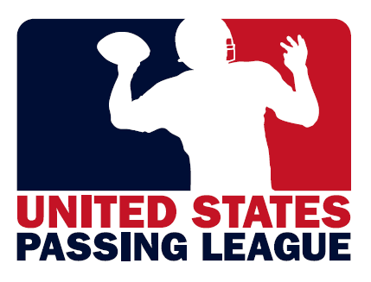 | 
USPL 2012 - EYEBLACK.com
Overview
The USPL proposes EyeBlack.com partner with the United States Marine Corps – Passing League Maryland (USMC-PLM) for our two events in Maryland in 2012. In 2011, Woodlawn High School hosted the first-ever USMC-PLM event. In 2012, the USMC-PLM will host two events a northern event (Baltimore) and a southern Maryland event (suburban Washington, D.C.).

Our USPL events will give EyeBlack.com the opportunity to showcase your products to players at a competition that’s played during the day, usually without helmets, and often in bright, sunny conditions. This will be an opportunity for EyeBlack.com to introduce your products to as many as 1,000 high school athletes.

The demonstration of your product’s effectiveness in these conditions can help position your product as a “must have” item for any student-athlete.

Tentative USMC-PLM Schedule
July 21 – U.S. Marine Corps – Passing League Maryland - Baltimore
July 28 – U.S. Marine Corps – Passing League Maryland – Washington, D.C.

U.S. Marine Corps – Passing League Maryland presented by EyeBlack.com - $2,500
As the presenting sponsor of the USMC-PLM, your company will receive the following:

-secondary naming rights for two events with 32-40 teams, 800-1,000 student-athletes;
-both USMC-PLM events will be presented by EyeBlack.com;
-inclusion in all press releases, media relations efforts to promote USMC-PLM;
-secondary signage locations throughout the event’s facility;
-booth space in the secondary location of the event’s facility;
-posting of your click-through web banner at the USMC-PLM official web site; and,
-opportunity to distribute information, product to participating teams.

U.S. Marine Corps – Passing League Maryland - SOUTH - $1,250
As an associate sponsor of the USMC-PLM South, your company will receive the following:

-participation in event with 16-20 high school football teams, or 400-500 student-athletes;
-signage locations, where available, throughout facility; and,
-booth space at facility to distribute information, products to participants.

United States Passing League – 1516 Lytell Johne’s Path – Williamston, MI - 48895
Mike Sinnott – (517) 927-4570 – www.TheSportsFlash.com – TheSportsFlash@aol.com – mike@thesportsflash.com.

