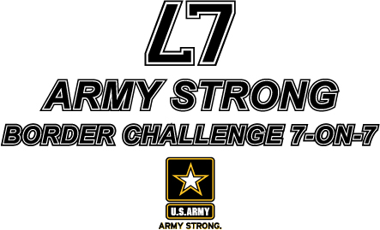
ARMY STRONG BORDER CHALLENGE 7-ON-7 - JUNE 30 @ SHAWNEE MISSION WEST
POOL A |  | POOL B |  | POOL C
BV NORTH |  | BV SOUTHWEST |  | BV NORTHWEST
OLATHE NORTH |  | SM WEST |  | KC EAST
SM EAST |  | TURNER |  | SCHLAGLE
TONGANOXIE |  | WYANDOTTE |  | SM NORTHWEST
 |  | GAME ONE
POOL A – 8:30 AM |  | POOL B – 8:30 AM |  | POOL C – 9:00 AM
F1 – TONGANOXIE v. BV NORTH |  | F3 – SM WEST v. WYANDOTTE |  | F1 – SCHLAGLE v. SM NW
F2 – SM EAST v. OLATHE NORTH |  | F4 – BV SW v. TURNER |  | F2 – BV NW v. KC EAST
 |  | GAME TWO
POOL A – 9:00 AM |  | POOL B – 9:30 AM |  | POOL C – 9:30 AM
F3 – TONGANOXIE v. SM EAST |  | F1 – SM WEST v. BV SW |  | F3-SCHLAGLE vs. BV NW
F4– OLATHE NO. v. BV NORTH |  | F2 – TURNER V. WYANDOTTE |  | F4-KC EAST v. SM NW
 |  | GAME THREE
POOL A – 10:00 AM |  | POOL B – 10:00 AM |  | POOL C – 10:30 AM
F2 – TONGA. v. OLATHE NO. |  | F4 – SM WEST v. TURNER |  | F2 – SCHLAGLE v. KC EAST
F1 – SM EAST v. BV NORTH |  | F3-BV SW v. WYANDOTTE |  | F1-BV NW v. SM NW
 |  | POOL PLAY ENDS AT APPROXIMATELY 10:55 AM

