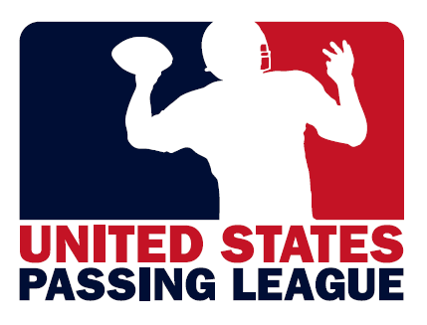
USPL APPAREL PARTNERSHIPS
The United States Passing League’s apparel partnerships are an opportunity for you to earn the benefits of a sponsorship of a USPL event without the monetary investment. The USPL will accept apparel in exchange for marketing considerations at our USPL events. Our events are an opportunity for your business to introduce your products to high school football coaches, athletic directors, and student-athletes.

“Official Outfitter” of the United States Passing League- $5,500/event value
As the “Official Outfitter” of the United States Passing League, you’ll provide our student-athletes with tee-shirts that will be worn during competition. These shirts will include your logo, the USPL logo, and the event-specific logo. These can be tee-shirts or sublimated performance gear. That’s your choice. The USPL will provide each team with 15 tee-shirts for the student-athletes. Teams often bring more than 15 student-athletes to an event, and any additional tee-shirts will have to be purchased from your business for the competition. In exchange for 240 shirts per event, your company will receive the following marketing considerations:

-event branded with your corporate identity, featuring 16-20 high school football teams at each event;
-inclusion of your brand identity in all materials to promote our events;
-primary signage locations throughout the event’s facility;
-booth space in the highest-profile location of the event’s facility;
-opportunity to make one-on-one presentations to participating teams;
-brand identity included on tee-shirts provided to student-athletes;
-posting of your click through web banner at primary location at event’s official web site;
-access to database of all participating student-athletes;
-logo included on “championship” gear provided to the student-athletes of each winning team; and,
-inclusion on the trophy that is presented to the tournament champion.

“Official Coaching Shirt” of the United States Passing League - $2,500/event value
As the “Official Coaching Shirt” of the United States Passing League, you’ll provide us with collared coaching shirts for our coaches and staff at each of our ten events this summer. The shirts will be branded with your logo and our USPL and/or event specific logo. In exchange for 200 collared, polo-style golf shirts, we’ll provide your company with the following marketing considerations:

-logo prominently included on USPL and/or event branded shirts;
-secondary signage locations throughout each USPL venue;
-booth space at each USPL venue;
-public address announcements during each event;
-web banners at USPL and each event-specific web site; and,
-distribution of information about your business to coaches, and athletic directors.

“Official Championship Gear” of the United States Passing League - $1,250/event value
As the “Official Championship Gear Provider” of the United States Passing League, you’ll provide the winning team at each USPL event with 16 “championship” tee-shirts. The “championship” tee-shirts will include the event-specific logo and “2012 Champions” on the front and your logo on the back. The USPL will handle all costs associated with printing the shirts. We provide the 16 shirts to each championship and they’ll order any additional shirts from you. In exchange for 160 tee-shirts for our “championship” teams, we’ll provide your company with the following marketing considerations:

-signage locations, where available, throughout facility;
-booth space at facility to distribute information, products to participants;
-public address announcements during each event;
-logo on all championship gear provided to title-winning teams; and,
-web banner placed on each event-specific web site.

For more information on the sponsorship packages available with the United States Passing League, please contact Mike Sinnott at (517) 927-4570.

