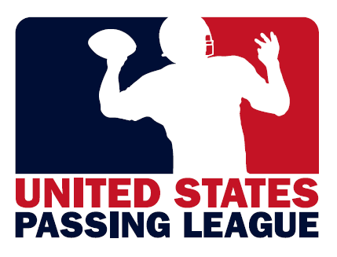
2012 USPL Schedule

JUNE 16, 2012 Pennsylvania Passing League presented by U.S. Army
Pittsburgh, PA (PPL-WEST) – Baldwin High School

JUNE 23, 2012 Palmetto Passing League presented by U.S. Army
Florence/Myrtle Beach, SC – Freedom Florence Recreation Complex

JUNE 23, 2012 ARMY STRONG River City 7-on-7
St. Louis, MO – Francis Howell High School

JUNE 30, 2012 North Carolina Passing League
Asheville, NC – Erwin High School

JUNE 30, 2012 ARMY STRONG MO-v-KS BORDER CHALLENGE 7-on-7
Kansas City, MO - Shawnee Mission West

JULY 13, 2012 U.S. Marine Corps – Passing League Maryland
Washington, D.C. – Coolidge High School

JULY 15, 2012 Pennsylvania Passing League presented by the U.S. Army
Harrisburg, PA (PPL-EAST) – Susquehanna Twp. High School

JULY 21, 2012 Pennsylvania Passing League
Philadelphia, PA – Wissahickon High School

JULY 28, 2012 U.S. Marine Corps – Passing League Maryland
Baltimore, MD – Woodlawn High School

United States Passing League – 1516 Lytell Johne’s Path – Williamston, MI - 48895
Mike Sinnott – (517) 927-4570 – www.TheSportsFlash.com – TheSportsFlash@aol.com – mike@thesportsflash.com

