
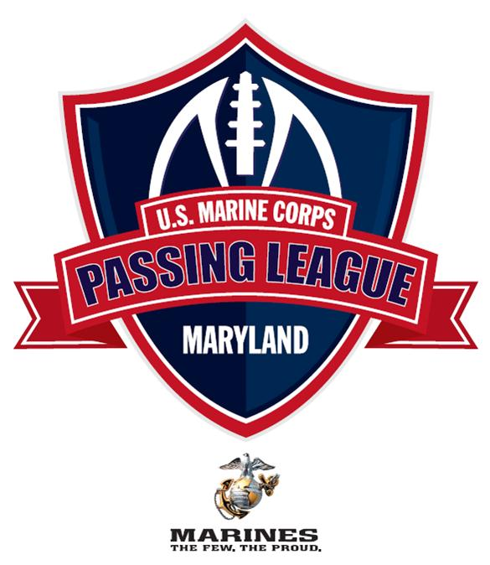
U.S. Marine Corps - Passing League Maryland to host 28 teams at Woodlawn High School on July 28
Woodlawn High School facility to host second-ever USMC-PLM NORTH event on July 28

FOR IMMEDIATE RELEASE | CONTACT: Mike Sinnott, TSF Radio Network
27 JULY 2012 | (517) 927-4570 or TheSportsFlash@aol.com

BALTIMORE, MD - The U.S. Marine Corps Recruiting Station Baltimore is proud to announce that 28 teams will compete in the 2nd Annual U.S. Marine Corps – Passing League Maryland North division event at Woodlawn High School on July 28. The seven-on-seven tournament will feature high school student-athletes and coaches from throughout Maryland.

In accordance with Maryland Public Secondary Schools Athletic Association rules regarding out of season practice and competition, the U.S. Marine Corps – Passing League Maryland has assigned team names or monikers that are not connected with any specific public high school in the state. The U.S. Marine Corps – Passing League Maryland team names are all associated with regiments, battalions, air wings, etc., from the rich history of the U.S. Marine Corps.

U.S. Marine Corps - Passing League Maryland – Team Nicknames
Arctic Warriors (25th Marine Regiment)
Head Coach: Joseph Holland (New Town)

Black Sheep (Marine Attack Squadron 214)
Head Coach: Craig Jefferies (Oxon Hill)

Cold Steel Warriors (3rd Battalion, 25th Marines)
Head Coach: Jake Coleman (Cambridge-South Dorchester)

Darkhorse (3rd Battalion, 5th Marines)
Head Coach: DaVaughn Mellerson (Woodlawn)

Death Rattlers (Marine Fighter Attack Squadron 323 VMFA-323)
Head Coach: Eric Woodson (Northwestern)

Destroyers (2nd Light Armored Reconnaissance Battalion)
Head Coach: Rich Holzer (Meade)

Devil Dogs (Nickname for Marines)
Head Coach: Eddie Tolliver (Wootton)

Dragon Warriors (1st Supply Battalion)
Head Coach: Messay Hailemariam (St. Frances Academy)

Fighting Fifth (5th Marine Regiment)
Head Coach: Jae Jackson (Bowie)

Fighting Griffins (Marine Medium Tiltrotor Squadron VMM-266)
Head Coach: Ernest Williams (Wheaton)

Highlander (1st Armored Reconnaissance Battalion)
Head Coach: Donald Davis (Calvert Hall)

Iron Horse (2nd Tank Battalion)
Head Coach: Dante Jones (Edmonson-Westside)

Island Warriors (2nd Battalion, 3rd Marines)
Head Coach: Dwayne Green (Bluford Drew Jemison)

Lava Dogs (1st Battalion, 3rd Marines)
Head Coach: Wayne Jackson (Carver Vo-Tech)

Leathernecks (Nickname for Marines)
Head Coach: Rob Elliott (Chesapeake)

Lucky 13 (Combat Logistics Battalion 13)
Head Coach: Reggie White (Milford Mill Academy)

Mortalis (3rd Reconnaissance Battalion)
Head Coach: Donald Davis (Calvert Hall)

Nightmare (1st Battalion, 10th Marines)
Head Coach: Chris Fallon (Dulaney)

Purple Foxes (Marine Medium Helicopter Squadron HMM-268)
Head Coach: Lance Clelland (South River)

Samurai (Headquarters Battalion, 3rd Marine Division)
Head Coach Elwood Townsend (Frederick Douglass)

Shadow Warriors (3rd Battalion, 9th Marines)
Head Coach: Rob Harris (Broadneck)

Striking Ninth (3rd Battalion, 9th Marines)
Head Coach: John Marquette (Parkville)

Teufelhunden (German word for Devil Dogs)
Head Coach: Steve Holmes (Archbishop Spalding)

The Mad Ghosts (2nd Battalion, 24th Marines)
Head Coach: Adam Bahr (Springbrook)

Thundering Third (3rd Battalion, 1st Marines)
Head Coach: Jamie Willis (Pikesville)

Timberwolf (1st Battalion, 2nd Marines)
Head Coach: Jason Koenig (Bladensburg)

Thunder (3rd Battalion, 11th Marines)
Head Coach: Jeff Seals (Montgomery Blair)

Wolfpack (3rd Light Armored Reconnaissance Battalion)
Head Coach: Frank Brown (Southwestern)

The single-day event will feature 20 teams, with each team guaranteed to play a minimum of four games. Each team will play three games in pool play to determine the seeding for the single-elimination championship round.

The U.S. Marine Corps Passing League - Maryland is a traditional seven-on-seven non-contact passing league played on a shortened field with only passing plays from the line of scrimmage. The games feature quarterbacks, wide receivers, running backs, and defensive backs, giving these skill players an opportunity to sharpen their skills in a fun, competitive atmosphere.

Woodlawn High School is part of the Baltimore County Public Schools and is located at 1801 Woodlawn Drive in Baltimore. Woodlawn High School is committed to fostering an environment of high expectation and academic excellence accomplished through the ideals of teamwork, respect, and responsibility. Woodlawn High School is a four-year, public, comprehensive high school serving approximately 1,800 students. The school has received accreditation from the Middle States Association of Colleges and Secondary Schools by the Maryland Department of Education. Woodlawn High School is also a member of the College Entrance Examination Board and the National Association of College Admissions Counselors.

Woodlawn High School is located one half mile east of exit 17 (Security Blvd.) off the Baltimore Beltway I-695 at 1801 Woodlawn Drive.

The U.S. Marine Corps is a branch of the United States armed forces responsible for providing power projection from the sea and serving as an amphibious force-in-readiness. For more information about become one of the few and the proud, go online to www.Marines.com.

“The Sports Flash” (TSF) Radio Network manages the U.S. Marine Corps – Passing League Maryland. In 2010, TSF Radio Network launched the Pennsylvania Passing League, which featured 32 teams playing in two divisions with more than 600 student-athletes participating. The National Football League’s Pittsburgh Steelers invited the Pennsylvania Passing League’s division winners to play an exhibition at halftime of their 2010 preseason opener at Heinz Field. The Pennsylvania Passing League held two tournaments in 2011 in Harrisburg and suburban Pittsburgh.

“The Sports Flash” Radio Network provides 190 radio stations in 13 states with customized, local sports reports, reaching 2.5-million listeners each week. In addition to its traditional radio advertising campaigns, TSF Radio Network has expanded into sports marketing, managing tobacco prevention campaigns that target high school students in several states, including: Kentucky; Montana; North Carolina; South Carolina; and Wyoming. Since 2006, TSF Radio Network has managed the Army Iron Man campaign; the Army STRONG Wrestler of the Year; and HOOP STARS of the Year campaigns for U.S. Army Recruiting battalion’s across the country. In 2010, TSF Radio Network expanded into event management, sponsorship with its creation of the Pennsylvania Passing League. For more info about the TSF Radio Network, contact Mike Sinnott at (517) 927-4570.

 |  | 

