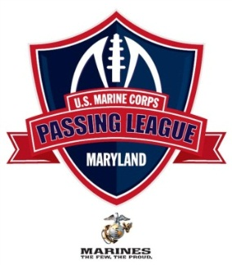
U.S. Marine Corps – Passing League Maryland - SOUTH @ Coolidge High – July 13, 2012
Pool A | Pool B |  | Pool C | Pool D
DESTROYERS (R) | NIGHTMARE (R) |  | DEVIL DOGS (R) | TEUFELHUNDEN (R)
Coolidge’s Randolph | Blake’s Nazzaro |  | Northwestern’s Sapp | Great Mills’ Foreman
LEATHERNECKS (B) | ARCTIC WARRIORS (B) |  | PURPLE FOXES (B) | ISLAND WARRIORS (B)
FMA’s Harley | Friendly’s Quaweay |  | Woodrow Wilson’s Martin | High Point’s Brown
THE MAD GHOSTS (Y) | THE BLACK SHEEP (Y) |  | LAVA DOGS (Y) | TIMBERWOLF (Y)
Northwood’s Harris |  |  | Wheaton’s Williams | Duval’s Powell
WOLFPACK (G) | DEATH RATTLERS (G) |  | THUNDER (G) | THUNDER (G)
Mont. Blair’s Seals | Wootton’s Spinner |  | Laurel’s Sommerville | Fairmont Heights’ Dyke
Game 1
Pool A – 8:30 AM | Pool B – 8:55 AM |  |  | Pool C – 9:20 AM | Pool E -9:45 AM
F1- Destroyers v. Wolfpack | F1 – Nightmare Nv. Death Rattlerss |  |  | F1 – Devil DogsN v. Thunder | F1 – Teufelhunen v. Thunder
F2 – Leathernecks v. Mad Ghosts | F2 – Arctic Warriors v. Black Sheep |  |  | F2 – Purple Foxes v. Lava Dogs | F2 – Island Warriors v. Timberwolf

Game 2
Pool A – 10:05 AM | Pool B – 10:30 AM |  | Pool C – 10:55 AM | Pool E – 11:20 AM
F2 – Destroyers v. Leathernecks | F2 – Nightmare N v. Arctic Warriors |  | F2 – Devil Dogs v. Purple Foxes | F2 – Teufelhunen v.Island Warriors
F1 – Mad Ghosts v. Wolfpack | F1– Black Sheep v. Death Rattlerss |  | F1 – Lava Dogs v. Thunder | F1- Timberwolf v. Thunder
Game 3
Pool A – 11:45 AM | Pool B – 12:10 PM |  | Pool C – 12:35 PM | Pool E – 12:55 PM
F1– Destroyers v. Mad Ghosts | F1 – Nightmare N v. Black Sheep |  | F1 – Devil Dogs v. Lava Dogs | F2 – Teufelhunen v. Timberwolf
F2– Leathernecks v. Wolfpack | F2– Arctic Warriors v. Death Rattlerss |  | F2 – Purple Foxes v. Thunder | F1 – Island Warriors v. Thunder

POOL PLAY ends by 1: 30 PM

