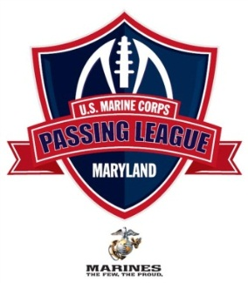
U.S. Marine Corps – Passing League Maryland - SOUTH @ Coolidge High – July 13, 2012
Pool A |  | Pool B |  | Pool D
DESTROYERS 3-0 |  | DEVIL DOGS 3-0 |  | TEUFELHUNDEN 2-1
Coolidge’s Randolph |  | Northwestern’s Sapp |  | Great Mills’ Foreman
LEATHERNECKS 1-1-1 |  | PURPLE FOXES 2-1 |  | NIGHTMARE 2-1
Duval’s Powell |  | Woodrow Wilson’s Martin |  | Blake’s Nazzaro
THE MAD GHOSTS 0-3 |  | LAVA DOGS 0-3 |  | DEATH RATTLERS 2-1
Northwood’s Harris |  | Wheaton’s Williams |  | Laurel’s Sommerville
WOLFPACK 1-1-1 |  | HIGHLANDER 2-1 |  | THUNDER 0-3
Mont. Blair’s Seals |  | Wootton’s Spinner |  | Fairmont Heights’ Dyke
Game 1
Pool A – 8:30 AM |  | Pool C – 8:55 AM |  |  |  | Pool E -9:20 AM
Destroyer 21Wolfpack 0 |  |  | Devil Dog 3Highlander 20 |  | Teufelhunen 18v.Thunder 0
Leathernecks 32 Mad Ghosts 6 |  | Purple Foxes 12 Lava Dogs 6 |  |  |  | Nightmare 24vDeath Rattlers 12

Game 2
Pool A – 9:45 AM |  | Pool C – 10:10 AM |  | Pool E – 10:35 AM
Destroyers 12Leathernecks 0 |  | Devil Dog 28Purple Foxes 18 |  | Teufelhune 20 Nightmare 6
Mad Ghosts 6Wolfpack 14 |  | Lava Dogs 22 Highlander 28 |  | Death Rattlers 20 Thunder 0
Game 3
Pool A – 11:00 AM |  | Pool C – 11:25 AM |  | Pool E – 11:50 AM
Destroyers 30Mad Ghosts 19 |  | Devil Dogs 40Lava Dogs 18 |  | Teufelhunen 0Death Rattlers20
Leathernecks 12Wolfpack 12 |  | Purple Foxes 14 Highlander 21 |  | Nightmare 18 Thunder 6 6
POOL PLAY ends by 12:15 PM

