“The Sports Flash” Radio Network
2011 U.S. Marine Corps – Passing League Maryland
Executive Summary

Overview
“The Sports Flash” (TSF) Radio Network partnered with Recruiting Station (RS) Baltimore for the U.S. Marine Corps – Passing League Maryland (USMC-PLM), a 7-on-7 football competition that featured more than 475 high school football players from 19 teams throughout Maryland.

What is a passing league?
As the name implies, a passing league highlights only the passing game. There are no running plays, the games are played on a shortened field, and there is no tackling in the traditional sense since players are tagged down. Passing leagues are gaining popularity as a fun method of sharpening skills and maintaining conditioning during the off-season.

Eligible participants
The USMC-PLM featured high school student-athletes between the ages of 13-17 who have not yet graduated from high school. High school graduates are prohibited from participating. The oldest participants are rising seniors.

Teams
TSF Radio Network targeted high school football teams from throughout RS Baltimore’s recruiting territory for participation in the USMC-PLM.

Logo Development
Our design team created the logo identify for the campaign, coming up with several possible alternatives before deciding on the final logo design. The logo identity of the campaign was used in all campaign materials.

Direct Contact
TSF Radio Network mailed an introductory letter, registration forms, and a flyer to high school football coaches throughout RS Baltimore’s recruiting territory. In addition, targeted schools received e-mails, faxes, and phone calls encouraging participation in the USMC-PLM.

Earned Media
Press releases were distributed to the media and received significant media coverage, including coverage in the Baltimore Sun; The Gazette; and the Washington City Paper.

Host Facility
RS Baltimore and TSF Radio Network selected Woodlawn High School as the host site for the first-ever USMC-PLM. The facility included an artificial turf field and three additional fields.

Tournament Structure
Twenty teams committed to the U.S. Marine Corps – Passing League Maryland, with nineteen teams participating in five pools of four teams each. Pool play determined the seeding for the single-elimination championship round.

Team Names
Per Maryland Public Secondary Schools Athletic Association (MPSSAA) rules, the participating teams could not be associated with any high school football team in Maryland. Each team wore USMC-PLM tee-shirts in red; green; blue; and gold. The teams were assigned nicknames derived from the Marine Corps rich history.

Purple Foxes win U.S. Marine Corps – Passing League Maryland
The Purple Foxes, coached by Dunbar’s Travis Blackston, won the inaugural USMC-PLM title, beating the Destroyers, 29-18, in the title game, to finish 7-0 for the event.
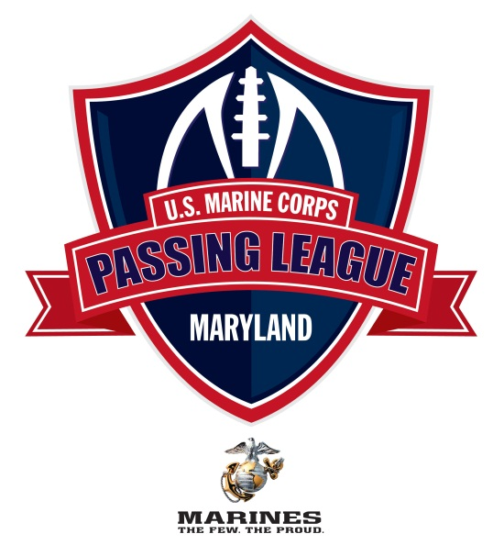
U.S. Marine Corps
Passing League Maryland – 2011

Overview
“The Sports Flash” (TSF) Radio Network and Recruiting Station (RS) Baltimore partnered for a high school football passing league that featured high school football players from throughout recruiting territory. The U.S. Marine Corps – Passing League Maryland (USMC-PLM) featured more than 475 high school football players from 19 high schools throughout RS Baltimore’s area of operation.

For the Marines of RS Baltimore, the recruiters had the opportunity to build relationships with student-athletes, coaches, and administrators from targeted high school throughout Maryland.

What is a passing league?
Passing league football is a non-contact 7-on-7 game played on a shortened field that features only the passing game. Many state associations prohibit contact during off-season drills, so passing leagues are very popular with high school football teams as a method of keeping their teams in shape during the summer.

While high school basketball has AAU competition and high school baseball has traveling teams or American Legion, there is nothing for high school football players who want to remain in shape and sharpen their skills during the off season. The passing league provides that opportunity.

Organization of the U.S. Marine Corps – Passing League Maryland
Twenty teams committed to participate in the USMC-PLM at Woodlawn High School on 23 July 2011. On the evening before the tournament, one team withdrew from the event, giving us 19 participating teams. The teams were divided into five pools of four teams each, with a few schools volunteering to play an additional game to fill out the bracket.

Each participating team was guaranteed to play at least four games, with three games in pool play and one game in the single-elimination championship round. The three pool play games determined the seeding for the single-elimination championship round. Due to the weather conditions on the day of the event, with dangerous heat indexes making player safety a concern, the single-elimination championship round was shortened from all 19 teams to eight teams.

In all, 37 games of 25-minutes each were played during the one-day tournament, utilizing two 100-yard fields and another 60-yard field, enabling five games to be played, simultaneously.

Under the direction of RS Baltimore, TSF Radio Network managed all aspects of the USMC-PLM, including:

-developing the USMC-PLM logo;
-securing the host site;
-writing, distributing direct mail to encourage participation;
-contacting, securing participating teams;
-developing school database;
-drafting the official USMC-PLM rules;
-serving as the media relations contact;
-writing and distributing press releases; and,
-managing the event.

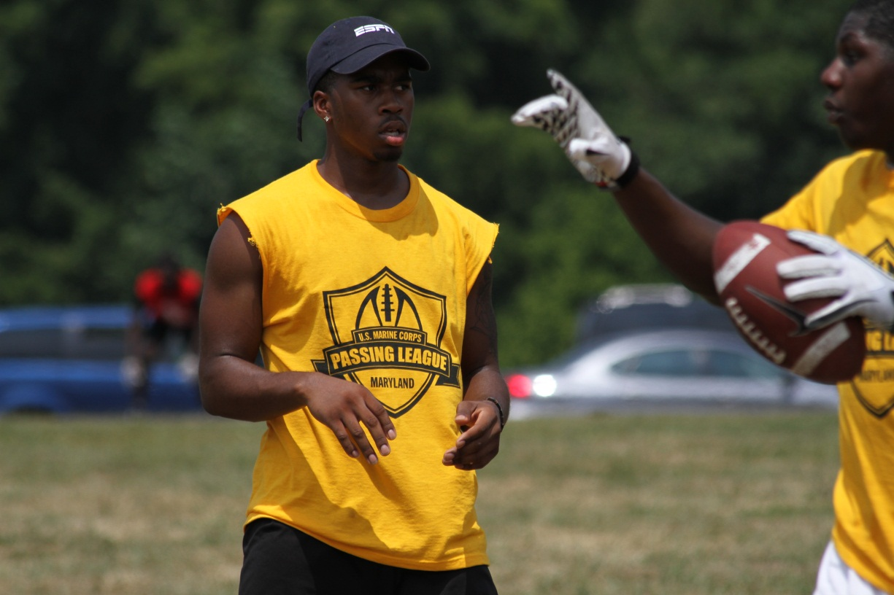

Logo Development
Our design team worked to create the logo identity for the USMC-PLM. The logo needed to convey a vigorously athletic message that would appeal to the target audience while conforming to the Marine Corps branding guidelines.

Our design team came up with several options from which to choose, including:

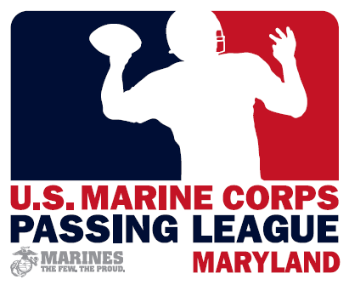

Participating Teams
The USMC-PLM targeted high schools in RS Baltimore’s area of operation. During the process, TSF Radio Network created a database of all of the schools in the recruiting territory, including contact information for school administrators, athletic directors, and coaches.

In securing the participating teams, TSF Radio Network engaged head football coaches, athletic directors, and principals in a variety of methods, including:

-introductory letter;
-press releases;
-e-mail updates;
-faxed flyer; and,
-phone calls.

In addition, USMC-PLM partnered with Woodlawn High School head football coach DaVaughn Mellerson, who serves as our on-site coordinator for the event. Coach Mellerson was helpful in securing teams for the event and providing guidance as we moved forward with the planning of the event.

Often, teams will pay $350-$500 per team to participate in events similar to the USMC-PLM. The Marine Corps partnership ensured that teams would not be charged to participate in the event. That’s a tremendous help to teams looking to participate in passing league events on budgets that are being continually slashed in this tough economy.

Direct Mail
TSF Radio Network drafted, distributed an introductory letter, a flyer, and a registration form that was distributed to all high school football coaches in the RS Baltimore area of operation.

Although the direct mail copy indicated that the USMC-PLM was a FREE event for the first 16 teams that participated, this is a direct mail copywriting technique designed to trigger an immediate response from the target audience.

Faxes
In addition to the direct mail, TSF Radio Network also faxed a copy of the letter and the flyer to the targeted high school, encouraging their participation. Like the direct mail, we used the offer of FREE registration to trigger early registration in the event.

Phone Calls
After the direct mail dropped with the coaches, TSF Radio Network followed up with phone calls to the head coaches, athletic directors throughout the state, encouraging their participation in the USMC-PLM. The phone calls were an extremely effective method of generating interest. The phone calls were timed to follow the mail, faxes, and e-mails, so the coaches, athletic directors were aware of the event. This soft method builds awareness and alleviates somewhat the typical “educating” of the target audience about the event.

Registered Teams
In a matter of weeks after launching the USMC-PLM, TSF Radio Network had secured the guaranteed 16 teams for the event. In the end, 20 teams committed to participate in the USMC-PLM, but one team backed out the night before the event, giving us 19 teams for the first-ever event.

Maryland Public Secondary Schools Athletic Association (MPSSAA) regulations prevent the use of anything associated with the high schools in relation to any off-season competition. During our process of securing teams for the tournament, a few district-level athletic directors objected to the USMC-PLM’s rules and regulations. In fact, a few school districts banned their schools from participating in our tournament until the USMC-PLM rules and regulations were in compliance with the MPSSAA rules.

TSF Radio Network revised the official rules of the USMC-PLM to require that all participating teams to wear USMC-PLM tee-shirts during competition. In addition, we assigned each team a name/nickname that was not associated in anyway with any high school team in the state. After revising the rules, the district-level athletic directors dropped their objections to the USMC-PLM and actually started encouraging their schools to participate in the event.

At first, the MPSSAA rules would appear to be a negative for the USMC-PLM, but the rule created an opportunity for the Marines. For each participating team, we assigned a team name associated with the rich history of the United States Marine Corps, using regiment, battalion nicknames for the team names.

U.S. Marine Corps - Passing League Maryland – Team Nicknames

Arctic Warriors (25th Marine Regiment)
Head Coach: Jeff Seals (Montgomery Blair)

Black Sheep (Marine Attack Squadron 214)
Head Coach: Rich Holzer (Meade)

Death Rattlers (Marine Fighter Attack Squadron 323 VMFA-323)
Head Coach: Donald Davis (Calvert Hall)

Destroyers (2nd Light Armored Reconnaissance Battalion)
Head Coach: Dante Jones (Edmondson-Westside)

Devil Dogs (Nickname for Marines)
Head Coach: Lance Clelland (South River)

Fighting Fifth (5th Marine Regiment)
Head Coach: Terry Hayes (Bowie)

Highlander (1st Armored Reconnaissance Battalion)
Head Coach: Terry Hayes (Bowie)

Island Warriors (2nd Battalion, 3rd Marines)
Head Coach: Edmund Hughes (Long Reach)

Lava Dogs (1st Battalion, 3rd Marines)
Head Coach: Mike Melton (Glen Burine)

Leathernecks (Nickname for Marines)
Head Coach: Todd Sommerville (Laurel)

Mortalis (3rd Reconnaissance Battalion)
Head Coach: Dwayne Green (Bluford Drew Jemison Academy)

Nightmare (1st Battalion, 10th Marines)
Head Coach: Matt Wyskiel (Baltimore City)

Purple Foxes (Marine Medium Helicopter Squadron HMM-268)
Head Coach: Travis Blackston (Dunbar)

Striking Ninth (3rd Battalion, 9th Marines)
Head Coach: Mike Melton (Glen Burine)

Teufelhunden (German word for Devil Dogs)
Head Coach: Rob Elliott (Chesapeake)

The Mad Ghosts (2nd Battalion, 24th Marines)
Head Coach: Rich Holzer (Meade)

Thundering Third (3rd Battalion, 1st Marines)
Head Coach: DaVaughn Mellerson (Woodlawn)

Timberwolf (1st Battalion, 2nd Marines)
Head Coach: Andre Brown (High Point)

Thunder (3rd Battalion, 11th Marines)
Head Coach: Reggie White (Milford Mill Academy)

Wolfpack (3rd Light Armored Reconnaissance Battalion)
Head Coach: DaVaughn Mellerson (Woodlawn)

After each head coach committed to participate in the USMC-PLM, TSF Radio Network mailed a packet of information to each team that included:

-letter thanking the head coach for his participation in the USMC-PLM;
-a team registration form;
-participant release forms; and,
-one-page overview of USMC-PLM rules.

The USMC-PLM release forms included information that is typically gathered when students filled out Marine Corps lead cards.

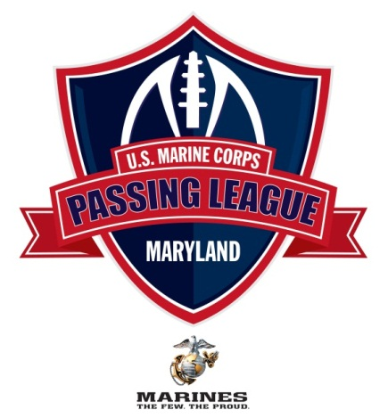

July 12, 2011

I want to thank you for your participation in the U.S. Marine Corps Passing League – Maryland (USMC-PLM). The event is scheduled for Saturday, July 23 at Woodlawn High School. At this time, we’re scheduling the coaches meeting to begin at 8:10 AM at the 50-yard-line with the first game of the day beginning at 8:30 AM. I have enclosed release forms for each of your participating student-athletes, a team information form, and an abridged version of the USMC-PLM rules and penalties.

I have enclosed 15 release forms for your student-athletes. The student-athlete needs to fill out the form completely, and we need the signature of each participant’s parent or guardian. If you need more than 15 release forms, please make a copy of one of the enclosed release forms, or download a release form from the PPL web site, which you can access by visiting www.TheSportsFlash.com.

We must have a signed participant release from every student-athlete competing in the event, or they will not be allowed to compete. The release forms can be turned in when your team checks in on the day of the event, or you can send them to us via e-mail, fax, or regular mail.

To remain in compliance with Maryland Public Secondary Schools Athletic Association rules, we will assign you with a team name and provide you with a USMC-PLM tee-shirt for your players to wear during competition. Please have your players wear a white or gray shirt that day, so we’ll have an “alternate” shirt should you get matched up with a team that has the same shirt color as your team.

The tee-shirts will be distributed the day of the event. Each team will receive 15 tee-shirts for the event, so we’re restricting the rosters to 15 players. If you’d like to bring more than 15 players, that’s fine. Please be advised that we’ll need to purchase a tee-shirt for them or share the shirts during the event. We will offer additional tee-shirts at cost, which should not be more than $10 each, but they’ll need to be purchase before the event. I will send along an order form and a deadline for pre-tournament purchase before the end of June.

If you have any questions, please feel free to contact me at your convenience. I’m available at (517) 927-4570 or by e-mail at TheSportsFlash@aol.com or mike@TheSportsFlash.com. Woodlawn’s DaVaughn Mellerson is serving as our tournament coordinator and is available at (443) 850-5251 or via e-mail at d.mellerson@live.com.

Thanks for your participation,

Mike Sinnott
“The Sports Flash” Radio Network

“The Sports Flash” Radio Network - Your teams. Your scores.
Mike Sinnott - 517-927-4570 - TheSportsFlash@aol.com - www.TheSportsFlash.com

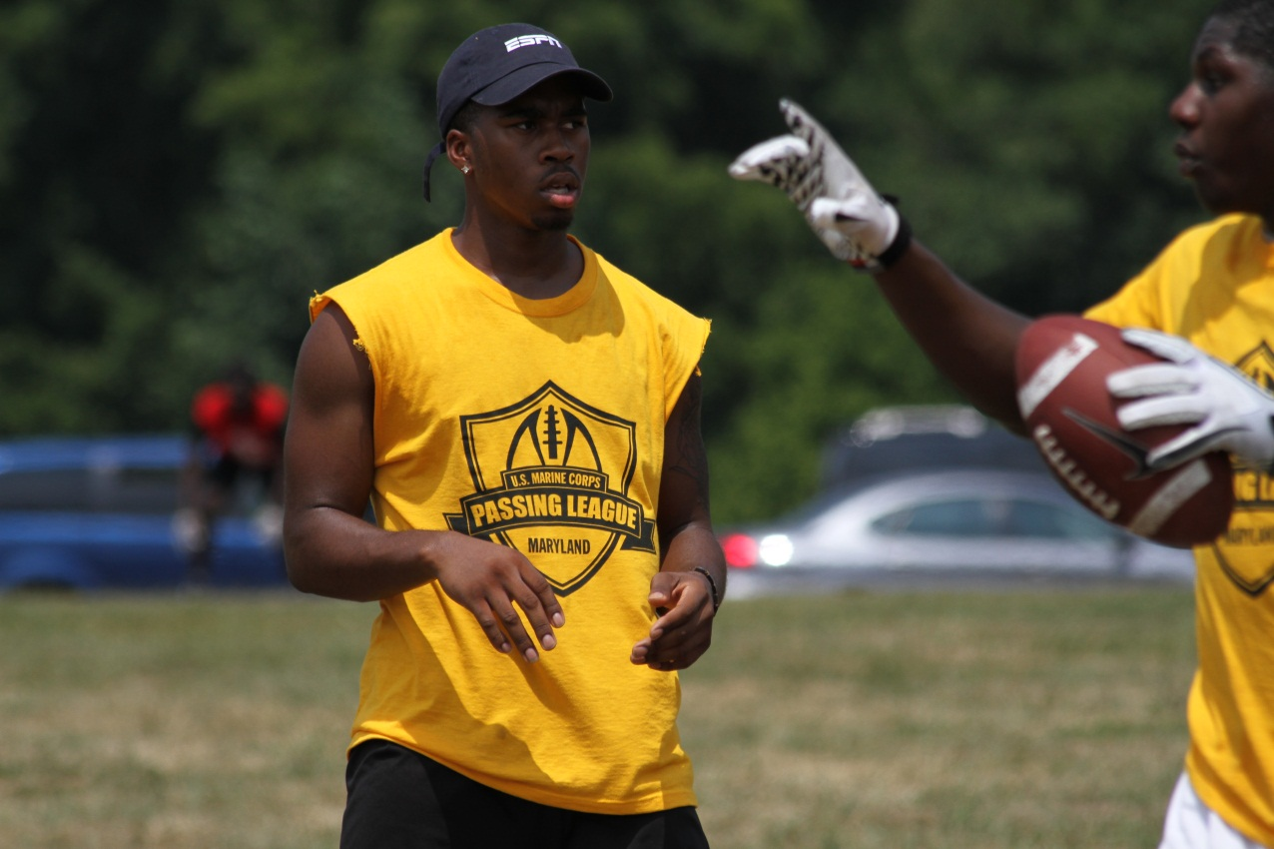
 | Maryland Public Secondary Schools Activities Association (MPSSAA) rules required that all teams wear tee-shirts not associated with any high school in Maryland. TSF Radio Network provided teams with green, navy blue, green, and red tee-shirts that included the USMC-PLM logo and Marine Corps branding.  Tee-Shirt Designs
  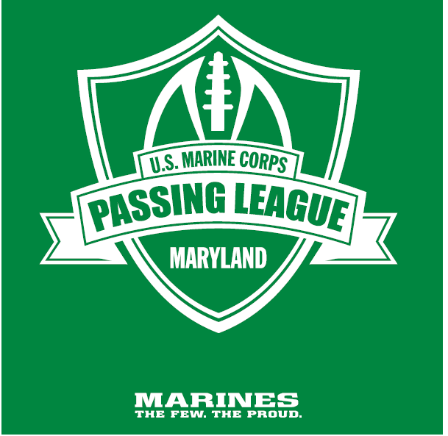

Securing the Host Site – Woodlawn High School
TSF Radio Network secured the host site for the U.S. Marine Corps – Passing League Maryland. The site at Woodlawn High School was a reasonable distance from many of the participating schools.

In determining the possible host sites for the USMC-PLM, TSF Radio Network considered several possible locations. TSF Radio Network evaluated the possible hosts shites based on our established minimum requirements for a facility to host an event, including:

-a minimum of two (2), 100-yard playing field;
-one (1) 100-yard artificial surface field, if possible;
-registration tables;
-field house/locker room facilities;
-restrooms;
-concessions;
-public address system;
-scoreboard; and,
-stadium lights.

Fields
USMC-PLM events are played on 40-yard fields. The requirement that the host site provide a minimum of two (2) 100-yard fields, ensures that four games can be played simultaneously. This requirement ensures that pool play and the single-elimination tournament can be reasonably completed in a single day.

In an ideal situation, the facility needs to have an artificial turf field. With an artificial turf field, it is possible to play the tournament rain or shine, if the rain is moderate without severe weather. With grass fields, rain could wipe out the entire tournament, if the conditions become unsafe for competitors.

Woodlawn High School had one artificial turf field available for competition. In addition, Woodlawn prepared another 100-yard grass field and a 40-yard grass field for competition. In all, five games could be played simultaneously throughout the day at Woodlawn.

The next page is an image of the field configuration for (1) one, 100-yard playing surface that enables two games to be played simultaneously.

Restrooms
The restroom facilities need to be open, available to the public throughout the day.

Concessions
A concession stand is manned throughout the day by the Woodlawn Football Boosters and benefit the high school football program. The concessions are an opportunity for the booster club to use the event as a fundraising for the football program.

Public Address System
A public address system is required for all host sites. The PA system ensures the timely communication between game management and all participating teams and fans in attendance at the event. This is also a safety issue in regards to having the ability to quickly communicate with fans on-site throughout the day and during an occurrence of inclement weather.

The use of a wireless microphone is also helpful when planning on-field presentations or any kind of opening ceremonies for the event. The wireless microphone is not required, but is highly recommended. A wireless microphone gives you the opportunity to conduct a on-field presentation in front of all of those in attendance at the event.

At the USMC-PLM, the public address announcer was incredibly helpful in keeping fans informed throughout the day, keeping spectators updated on scores, reminding teams of their upcoming games, and encouraging fans, spectators to register to win a Wii gaming console at the Marine Corps booth.

Scoreboard
A working scoreboard is incredibly helpful, but not necessary. Since the scores, timing of each game is kept at each field, the scoreboard is for the timing of the event only. One operating scoreboard can keep time for the entire event, since games are supposed to start simultaneously. In addition, time for each game is kept on separate stop watches should the facility lose power during competition.

The PA Announcer keeps the crowd informed of the time remaining for each game, announcing the time remaining with 15 minutes, 10 minutes, and five minutes remaining during each game. The announcing of the time remaining is helpful when the scoreboard is not visible from the secondary fields.

Stadium Lights
In the unlikely event that the games run beyond daylight hours, then stadium lights would be necessary to complete the event. The host site must have at least one field with lights.

U.S. Marine Corps: Host Site Requirement
Each host site must meet the Marine Corps requirements for locations for the utilization of the following assets:

-exhibit area for Marine Corps recruiting assets (Humvee, football toss, pull-up bar, etc.);
-booth space for the distribution of Marine Corps information;
-conference room, locker room for Marine Corps information presentation; and,
-high-profile signage locations throughout facility.

TSF Radio Network worked with RS Baltimore to ensure that the host site had all of the requirements for hosting the event.

TSF Radio Network worked out monetary arrangements for the host site, including:

-renting of the facility;
-securing, compensating on-site medical personnel for event;
-securing, compensating on-site security, if necessary;
-compensating the game officials, if necessary; and,
-renting any necessary game-management equipment.

Event Management
TSF Radio Network, our on-site partner coach, and RS Baltimore provided the game management for the USMC-PLM. The event management included:

-registering teams upon arrival;
-setting up, breaking down of tables, tents, chairs;
-providing water for all competitors;
-coordinating with food vendors, concessions staff;
-assigning officiating crews to particular games;
-interpreting rules;
-scheduling of games;
-ensuring a high-level of sportsmanship, fair play; and
-providing security for the venue, along with a variety of other duties.

Marines of RS Baltimore were assigned to a variety of duties during the game day for each event, serving as field managers, game managers, and school liaisons.

Field Managers
Three Marines worked as field managers. The field manager is responsible for ensuring that everything runs smoothly on each field, answers any questions regarding the game rules, keeps an accurate score of each game, and reports the final scores to the tournament score coordinator. In addition, the field manager is responsible for settling any disputes regarding the enforcement of the rules.

Game Managers
Five Marines worked as game managers and were responsible for individual games. The game managers were responsible for keeping the “official” score of each game, running the four-second clock for the quarterback, and ensuring the prompt placement of the ball marker at the line of scrimmage.

Drafting PPL Rules
TSF Radio Network drafted the rules of the USMC-PLM, based on a composite of several different passing leagues from throughout the country. During the process, our goal was to draft rules that ensured a fair, safe competition for the participating student-athletes while setting a high standard of sportsmanship among the competitors that aligned itself with Marine Corps values.

After the initial draft, TSF Radio Network sought feedback on the rules from several head football coaches, athletic directors in Maryland, including: Woodlawn’s DaVaughn Mellerson; Bowie’s Terry Hayes; Chesapeake’s Rob Elliott; and Anne Arundel County Public Schools Athletic Director Greg LeGrand.

TSF Radio Network distributed the rules to all of the participating schools via e-mail and made the rules available for download at the “official” USMC-PLM web site. In addition, a one-page document that included an abridged version of the rules and penalties were distributed to the coaches on the day of the event.

The abridged version of the rules was drafted from a more extensive rules document that outlined the rules of play; conduct of coaches, athletes; and tournament procedures. The tournament procedures included the rules for determining the field for the single-elimination tournament.

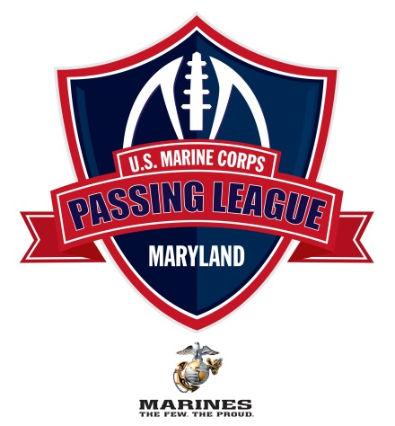
U.S. Marine Corps Passing League – Maryland
Rules Overview
1. Field is 40-yards (1.a); a first-down is 20-yards and two first-downs without a penalty results in a touchdown for the offense (5.b).
2. All offensive plays must be forward passes. No shovel passes; no double passes; and no tailback screens (5.a). No running plays are allowed.
3. Participants must wear mouth pieces at all times during competition (2.d – 2.d.4).
4. The quarterback must release the ball in four (4) seconds, or the play would be blown dead, resulting in an incomplete pass (5.f.1-5.f.2).
5. On each down, seven players per team; on offense, a center, quarterback, and five eligible receivers; on defense, seven defenders for each down. (2.f – 2.f.1b)
6. One hand or two-hand touch required to “tackle” the ball carrier. (6.a)
7. No blocking. (5.i)
8. All games are 25-minutes with a running clock. (3.a)
9. Six (6) points are scored on a touchdown. (9.a)
10. Point After Attempt is a PASSING PLAY, no kicking. (9.a) One (1) point is scored on a PAT from the 5-yard-line and two (2) points scored on a PAT from the 10-yard-line. (9.b.1-9.b.2). An intercepted pass during a PAT is a dead ball and no points are scored.
11. An interception returned by the defense beyond the 40-yard-line is a touchdown (6) with the extra-point to follow. (7.c.2 – 7.c.3) SEE ALSO (9.e – 9.d.2)
12. A safety is recorded when a legal pass is completed to an eligible receiver and the defensive player “tackles” the ball carrier behind the 40-yard-line. Two points awarded to the defensive team, and the defensive team will take possession at the 40-yard-line. (9.c)
13. Overtime is three plays from the 15-yard-line (9.f.2) and teams are required to go for two-points on all conversions in overtime (9.f.4).
14. Fumbles which hit the ground are dead balls at the spot of the fumble. (8.a) Muffed snap that hits the ground is a dead ball and a loss of down. (8.c) Fumbles may be recovered in the air before the ball hits the ground. (8.a.1)
U.S. Marine Corps Passing League – Maryland
Penalties
1. Defensive pass interference is an automatic first-down at the spot of the foul. (7.a)
2. Offensive pass interference is a five-yard penalty and a loss of down. (7.b)
3. Defensive holding is a 10-yard penalty and repeat the down.
4. Taunting or “trash talking” will not be tolerated. First unsportsmanlike offense is a five (5) yard penalty; second offense is 15-yards and automatic first down; and third unsportsmanlike penalty results in the automatic ejection from the game. (10.j – 10.k.2)
5. Unnecessary roughness or excessive force by shoving, pushing, or striking a blow is a penalty, resulting in an automatic first-down at the spot of the foul. (6.a.1) Officials have the discretion to eject any player from the game. Decision to eject a player is entirely at the discretion of the game official and cannot be appealed (6.a.2)
6. Illegal procedure results in a five-yard penalty (5.j)
7. No offensive foul can take the ball beyond the 40-yard-line.
8. Offense has 25 seconds to put the ball in play once it has been marked for play. Failure to snap the ball in 25-seconds is a 5-yard delay of game penalty with two delay of game penalties on the same possession resulting in a turnover with no points awarded to the defense. (3.i – 3.i.2)

 |  | 
Media Relations
Throughout the campaign, TSF Radio Network generated free media coverage for the U.S. Marine Corps – Passing League Maryland. TSF Radio Network drafted press releases and distributed the releases to the sports media throughout RS Baltimore’s area of operation.

We kept the media updated as the USMC-PLM moved forward with each milestone of its inaugural seasons, including:

-formation of the U.S. Marine Corps – Passing League Maryland;
-decision on Woodlawn as the host site;
-participating teams as they entered the tournament;
-adoption of the USMC-PLM’s official rules; and,
-recap of the action of the USMC-PLM event, including game results.

In addition to targeting all of the major media outlets in the Baltmore-Washington, D.C. market, TSF Radio Network also specifically targeted the community media outlets that cover each of the participating schools. TSF Radio Network pitched the media stories related to local high school football teams and their off-season participation in the U.S. Marine Corps – Passing League Maryland.

Media advisories were distributed the week of the event; the day before the event; and the day of the event. In addition, TSF Radio Network contacted media outlets during the day of the event to encourage media coverage of the event. If coverage was not possible, TSF Radio Network called media outlet at the end of the day to give them the result of the championship game.

TSF Radio Network’s earned media efforts were successful in generating a tremendous amount of media coverage of the Palmetto Passing League, with coverage in the following publications:

-The Baltimore Sun;
-The Gazette; and,
-Washington’s City Paper.

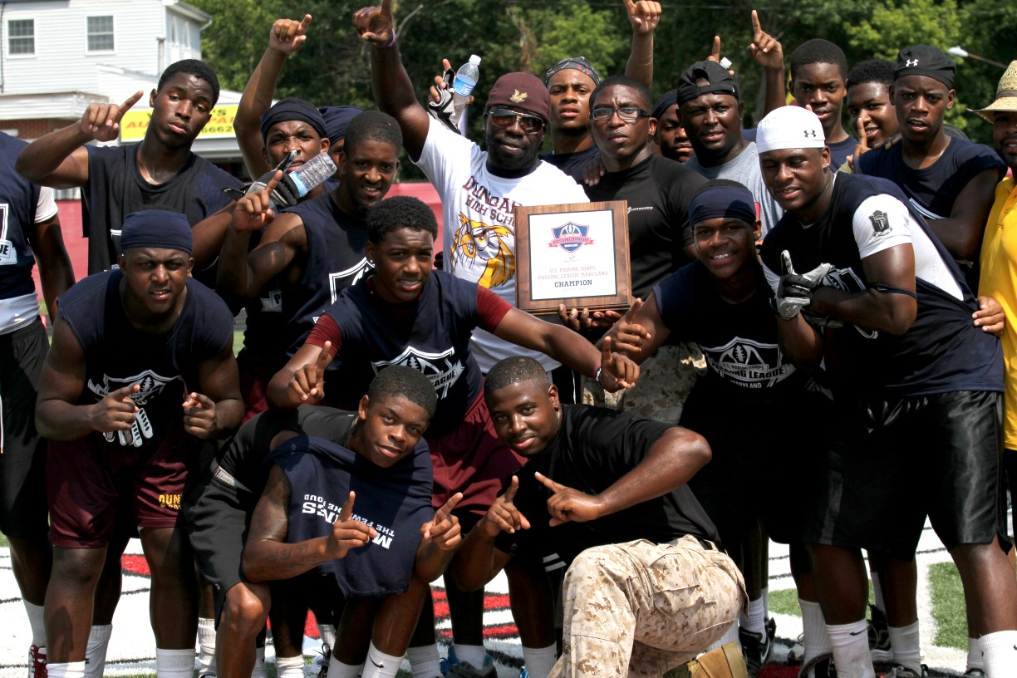

Marine Corps recruiters present the U.S. Marine Corps – Passing League Maryland championship plaque to Dunbar High School’s Travis Blackston, whose Purple Foxes went 7-0 to in the title at Woodlawn High School.

Purple Foxes win inagural U.S. Marine Corps – Passing League Maryland
The U.S. Marine Corps Recruiting Station Baltimore crowned the first-ever champion of the U.S. Marine Corps – Passing League Maryland on Saturday, July 23 at Woodlawn High School. Dunbar’s Travis Blackston coached the Purple Foxes to a 29-18 win over the Destroyers in the championship game of the inaugural event. The Purple Foxes went 7-0 to win the event. The Edmonson-Westside’s Dante Jones coached his Destroyers to a runner-up finish with a 6-1 record.

First-year Woodlawn head coach DaVaughn Mellerson coached his Wolfpack to a third-place finish with a 4-1 record. The Thunder, coached by Milford Mill Academy’s Reggie White, finished fourth with a 3-2 mark.

Pool play determined the seeding for the eight-team single-elimination championship round. The Purple Foxes won Pool D with a 3-0 record. Other pool winners included: Wolfpack (Pool A); Destroyers (Pool B); Bowie’s Terry Hayes-coached Highlander (Pool C); and Glen Burnie’s Mike Melton led the Lava Dogs to the title in Pool E.

Based on the total number of points scored in pool play, three at-large teams were selected to play in the championship-round, including: the Devil Dogs, coached by South River’s Lance Clelland (78 points); the Thunder, led by Milford Mill’s Reggie White (58 points); and the Nightmare, coached by Baltimore City College’s Matt Wyskiel.

