
INVOICE – PROOF OF PERFORMANCE

Invoice Number: 11-USMC-PLM-8002

Order Number: 0-00621-8002

Date of Invoice: August 15, 2011

Date of Event: July 23, 2011

Agency Mindshare
Attn: Gracie Childress
3630 Peachtree Road NE, Suite 1100
Atlanta, GA 30326

Client: U.S. Marine Corps

Battalion: U.S. Marine Corps 4th MCD

Event: U.S. Marine Corps – Passing League Maryland

Deliverables: Marines logo included on all tee shirts
Marines logo included in all press releases
Developed USMC-PLM logo
Managed USMC-PLM web site
Managed 16-team HS FB 7-on-7 tournament
Branded event as a MARINES event
Provided MARINES branded trophy for winning teams
Wii give away to participating player

Invoice Total: $5,000.00

Please remit to: TSF Radio Network
1516 Lytell Johne’s Path
Williamston, MI 48895

Check payable to: TSF Radio Network

Federal Tax ID: 237535486

“The Sports Flash” Radio Network - Your teams. Your scores.
Mike Sinnott - 517-927-4570 - TheSportsFlash@aol.com - www.TheSportsFlash.com

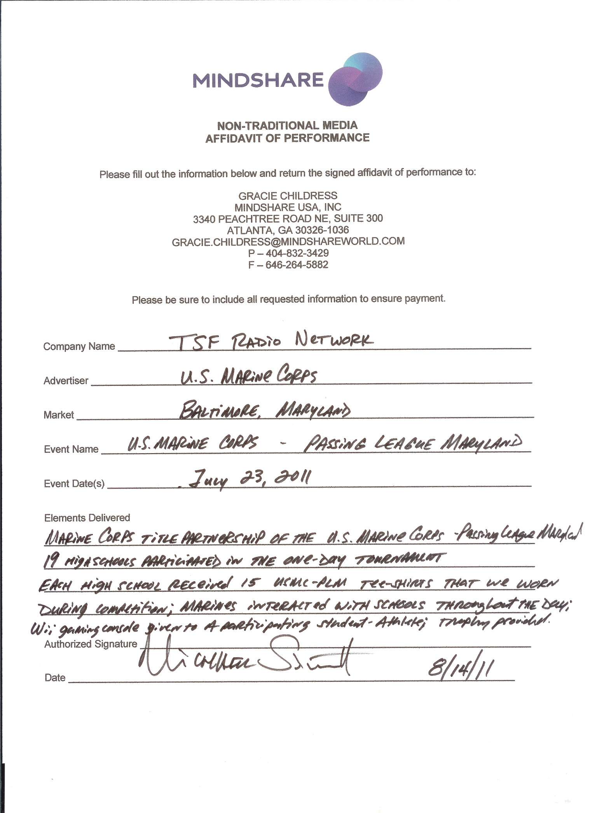
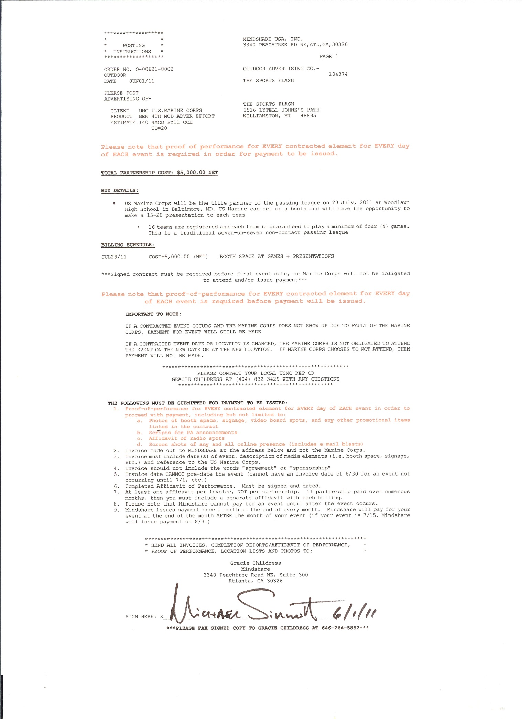
LOGO Devlopment
TSF Radio Network designed the logo for the Marine Corps – Passing League Maryland.



Press Releases
TSF Radio Network drafted press releases to promote the Marine Corps – Passing League Maryland, and distributed those press releases to the media to promote the event.

A few press releases appear below:


Recruiting Station Baltimore launches the
U.S. Marine Corps Passing League - Maryland
The seven-on-seven passing tournament to feature high school teams from Maryland

FOR IMMEDIATE RELEASE | CONTACT: Mike Sinnott, TSF Radio Network
5 May 2011 | (517) 927-4570 or TheSportsFlash@aol.com

BALTIMORE, MD - The U.S. Marine Corps Recruiting Station Baltimore is proud to announce the launch of the U.S. Marine Corps Passing League - Maryland, a seven-on-seven high school football passing league that will begin in the late spring/early summer of 2011. The U.S. Marine Corps Passing League – Maryland will consist of teams from RS Baltimore’s recruiting territory in the state of Maryland.

The U.S. Marine Corps Passing League will be a single-day 16-team passing tournament at a site to be determined. Unlike other passing league tournaments, thanks to the Marine Corps partnership, the event will be FREE for all of the participating teams. Each team is guaranteed to play four games, with three games in pool play and one game in the single-elimination championship round.

The U.S. Marine Corps Passing League – Maryland is a traditional seven-on-seven non-contact passing league played on a shortened field with only passing plays from the line of scrimmage. The games feature quarterbacks, wide receivers, running backs, and defensive backs, giving them an opportunity to sharpen their skills in a fun, competitive atmosphere.

“The Sports Flash” (TSF) Radio Network will manage the U.S. Marine Corps Passing League. In 2010, TSF Radio Network launched the Pennsylvania Passing League, which featured 32 teams playing in two divisions with more than 600 student-athletes participating. The National Football League’s Pittsburgh Steelers invited the Pennsylvania Passing League’s division winners to play an exhibition at halftime of their 2010 preseason opener at Heinz Field. The 2011 Pennsylvania Passing League begins on June 11 with the PPL West Division at Gateway High School, outside of Pittsburgh. The PPL East Division will be played on June 25 at Susquehanna Township High School, outside of Harrisburg. In 2011, TSF Radio Network also launched the Palmetto Passing League in South Carolina, featuring high school teams from the Florence/Myrtle Beach markets.

“The Sports Flash” Radio Network provides 190 radio stations in 13 states with customized, local sports reports, reaching 2.5-million listeners each week. In addition to its traditional radio advertising campaigns, TSF Radio Network has expanded into sports marketing, managing tobacco prevention campaigns that target high school students in several states, including: Kentucky; Montana; North Carolina; South Carolina; and Wyoming. In addition, TSF Radio Network manages marketing campaigns that target high school student-athletes, their peers, parents, and coaches for military recruiting forces around the country. For more info about the TSF Radio Network, contact Mike Sinnott at (517) 927-4570.

The U.S. Marine Corps’ title partnership of the passing league ensures that teams will not be charged to participate. At this time, TSF Radio Network is working to secure a host site and teams to participate. TSF Radio Network expects to announce a host site for the tournament in the next few weeks.

The United States Marine Corps is a branch of the United States armed forces responsible for providing power projection from the sea and serving as an amphibious force-in-readiness. For more information about becoming one of the few and the proud, go online to www.Marines.com.

If your school is interested in participating in or even hosting the U.S. Marine Corps Passing League- Maryland event, please contact TSF Radio Network’s Mike Sinnott at (517) 927-4570 or via e-mail at TheSportsFlash@aol.com. For additional information about the Palmetto Passing League, visit the official PPL web site at www.TheSportsFlash.com/USMC-PL-MARYLAND. At the site, visitors can learn about the latest information regarding the passing league, download the official rules of play, and registration forms.

###

 |  | 

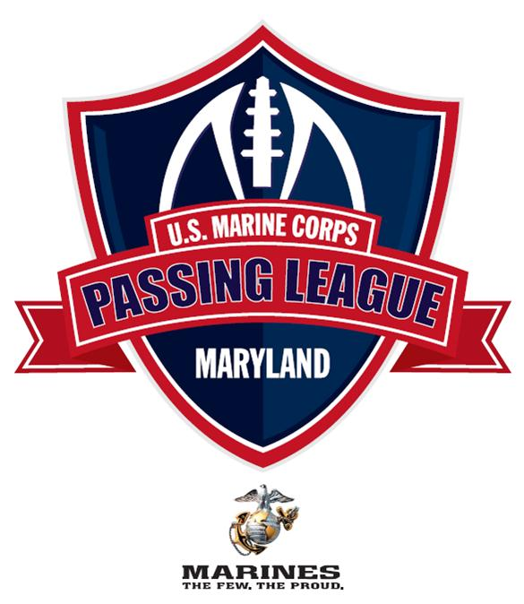
Woodlawn High School to host the inaugural
U.S. Marine Corps Passing League - Maryland
Baltimore County facility to host the seven-on-seven tournament on Saturday, July 23

FOR IMMEDIATE RELEASE | CONTACT: Mike Sinnott, TSF Radio Network
16 May 2011 | (517) 927-4570 or TheSportsFlash@aol.com

BALTIMORE, MD - The U.S. Marine Corps Recruiting Station Baltimore is proud to announce that Woodlawn High School in Baltimore will host the U.S. Marine Corps Passing League – Maryland on Saturday, July 23. The seven-on-seven tournament will feature teams from throughout Maryland. The U.S. Marine Corps’ title partnership of the passing league ensures that teams will not be charged to participate.

The single-day event will feature a minimum of 16 teams, with each team guaranteed to play a minimum of four games. Each team will play three games in pool play to determine the seeding for the 16-team single-elimination tournament.

The U.S. Marine Corps Passing League - Maryland is a traditional seven-on-seven non-contact passing league played on a shortened field with only passing plays from the line of scrimmage. The games feature quarterbacks, wide receivers, running backs, and defensive backs, giving these skill players an opportunity to sharpen their skills in a fun, competitive atmosphere.

Although the league is restricted to those student-athletes who are enrolled in high school, the participating teams of the U.S. Marine Corps Passing League – Maryland are not associated with or representative of any high school football program. Instead, each team represents communities throughout the state. Although Woodlawn High School is hosting the event, the U.S. Marine Corps Passing League – Maryland is not sponsored, endorsed, or supported by Woodlawn High School or the Baltimore County Public Schools.

Woodlawn High School is located one half mile east of exit 17 (Security Blvd.) off the Baltimore Beltway I-695 at 1801 Woodlawn Drive.

The U.S. Marine Corps is a branch of the United States armed forces responsible for providing power projection from the sea and serving as an amphibious force-in-readiness. For more information about become one of the few and the proud, go online to www.Marines.com.

“The Sports Flash” (TSF) Radio Network will manage the Palmetto Passing League. In 2010, TSF Radio Network launched the Pennsylvania Passing League, which featured 32 teams playing in two divisions with more than 600 student-athletes participating. The National Football League’s Pittsburgh Steelers invited the Pennsylvania Passing League’s division winners to play an exhibition at halftime of their 2010 preseason opener at Heinz Field. The 2011 Pennsylvania Passing League begins on June 11 with the PPL West Division at Gateway High School, outside of Pittsburgh. The PPL East Division will be played on June 25 at Susquehanna Township High School, outside of Harrisburg.

“The Sports Flash” Radio Network provides 190 radio stations in 13 states with customized, local sports reports, reaching 2.5-million listeners each week. In addition to its traditional radio advertising campaigns, TSF Radio Network has expanded into sports marketing, managing tobacco prevention campaigns that target high school students in several states, including: Kentucky; Montana; North Carolina; South Carolina; and Wyoming. Since 2006, TSF Radio Network has managed the Army Iron Man campaign; the Army STRONG Wrestler of the Year; and HOOP STARS of the Year campaigns for U.S. Army Recruiting battalion’s across the country. In 2010, TSF Radio Network expanded into event management, sponsorship with its creation of the Pennsylvania Passing League. For more info about the TSF Radio Network, contact Mike Sinnott at (517) 927-4570.

U.S. Marine Corps - Passing League Maryland host 20 teams at Woodlawn High School on Saturday, July 23
Woodlawn High School facility to host seven-on-seven tournament

FOR IMMEDIATE RELEASE | CONTACT: Mike Sinnott, TSF Radio Network
23 July 2011 - UPDATED | (517) 927-4570 or TheSportsFlash@aol.com

BALTIMORE, MD - The U.S. Marine Corps Recruiting Station Baltimore is proud to announce that 20 teams will compete in the U.S. Marine Corps Passing League – Maryland at Woodlawn High School on Saturday, July 23. The seven-on-seven tournament will feature high school football student-athletes and coaches from throughout Maryland.

In accordance with Maryland Public Secondary Schools Athletic Association rules regarding out of season practice and competition, the U.S. Marine Corps – Passing League Maryland has assigned team names or monikers that are not connected with any specific public high school in the state. The U.S. Marine Corps – Passing League Maryland team names are all associated with regiments, battalions, air wings, etc., from the rich history of the U.S. Marine Corps.

U.S. Marine Corps - Passing League Maryland – Team Nicknames
Arctic Warriors (25th Marine Regiment)
Head Coach: Jeff Seals (Montgomery Blair)

Black Sheep (Marine Attack Squadron 214)
Head Coach: Rich Holzer (Meade)

Death Rattlers (Marine Fighter Attack Squadron 323 VMFA-323)
Head Coach: Donald Davis (Calvert Hall)

Destroyers (2nd Light Armored Reconnaissance Battalion)
Head Coach: Dante Jones (Edmondson-Westside)

Devil Dogs (Nickname for Marines)
Head Coach: Lance Clelland (South River)

Fighting Fifth (5th Marine Regiment)
Head Coach: Terry Hayes (Bowie)

Highlander (1st Armored Reconnaissance Battalion)
Head Coach: Terry Hayes (Bowie)

Island Warriors (2nd Battalion, 3rd Marines)
Head Coach: Edmund Hughes (Long Reach)

Lava Dogs (1st Battalion, 3rd Marines)
Head Coach: Mike Melton (Glen Burine)

Leathernecks (Nickname for Marines)
Head Coach: Todd Sommerville (Laurel)

Mortalis (3rd Reconnaissance Battalion)
Head Coach: Dwayne Green (Bluford Drew Jemison Academy)

Nightmare (1st Battalion, 10th Marines)
Head Coach: Michael Nines (Leonardtown)

Purple Foxes (Marine Medium Helicopter Squadron HMM-268)
Head Coach: Travis Blackston (Dunbar)

Striking Ninth (3rd Battalion, 9th Marines)
Head Coach: Mike Melton (Glen Burine)

Teufelhunden (German word for Devil Dogs)
Head Coach: Rob Elliott (Chesapeake)

The Mad Ghosts (2nd Battalion, 24th Marines)
Head Coach: Rich Holzer (Meade)

Thundering Third (3rd Battalion, 1st Marines)
Head Coach: DaVaughn Mellerson

Timberwolf (1st Battalion, 2nd Marines)
Head Coach: Andre Brown (High Point)

Thunder (3rd Battalion, 11th Marines)
Head Coach: Reggie White (Milford Mill Academy)

Wolfpack (3rd Light Armored Reconnaissance Battalion)
Head Coach: DaVaughn Mellerson

The single-day event will feature 20 teams, with each team guaranteed to play a minimum of four games. Each team will play three games in pool play to determine the seeding for the single-elimination championship round.

The U.S. Marine Corps Passing League - Maryland is a traditional seven-on-seven non-contact passing league played on a shortened field with only passing plays from the line of scrimmage. The games feature quarterbacks, wide receivers, running backs, and defensive backs, giving these skill players an opportunity to sharpen their skills in a fun, competitive atmosphere.

Woodlawn High School is part of the Baltimore County Public Schools and is located at 1801 Woodlawn Drive in Baltimore. Woodlawn High School is committed to fostering an environment of high expectation and academic excellence accomplished through the ideals of teamwork, respect, and responsibility. Woodlawn High School is a four-year, public, comprehensive high school serving approximately 1,800 students. The school has received accreditation from the Middle States Association of Colleges and Secondary Schools by the Maryland Department of Education. Woodlawn High School is also a member of the College Entrance Examination Board and the National Association of College Admissions Counselors.

Woodlawn High School is located one half mile east of exit 17 (Security Blvd.) off the Baltimore Beltway I-695 at 1801 Woodlawn Drive.

The U.S. Marine Corps is a branch of the United States armed forces responsible for providing power projection from the sea and serving as an amphibious force-in-readiness. For more information about become one of the few and the proud, go online to www.Marines.com.

“The Sports Flash” (TSF) Radio Network manages the U.S. Marine Corps – Passing League Maryland. In 2010, TSF Radio Network launched the Pennsylvania Passing League, which featured 32 teams playing in two divisions with more than 600 student-athletes participating. The National Football League’s Pittsburgh Steelers invited the Pennsylvania Passing League’s division winners to play an exhibition at halftime of their 2010 preseason opener at Heinz Field. The Pennsylvania Passing League held two tournaments in 2011 in Harrisburg and suburban Pittsburgh.

“The Sports Flash” Radio Network provides 190 radio stations in 13 states with customized, local sports reports, reaching 2.5-million listeners each week. In addition to its traditional radio advertising campaigns, TSF Radio Network has expanded into sports marketing, managing tobacco prevention campaigns that target high school students in several states, including: Kentucky; Montana; North Carolina; South Carolina; and Wyoming. Since 2006, TSF Radio Network has managed the Army Iron Man campaign; the Army STRONG Wrestler of the Year; and HOOP STARS of the Year campaigns for U.S. Army Recruiting battalion’s across the country. In 2010, TSF Radio Network expanded into event management, sponsorship with its creation of the Pennsylvania Passing League. For more info about the TSF Radio Network, contact Mike Sinnott at (517) 927-4570.

Dunbar’s Blackston leads Purple Foxes to the championship of the U.S. Marine Corps – Passing League Maryland
Purple Foxes beat the Destroyers, 29-18, in the title game for first-ever U.S. Marine Corps Passing League title

FOR IMMEDIATE RELEASE | CONTACT: Mike Sinnott, TSF Radio Network
23 July 2011 | (517) 927-4570 or TheSportsFlash@aol.com

BALTIMORE, MD - The U.S. Marine Corps Recruiting Station Baltimore crowned its first champion of the U.S. Marine Corps – Passing League Maryland on Saturday, July 23 at Woodlawn High School. Dunbar’s Travis Blackston coached the Purple Foxes to a 29-18 win over the Destroyers in the championship game of the inaugural event. The Purple Foxes went 7-0 to win the event. The Edmonson-Westside’s Dante Jones coached his Destroyers to a runner-up finish with a 6-1 record.

First-year Woodlawn head coach DaVaughn Mellerson coached his Wolfpack to a third-place finish with a 4-1 record. The Thunder, coached by Milford Mill Academy’s Reggie White, finished fourth with a 3-2 mark.

Pool play determined the seeding for the eight-team single-elimination championship round. The Purple Foxes won Pool D with a 3-0 record. Other pool winners included: the Wolfpack (Pool A); Destroyers (Pool B); Bowie’s Terry Hayes-coached Highlander (Pool C); and Glen Burnie’s Mike Melton led the Lava Dogs to the title in Pool E.

Based on the total number of points scored in pool play, three at-large teams were selected to play in the championship-round, including: the Devil Dogs, coached by South River’s Lance Clelland (78 points); the Thunder, led by Milford Mill’s Reggie White (58 points); and the Nightmare, coached by Baltimore City College’s Matt Wyskiel.

The United States Marine Corps – Passing League Maryland featured 19 teams and more than 350 student-athletes from throughout Maryland, playing in a single-day tournament event.
The U.S. Marine Corps Passing League - Maryland is a traditional seven-on-seven non-contact passing league played on a shortened field with only passing plays from the line of scrimmage. The games feature quarterbacks, wide receivers, running backs, and defensive backs, giving these skill players an opportunity to sharpen their skills in a fun, competitive atmosphere.

In accordance with Maryland Public Secondary Schools Athletic Association rules regarding out of season practice and competition, the U.S. Marine Corps – Passing League Maryland assigned team names or monikers that are not connected with any specific public high school in the state. The U.S. Marine Corps – Passing League Maryland team names are all associated with regiments, battalions, air wings, etc., from the rich history of the U.S. Marine Corps.

Woodlawn High School is part of the Baltimore County Public Schools and is located at 1801 Woodlawn Drive in Baltimore. Woodlawn High School is committed to fostering an environment of high expectation and academic excellence accomplished through the ideals of teamwork, respect, and responsibility. Woodlawn High School is a four-year, public, comprehensive high school serving approximately 1,800 students. The school has received accreditation from the Middle States Association of Colleges and Secondary Schools by the Maryland Department of Education. Woodlawn High School is also a member of the College Entrance Examination Board and the National Association of College Admissions Counselors.

The U.S. Marine Corps is a branch of the United States armed forces responsible for providing power projection from the sea and serving as an amphibious force-in-readiness. For more information about become one of the few and the proud, go online to www.Marines.com.

“The Sports Flash” (TSF) Radio Network managed the U.S. Marine Corps – Passing League Maryland. In 2010, TSF Radio Network launched the Pennsylvania Passing League, which featured 32 teams playing in two divisions with more than 600 student-athletes participating. The National Football League’s Pittsburgh Steelers invited the Pennsylvania Passing League’s division winners to play an exhibition at halftime of their 2010 preseason opener at Heinz Field. The Pennsylvania Passing League held two tournaments in 2011 in Harrisburg and suburban Pittsburgh.

“The Sports Flash” Radio Network provides 190 radio stations in 13 states with customized, local sports reports, reaching 2.5-million listeners each week. In addition to its traditional radio advertising campaigns, TSF Radio Network has expanded into sports marketing, managing tobacco prevention campaigns that target high school students in several states, including: Kentucky; Montana; North Carolina; South Carolina; and Wyoming. Since 2006, TSF Radio Network has managed the Army Iron Man campaign; the Army STRONG Wrestler of the Year; and HOOP STARS of the Year campaigns for U.S. Army Recruiting battalion’s across the country. In 2010, TSF Radio Network expanded into event management, sponsorship with its creation of the Pennsylvania Passing League. For more info about the TSF Radio Network, contact Mike Sinnott at (517) 927-4570.

Direct Mail
TSF Radio Network drafted a letter introducing the U.S. Marine Corps – Passing League Maryland to high schools throughout the RS Baltimore’s recruiting territory. After a team committed to playing in the event, TSF Radio Network sent along a letter that thanked them for their participation in the event and provided them with additional information about the event.

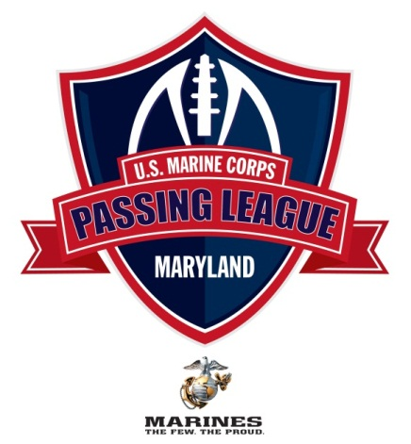

July 12, 2011

I want to thank you for your participation in the U.S. Marine Corps Passing League – Maryland (USMC-PLM). The event is scheduled for Saturday, July 23 at Woodlawn High School. At this time, we’re scheduling the coaches meeting to begin at 8:10 AM at the 50-yard-line with the first game of the day beginning at 8:30 AM. I have enclosed release forms for each of your participating student-athletes, a team information form, and an abridged version of the USMC-PLM rules and penalties.

I have enclosed 15 release forms for your student-athletes. The student-athlete needs to fill out the form completely, and we need the signature of each participant’s parent or guardian. If you need more than 15 release forms, please make a copy of one of the enclosed release forms, or download a release form from the PPL web site, which you can access by visiting www.TheSportsFlash.com.

We must have a signed participant release from every student-athlete competing in the event, or they will not be allowed to compete. The release forms can be turned in when your team checks in on the day of the event, or you can send them to us via e-mail, fax, or regular mail.

To remain in compliance with Maryland Public Secondary Schools Athletic Association rules, we will assign you with a team name and provide you with a USMC-PLM tee-shirt for your players to wear during competition. Please have your players wear a white or gray shirt that day, so we’ll have an “alternate” shirt should you get matched up with a team that has the same shirt color as your team.

The tee-shirts will be distributed the day of the event. Each team will receive 15 tee-shirts for the event, so we’re restricting the rosters to 15 players. If you’d like to bring more than 15 players, that’s fine. Please be advised that we’ll need to purchase a tee-shirt for them or share the shirts during the event. We will offer additional tee-shirts at cost, which should not be more than $10 each, but they’ll need to be purchase before the event. I will send along an order form and a deadline for pre-tournament purchase before the end of June.

If you have any questions, please feel free to contact me at your convenience. I’m available at (517) 927-4570 or by e-mail at TheSportsFlash@aol.com or mike@TheSportsFlash.com. Woodlawn’s DaVaughn Mellerson is serving as our tournament coordinator and is available at (443) 850-5251 or via e-mail at d.mellerson@live.com.

Thanks for your participation,

Mike Sinnott
“The Sports Flash” Radio Network
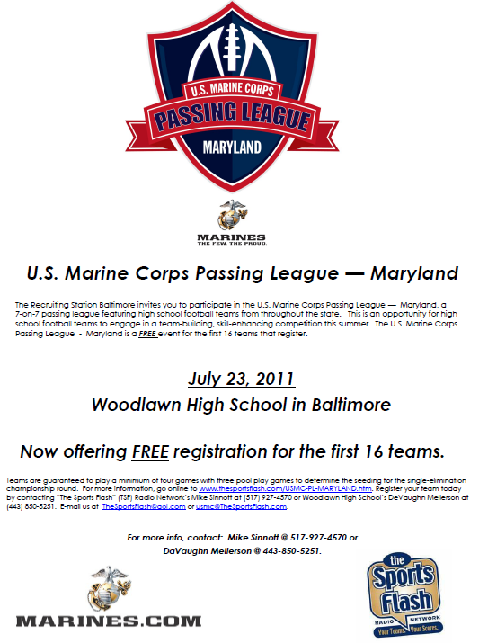

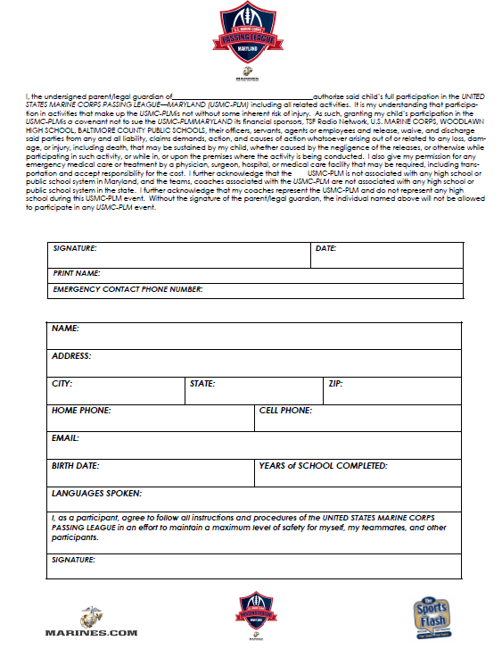

Participating Teams
TSF Radio Network guaranteed a minimum of 16 high schools for the U.S. Marine Corps – Passing League Maryland. TSF Radio Network secured 17 high schools and twenty teams for the tournament. Here’s a list of the participating teams for the U.S. Marine Corps – Passing League Maryland:

- Baltimore City College High School
- Bluford Drew Jemison Academy
- Bowie
- Chesapeake
- Calvert Hall
- Dunbar
- Edmondson-Westside
- Glen Burnie
- High Point
- Laurel
- Long Reach
- Leonardtown
- Meade High School
- Milford Mill Academy
- Montgomery Blair
- South River
- Woodlawn

Online
TSF Radio Network created an official web site for the U.S. Marine Corps – Passing League Maryland. The site’s address is: www.TheSportsFlash.com/USMC-PL-MARYLAND.htm.

Below is a screen capture of the web site.

Photos from the Marine Corps – Passing League Maryland

Champion Dunbar High School poses with championship trophy along with participating Marines.



Marines oversee the action at the U.S. Marine Corps – Passing League Maryland



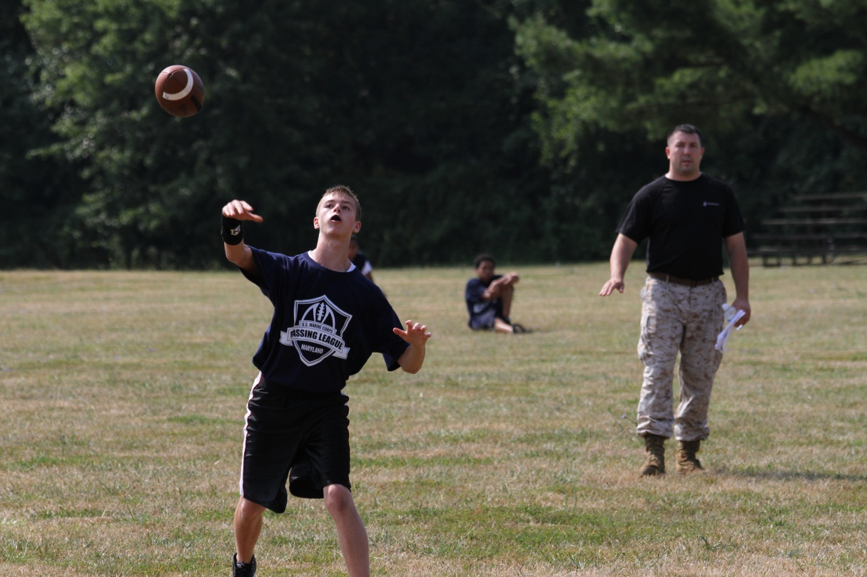

Navy blue Marine Corps – Passing League Maryland tee-shirt:



Gold U.S. Marine Corps – Passing League Maryland tee shirt.

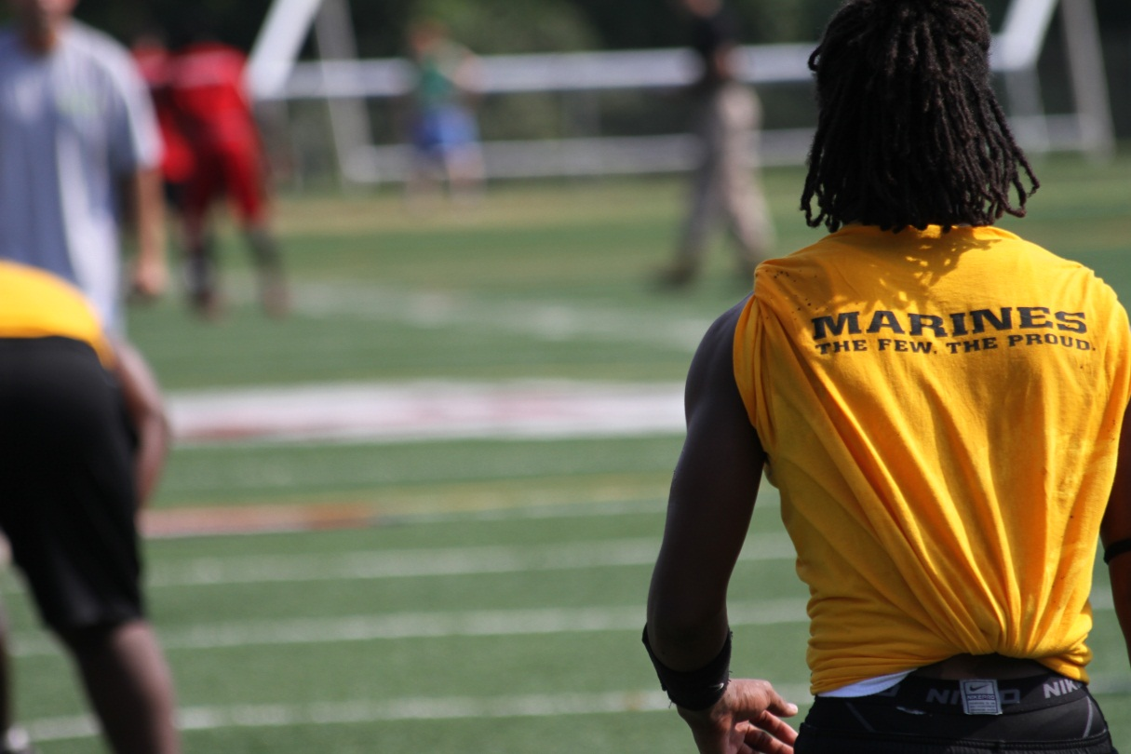

Green & Red U.S. Marine Corps – Passing League Maryland tee shirts.

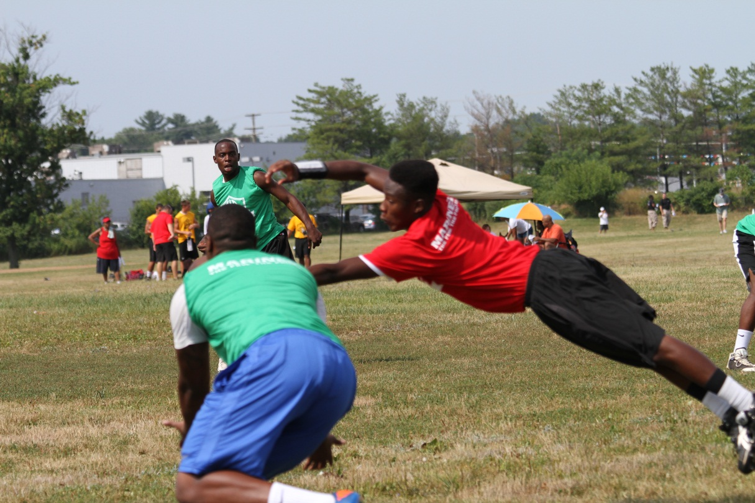

Marine presents Wii gaming console to a member of the Laurel High School football team.

