Please deliver this important, time-sensitive information IMMEDIATELY to your athletic director or head football coach.

This is page 1 of 2. THANKS!

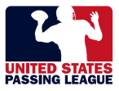

United States Passing League - RIVER CITY 7-on-7
1516 Lytell Johne’s Path – Williamston, MI - 48895
Mike Sinnott – (517) 927-4570 – www.TheSportsFlash.com – TheSportsFlash@aol.com – mike@thesportsflash.com

