PPL Title Sponsorship – SOLD – U.S. ARMY
As the title sponsor of the PPL regional event, your company will receive the following:

-event branded with your corporate identity, featuring 16-20 high school football teams;
-inclusion of your brand identity in the event logo;
-primary signage locations throughout the event’s facility;
-booth space in the highest-profile location of the event’s facility;
-opportunity to make one-on-one presentations to participating teams;
-brand identity included on tee-shirts provided to student-athletes;
-corporate branding included in all communications materials to promote event;
-posting of your click through web banner at primary location at event’s official web site;
-access to database of all participating student-athletes; and,
-presentation of trophy to tournament champion.

PPL Presenting Sponsors - $2,500/event
As the presenting sponsor of a PPL regional event, your company will receive the following:

-participation in event featuring 16-20 high school football teams;
-secondary signage locations throughout the event’s facility;
-booth space in the secondary location of the event’s facility;
-posting of your click-through web banner at secondary location at official web site;
-opportunity to distribute information to participating teams,

PPL Associate Sponsors - $750 - $1,250/event
As an associate sponsor of a PPL regional event, your company will receive the following:

-participation in event featuring 16-20 high school football teams;
-signage locations, where available, throughout facility; and,
-booth space at facility to distribute information, products to participants.

Please contact Palmetto Passing League’s Mike Sinnott at (517) 927-4570 for a proposal that is customized for your business.

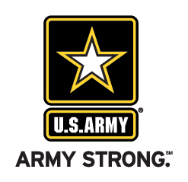 | 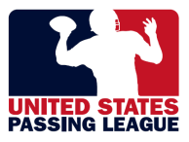 | 

