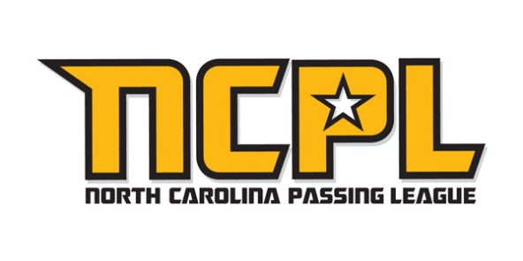 | 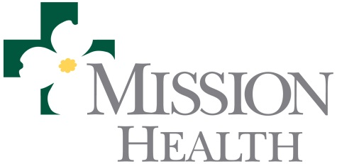

MEDIA CONTACT: Mike Sinnott, NCPL: (517) 927-4570
Jennifer McLucas for Mission Health: (828) 335-2514

FOR IMMEDIATE RELEASE - JUNE 24, 2012

MISSION SPORTS MEDICINE PARTNERS WITH
NORTH CAROLINA PASSING LEAGUE
NCPL to host as many as 20 teams on June 30 at Erwin High School in Asheville

ASHEVILLE, N.C. (June 18, 2012) - The North Carolina Passing League (NCPL) is honored to announce a partnership with Mission Health Sports Medicine that designates Mission Health as the “Official Sports Medicine Partner” of the NCPL. On June 30, 2012, the NCPL will host 21 high school football teams in a single-day, seven-on-seven passing tournament. The event will feature pool play to determine the seeding for the single-elimination championship round.

As part of this exclusive partnership, Mission Health Sports Medicine will provide on-site medical services for the 450-600 participating student-athletes at the event. In addition, Mission Health Sports Medicine will conduct a sports medicine seminar on topics that could include the benefits of proper nutrition; work out strategies to improve performance; the dangers of steroid use; the disadvantages of playing through injuries; the critical need for proper hydration, and other topics.

The Sports Medicine Program at Mission Health, whose focus is to improve the health of the people throughout western North Carolina, uses a multidisciplinary approach to provide preventative care, education, diagnosis, treatment, surgical care and rehabilitation for residents of all ages in the region. Experienced board certified surgeons use advanced technology to treat injuries that can otherwise sideline an athlete.

As of June 18, 2012, the following teams have committed to participate in the first-ever North Carolina Passing League: A.C. Reynolds; Bunker Hill; Burns; Chase; Chesnee (SC); Daniel (SC); East Burke; Enka; Erwin; Freedom; Greensboro Grimsley; Madison; North Buncombe; North Henderson; Patton; Pisgah; Shelby; South Rowan; Swain County; and T.C. Roberson. The U.S. Army is the title sponsor of the North Carolina Passing League. The Army’s support of the event ensures that all of the participating teams will compete FREE of charge.

For more information about the NCPL, please contact Mike Sinnott at (517) 927-4570.

For more information about Mission Sports Medicine, go online to www.msj.org or contact Jennifer McLucas at (828) 335-2514 or by e-mail at jennifer@integritive2.com.

- more –
Mission Sports Medicine Partners with NCPL/p. 2

About Mission Health
Mission Health, based in Asheville, N.C., is the state’s sixth largest health system and the tertiary care regional referral center for Western North Carolina and the adjoining region. In 2012, Mission Health was named by Thomson Reuters as one of the top 15 health systems in the nation – the only health system in North Carolina to receive this recognition.

Founded in 1885, Mission Health is a not-for-profit, independent community hospital system governed and managed exclusively in Western North Carolina. Mission operates five hospitals, numerous out-patient and surgery centers, and the region’s only dedicated Level II trauma center. Its medical staff consists of more than 750 physicians, and is certified in more than 50 medical specialties and subspecialties. Centers of excellence include heart, stroke care and neurosciences, and pediatrics. Mission Hospital, the system’s flagship hospital, is licensed for 730 beds and is the busiest surgical hospital in North Carolina. Other Mission hospitals include Blue Ridge Regional Hospital in Spruce Pine, McDowell Hospital in Marion, and Mission Children’s Hospital in Asheville. With approximately 8,800 employees and 700 volunteers, Mission Health is dedicated to serving and improving the health and wellness of the people of Western North Carolina.

# # #

