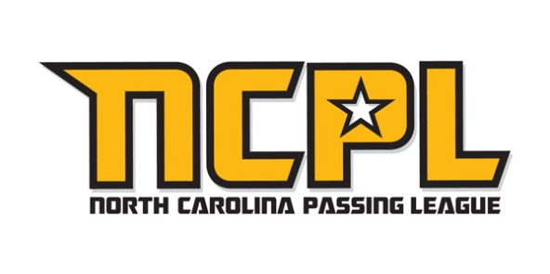
North Carolina Passing League names CUTTERS the “Official Performance Glove” of the NCPL
NCPL to host as many as 21 teams in inaugural event at Erwin High School on June 30

FOR IMMEDIATE RELEASE CONTACT: Mike Sinnott; USPL; (517) 927-4570
June 6, 2012 Chip Sivak; Cutters; (602) 381-5434

ASHEVILLE, NC - The North Carolina Passing League (NCPL) is proud to announce a partnership with Cutters Performance Gloves and Grips for 2012. This exclusive partnership makes Cutters Gloves the “official performance glove” of the NCPL. The first-ever NCPL will feature as many as 21 teams in a single-day, seven-on-seven football event with teams from across western North Carolina on June 30 at Erwin High School.

Cutters will have a presence at the event, giving high school student-athletes the opportunity to learn more about the cutting-edge technology that’s only found in the high-quality, durable Cutters gloves. Players will also have the opportunity to test their Cutters in game-like conditions. Cutters will honor each event’s Most Valuable Receivers as selected by the participating coaches.

Founded in 1997, Cutters is a market leader in the development of high-performance sports gloves and innovative training devices for football, baseball, golf, rugby, racquet sports, and action sports. Cutters is a pioneer in performance grip material with innovations that not only creates a strong grip, but a grip that is self-restoring and performs in all-weather conditions. Cutters’ proprietary C-TACKTM Performance Grip Material is worn by many professional football players, including Dez Bryant; Anquan Boldin; Frank Gore; Randy Moss, and Kellen Winslow, Jr.

Cutters is sold at all major retail outlets and specialty shops throughout the United States and Canada as well as Austria; Australia; Brazil; Denmark; Finland; Germany; Italy; Japan; Netherlands; New Zealand; South Korea; Sweden; and the United Kingdom. Cutters are available online, at www.cuttersgloves.com, where players can “Build Your Own Glove” (BYOG) by selecting your own unique color combinations and personalization.

As of June 6, 2012, the following local teams have committed to participate in the first-ever North Carolina Passing League: A.C. Reynolds; Bunker Hill; Burns; Chase; East Burke; Enka; Erwin; Freedom; Madison; North Buncombe; North Henderson; Patton; Pisgah; Shelby; Swain County; and T.C. Roberson. As many as five “out of town” teams have committed to participate in the event. The announcement of those teams is expected in the next couple of weeks.

Since 2010, the United States Passing League has managed passing league campaigns in Maryland; North Carolina; Pennsylvania; and South Carolina. The USPL is a marketing platform managed by “The Sports Flash” (TSF) Radio Network. TSF Radio Network provides local, customized sports updates to 179 network affiliates in 13 different states while managing unique sports marketing campaigns for many organizations, including Bluegrass Cellular; Kentucky’s Tobacco Quitline; Montana’s Tobacco Use Prevention Program; the North Carolina Spit Tobacco Education Program; South Carolina Department of Health and Environmental Control; U.S. Army; U.S. Marine Corps; and Wyoming Through With Chew.

For more information about the USPL or other marketing campaigns managed by TSF Radio Network, contact Mike Sinnott at (517) 927-4570.

###

