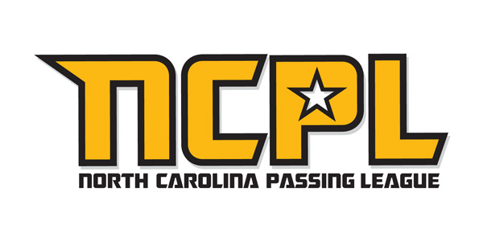 | 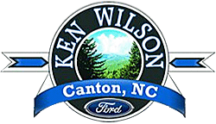

U.S. Army’s North Carolina Passing League
presented by Ken Wilson Ford

Objective:
The U.S. Army’s North Carolina Passing League will generate test-drive leads for Ken Wilson Ford at the NCPL event on June 30 at Erwin High School in Asheville.

North Carolina Passing League (NCPL)
The NCPL will bring together 21 high school football teams from across western North Carolina, upstate South Carolina, and as far east as Greensboro. This will be a single-day event that will feature pool play in the morning and a single-elimination championship round in the afternoon. At the end of the day, 49 games will have been played at Erwin High School.

As the presenting sponsor of the event, we will rename the event the “U.S. Army’s North Carolina Passing League presented by Ken Wilson Ford.” We will include Ken Wilson Ford in materials that are used to promote the event.

On-Site:
Fans at the event will have the opportunity to sign up for a test drive of a new FORD vehicle at Ken Wilson Ford. Each person that signs up for a test drive will receive a FREE tee-shirt or another giveaway item that is co-branded with the NCPL and Ken Wilson Ford logos.

Ken Wilson Ford will also have the following on-site marketing rights:

-display of Ford vehicles on-site during the event;
-distribution of information about Ford vehicles;
-placement of Ken Wilson Ford banners throughout facility;
-click-through web banner at the official NCPL web site;
-$500 donation to the Erwin High School athletic department;
-public address announcements at the event; and,
-distribution of 100 tee-shirts in exchange for test-drive leads.

Investment:
For the presenting sponsorship of the North Carolina Passing League, we require an investment of $2,500. The investment will ensure that Ken Wilson Ford is included in all branding for the event. In addition, the NCPL will distribute 100 co-branded tee-shirts in exchange for test drive lead, which the NCPL will deliver to Ken Wilson Ford.

