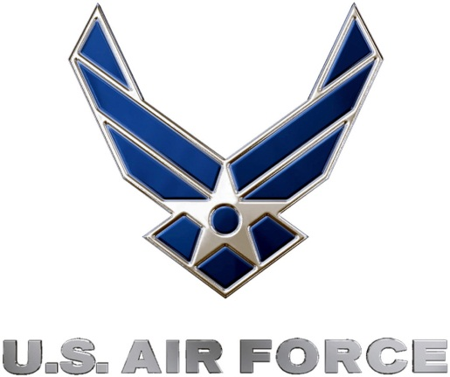 | 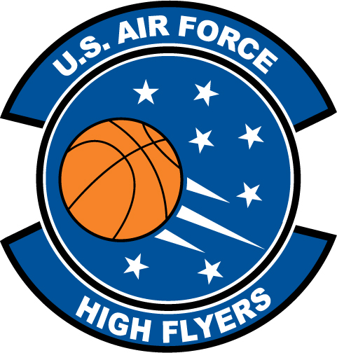
Timmonsville’s Sade Eli & Richland Northeast’s Travis Hammonds voted U.S. Air Force High Flyers of the Week
Air Force to honor the best high school basketball players in the state
FOR IMMEDIATE RELEASE CONTACT: Mike Sinnott
6 January 2012 (517) 927-4570

SHAW AFB, SC - The U.S. Air Force 337th Recruiting Squadron is honored to announce that Timmonsville’s Sade Eli and Richland Northeast’s Travis Hammonds have been voted the U.S. Air Force HIGH FLYERS of the Week as the state’s best high school basketball players. Eli dropped in a career-high 37 points in Timmonsville’s 62-25 win over ST. Johns at the Hemingway Holiday Invitational. Hammonds hit the game-winning three-pointer with three seconds to play as Richland Northeast knocked off Keenan in the Capital City Holiday Classic title game. Hammonds finished with 22 points, 13 rebounds in the win. As HIGH FLYERS of the Week, both players are finalists for the U.S. Air Force HIGH FLYER of the Year for South Carolina.

“The Sports Flash” (TSF) Radio Network will accept nominations each week from high school basketball coaches, athletic directors, the media, and high school basketball fans. High school basketball fans will vote online for the weekly winner. Each weekly winner will be a finalist for the U.S. Air Force High Flyer of the Year. Throughout the campaign, fans can visit the official U.S. Air Force High Flyers site at www.TheSportsFlash.com to stay updated on the campaign, vote for the weekly winner, and much more.

For the U.S. Air Force, people are its most valuable asset. Without them, even the most advanced systems are rendered useless. The U.S. Air Force recruits quality airmen from a cross-section of America to meet the Air Force’s ever-changing needs. The Air Force has more than 140 enlisted career opportunities available for qualified men and women. For more information about the enlisted, officer, and healthcare professional job opportunities in the U.S. Air Force, contact your local Air Force recruiter. Recruiter contact information is available by calling 1-800-423-USAF (8723) or visit the Recruiter Locator link on the official Air Force recruiting web site at www.airforce.com.

“The Sports Flash” (TSF) Radio Network delivers customized, local sports reports for 190 network affiliates in 13 states. TSF Radio Network coordinates the U.S. Air Force High Flyers campaign for the 337th Recruiting Squadron. For more information, please contact TSF Radio Network’s Mike Sinnott at (517) 927-4570.

###

