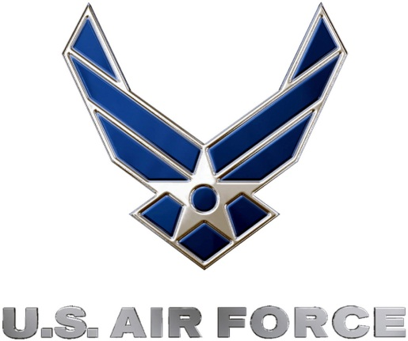 | 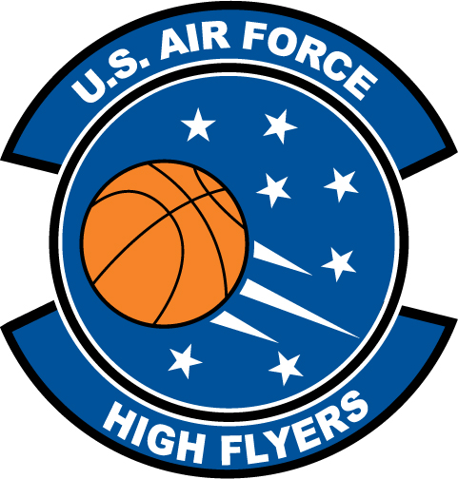
U.S. Air Force High Flyers – South Carolina
Week 1 Nominees – Boys’ Basketball
Air Force to honor the best high school basketball players in South Carolina
FOR IMMEDIATE RELEASE CONTACT: Mike Sinnott
2 January 2012 (517) 927-4570

SHAW AFB, SC - The U.S. Air Force’s 337th Recruiting Squadron is honored to announce the week one nominees for the U.S. Air Force High Flyers. The campaign honors the best boys’ and girls’ high school basketball players in South Carolina. Fans can vote online until 9:00 P.M. EDT on Thursday at www.TheSportsFlash.com. The winner will be announced on Monday.

U.S. Air Force High Flyers – South Carolina
Caleb Duggan – St. James | Duggan scored a game-high 25 points to lead St. James to a 63-36 win over Hunter Kinard Tyler at the Island Classic Tournament at Hilton Head.
Travis Hammonds – Richland Northeast | Hammonds hit the game-winning three with three seconds to play as Richland Northeast beat Keenan for the Capital City Holiday Classic championship. Hammonds finished with 22 points in 13 rebounds.
Chris Harley – Mullins | Harley earned tournament MVP honors after dropping in 21 points in leading Mullins to a 52-46 win over Wilson in the championship game of the Pepsi Carolina Classic.
Jordan Roper – Irmo | Roper dropped in 23 points to lead Irmo to a 64-48 win over Fort Myers (FL).
Deebo Samuel – Chapman | Samuel scored 25 points to lead Chapman to a 75-72 win over Blacksburg.
Jameel Taylor – T.L. Hanna | Taylor scored 18 to lead T.L. Hanna to a 61-38 win over Westside to win the Pepsi Holiday Invitational.

“The Sports Flash” (TSF) Radio Network will accept nominations each week from high school basketball coaches, athletic directors, the media, and high school basketball fans. High school basketball fans will vote online for the weekly winner. Each weekly winner will be a finalist for the U.S. Air Force High Flyer of the Year. Throughout the campaign, fans can visit the official U.S. Air Force High Flyers site at www.TheSportsFlash.com to stay updated on the campaign, vote for the weekly winner, and much more.

For the U.S. Air Force, people are its most valuable asset. Without them, even the most advanced systems are rendered useless. The U.S. Air Force recruits quality airmen from a cross-section of America to meet the Air Force’s ever-changing needs. The Air Force has more than 140 enlisted career opportunities available for qualified men and women. For more information about the enlisted, officer, and healthcare professional job opportunities in the U.S. Air Force, contact your local Air Force recruiter. Recruiter contact information is available by calling 1-800-423-USAF (8723) or visit the Recruiter Locator link on the official Air Force recruiting web site at www.airforce.com.

“The Sports Flash” (TSF) Radio Network delivers customized, local sports reports for 190 network affiliates in 13 states. TSF Radio Network coordinates the U.S. Air Force High Flyers campaign for the 337th Recruiting Squadron. For more information, please contact TSF Radio Network’s Mike Sinnott at (517) 927-4570.

###

