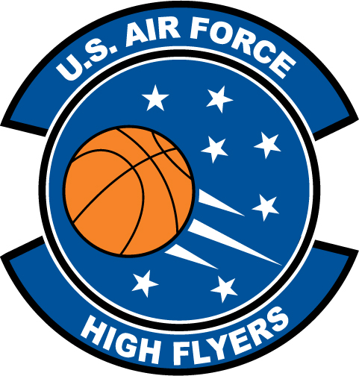

Stephanie Roberts – St. James High School
U.S. Air Force High Flyer of the Week – South Carolina

The U.S. Air Force 337th Recruiting Squadron honors St. James High School’s Stephanie Roberts as a 2011-2012 U.S. Air Force High Flyer of the Week as the best high school basketball player in South Carolina. Roberts recorded a double-double with a game-high 23 points and 15 rebounds to lead St. James to a 65-38 win over Andrews. The U.S. Air Force recognizes this exceptional individual performance and the incredible skill, dedication, and teamwork required to accomplish team goals.
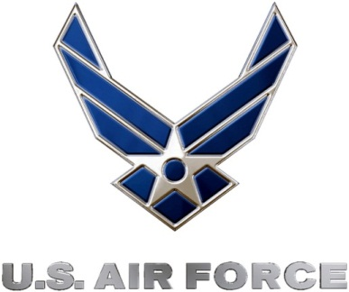 |  | TROY C. KIMBALL, Lieutenant Colonel, USAF  Commander, 337th Recruiting Squadron

