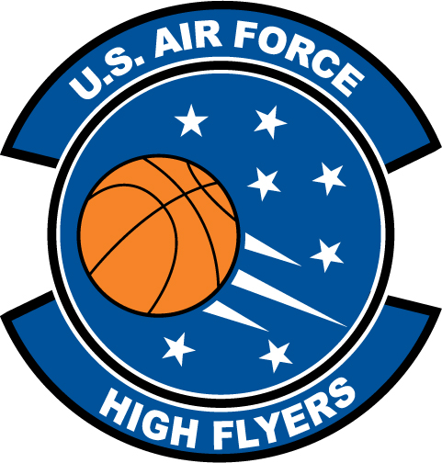

Will Daniels – South Florence High School
U.S. Air Force High Flyer of the Week – South Carolina

The U.S. Air Force 337th Recruiting Squadron honors South Florence High School’s Will Daniels as a 2011-2012 U.S. Air Force High Flyer of the Week as the best high school basketball player in South Carolina. Daniels recorded a double-double with 23 points, 10 rebounds to lead South Florence to a 66-58 win over Carolina Forest. The U.S. Air Force recognizes this exceptional individual performance and the incredible skill, dedication, and teamwork required to accomplish team goals.
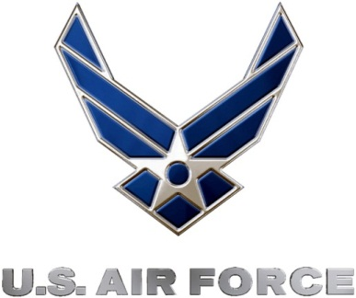 |  | TROY C. KIMBALL, Lieutenant Colonel, USAF  Commander, 337th Recruiting Squadron

