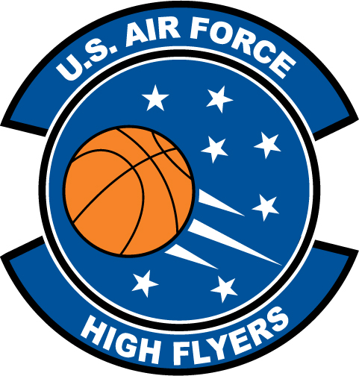

Mike Williams – Lake Marion
U.S. Air Force High Flyer of the Week – South Carolina

The U.S. Air Force 337th Recruiting Squadron honors Lake Marion’s Mike Williams as the 2011-2012 U.S. Air Force High Flyer of the Week as the best high school basketball player in South Carolina. Williams scored 23 points, grabbed 18 rebounds, and blocked four shots in Lake Marion’s 79-75 win over Darlington in the second-round of the Class 3A playoffs. The U.S. Air Force recognizes this exceptional individual performance and the incredible skill, dedication, and teamwork required to accomplish team goals.
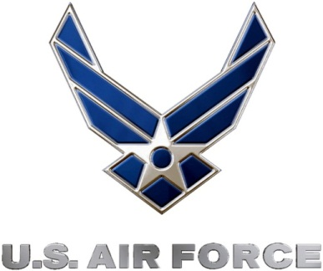 |  | TROY C. KIMBALL, Lieutenant Colonel, USAF  Commander, 337th Recruiting Squadron

