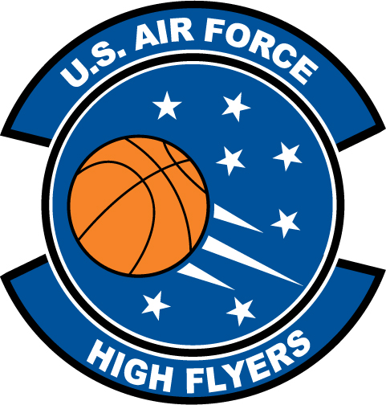

Keyarah Turner – Johnsonville High School
U.S. Air Force High Flyer of the Week – South Carolina

The U.S. Air Force 337th Recruiting Squadron honors Johnsonville High School’s Keyarah Turner as a 2011-2012 U.S. Air Force High Flyer of the Week as the best high school basketball player in South Carolina. Turner exploded for a game-high 29 points and collected 25 rebounds to lead Johnsonville to a 75-25 win over Green Sea Floyds. The U.S. Air Force recognizes this exceptional individual performance and the incredible skill, dedication, and teamwork required to accomplish team goals.
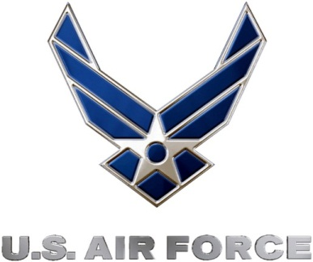 |  | TROY C. KIMBALL, Lieutenant Colonel, USAF  Commander, 337th Recruiting Squadron

