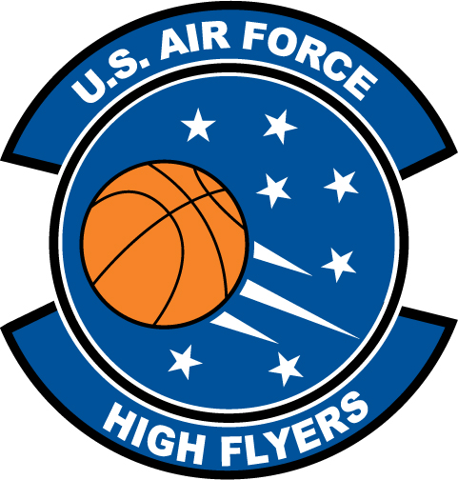

Spencer Collins – Easley High School
U.S. Air Force High Flyer of the Week – South Carolina

The U.S. Air Force 337th Recruiting Squadron honors Easley High School’s Spencer Collins as a 2011-2012 U.S. Air Force High Flyer of the Week as the best high school basketball player in South Carolina. Collins scored 29 points to lead Easley to a 76-64 win over Wren while scoring 33 points in a win over T.L. Hanna to eclipse 1,500 career points. The U.S. Air Force recognizes this exceptional individual performance and the incredible skill, dedication, and teamwork required to accomplish team goals.
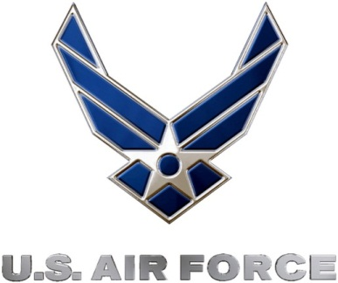 |  | TROY C. KIMBALL, Lieutenant Colonel, USAF  Commander, 337th Recruiting Squadron

