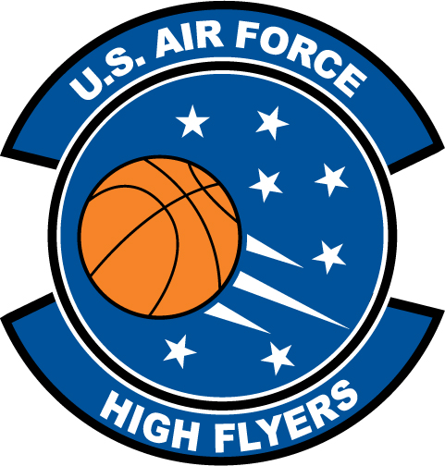

Deion Holmes – Chesnee High School
U.S. Air Force High Flyer of the Week – South Carolina

The U.S. Air Force 337th Recruiting Squadron honors Chesnee High School’s Deion Holmes as a 2011-2012 U.S. Air Force High Flyer of the Week as the best high school basketball player in South Carolina. Holmes poured in 38 points in Chesnee’s 72-56 win over Pendleton. The U.S. Air Force recognizes this exceptional individual performance and the incredible skill, dedication, and teamwork required to accomplish team goals.
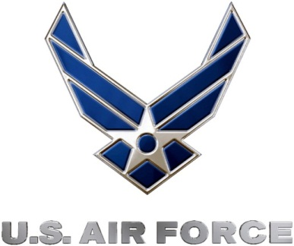 |  | TROY C. KIMBALL, Lieutenant Colonel, USAF  Commander, 337th Recruiting Squadron

