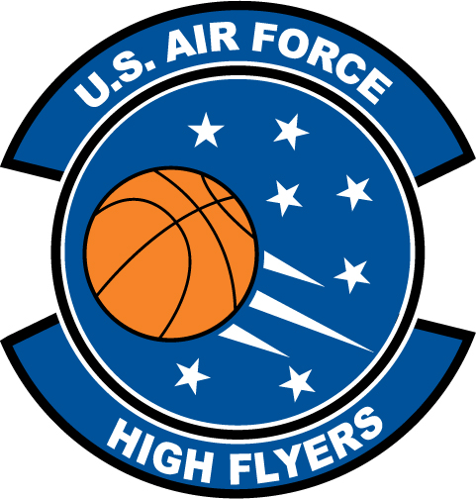

Austin Ajukwa – Cardinal Newman
U.S. Air Force High Flyer of the Week – South Carolina

The U.S. Air Force 337th Recruiting Squadron honors Cardinal Newman’s Austin Ajukwa as a 2011-2012 U.S. Air Force High Flyer of the Week as the best high school basketball player in South Carolina. Ajukwa poured in a career-high 40 points to lead Cardinal Newman to a 70-56 win over Heathwood Hall and added 21 points in a 44-40 win over Ben Lippen. The U.S. Air Force recognizes this exceptional individual performance and the incredible skill, dedication, and teamwork required to accomplish team goals.
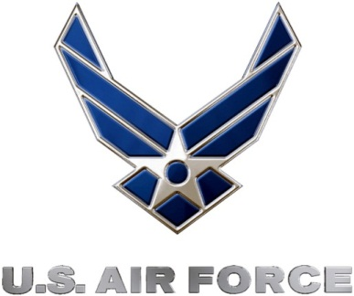 |  | TROY C. KIMBALL, Lieutenant Colonel, USAF  Commander, 337th Recruiting Squadron

