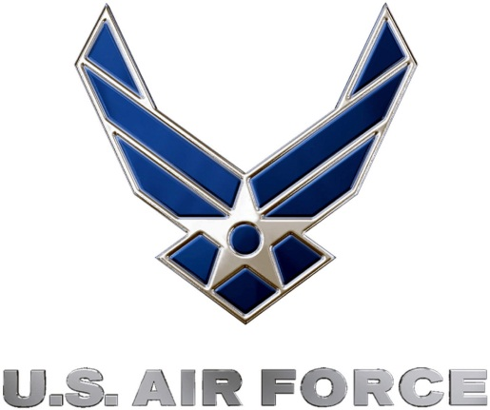 | 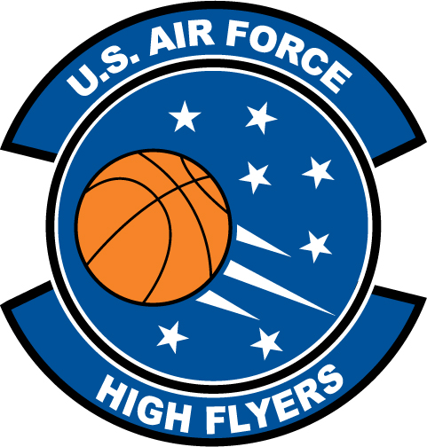
U.S. Air Force High Flyers – North Carolina
Week 1 Nominees – Girls’ Basketball
Air Force to honor the best high school basketball players in North Carolina
FOR IMMEDIATE RELEASE CONTACT: Mike Sinnott
2 January 2012 (517) 927-4570

SHAW AFB, SC - The U.S. Air Force’s 337th Recruiting Squadron is honored to announce the week one nominees for the U.S. Air Force High Flyers. The campaign honors the best high school basketball players in North Carolina. Fans can vote online until 9:00 P.M. EDT on Thursday at www.TheSportsFlash.com. The winner will be announced on Friday.

U.S. Air Force High Flyers – North Carolina
Essence Baucom – Berry Academy | Baucom earned tournament MVP honors at the Hardwood Classic after scoring 14 points, grabbing eight rebounds, and adding seven assists in Berry Academy’s 48-45 overtime win over Ardrey Kell in the championship game.
Celeste Burgess – Mount Tabor | Burgess scored 18 points to lead Mt. Tabor to a 61-46 win over Bartram Trail (FL) in the championship game of the Jim Clark Hornet Holiday Classic. Burgess was named tournament MVP.
Rachel Camp – East Rutherford | Camp scored 40 points, pulled down 21 rebounds, recorded five steals, and blocked four shots in East Rutherford’s 64-54 win over Landrum in the championship game of the Battle at the Border tournament.
Jackie Denny – North Wilkes | Denny scored 34 points to lead North Wilkes to a 61-56 win over North Stokes.
Tierra Ellerbe – Richmond County | Ellerbe scored 23 points to lead Richmond County to a 57-53 win over Northern at the Eastern Alamance Holiday Hoopla.
Paris Kea – Greensboro Page | Kea scored 15 points to lead Greensboro Page to a 56-45 win over Northwest Guilford in the title game of the Pizza Hut Invitational. Kea was named tournament MVP.
Ciara Morris – South View | Morris scored 15 points in the championship game of the Holiday Classic in helping South View to a 61-40 win over Pine Forest in the title game. Morris was named MVP of the Holiday Classic.
Roddreka Rogers – Charlotte Myers Park | Rogers earned MVP honors of the at the Holiday Invitational, averaging 17 points, 10.5 rebounds to lead Myers Park to the tournament title in a 50-45 win over Millbrook in the title game.

“The Sports Flash” (TSF) Radio Network will accept nominations each week from high school basketball coaches, athletic directors, the media, and high school basketball fans. High school basketball fans will vote online for the weekly winner. Each weekly winner will be a finalist for the U.S. Air Force High Flyer of the Year. Throughout the campaign, fans can visit the official U.S. Air Force High Flyers site at www.TheSportsFlash.com to stay updated on the campaign, vote for the weekly winner, and much more.

For the U.S. Air Force, people are its most valuable asset. Without them, even the most advanced systems are rendered useless. The U.S. Air Force recruits quality airmen from a cross-section of America to meet the Air Force’s ever-changing needs. The Air Force has more than 140 enlisted career opportunities available for qualified men and women. For more information about the enlisted, officer, and healthcare professional job opportunities in the U.S. Air Force, contact your local Air Force recruiter. Recruiter contact information is available by calling 1-800-423-USAF (8723) or visit the Recruiter Locator link on the official Air Force recruiting web site at www.airforce.com.

“The Sports Flash” (TSF) Radio Network delivers customized, local sports reports for 190 network affiliates in 13 states. TSF Radio Network coordinates the U.S. Air Force High Flyers campaign for the 337th Recruiting Squadron. For more information, please contact TSF Radio Network’s Mike Sinnott at (517) 927-4570.

###

