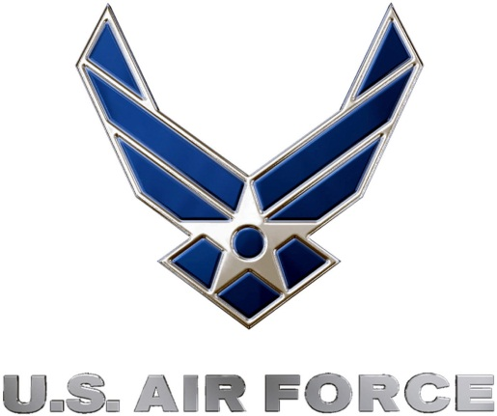 | 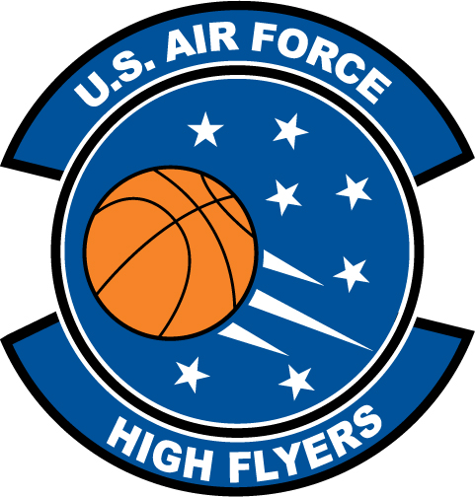
U.S. Air Force High Flyers – North Carolina
Week 1 Nominees – Boys’ Basketball
Air Force to honor the best high school basketball players in North Carolina
FOR IMMEDIATE RELEASE CONTACT: Mike Sinnott
2 January 2012 (517) 927-4570

SHAW AFB, SC - The U.S. Air Force’s 337th Recruiting Squadron is honored to announce the week one nominees for the U.S. Air Force High Flyers. The campaign honors the best boys’ and girls’ high school basketball players in North Carolina. Fans can vote online until 9:00 P.M. EDT on Thursday at www.TheSportsFlash.com. The winner will be announced on Monday.

U.S. Air Force High Flyers – North Carolina
Kadeem Allen – New Hanover | Allen poured in 30 points and snagged eight rebounds to lead New Hanover to a 66-53 win over Hoggard in the championship game of the Brogden Tournament.
Alex Bradley – Pine Forest | Bradley earned MVP honors of the Holiday Classic after scoring 14 points to lead Pine Forest to 54-42 win over Seventy-First in the championship game.
Austin Fleming – West Stokes | Fleming was named MVP of the Frank Spencer Holiday Classic after scoring 18 points as West Stokes knocked off Winston-Salem Prep in triple-overtime, 83-71.
Justin Gordon – Northside Christian | Gordon scored 15 points and pulled down eight rebounds in Northside Christian’s 77-48 win over Mooresville the championship game of the Hardwood Classic. Gordon was named tournament MVP.
Austin Hatfield – South Davidson | Hatfield scored 32 points in leading South Davidson to a 96-72 win over East Davidson in the championship game of the NewBridge Classic @ Ledford.
Denzel Ingram – Chapel Hill | Ingram poured in a career-high 43 points to lead Chapel Hill to a 75-71 win over Raleigh Broughton to win a four-team bracket at the Holiday Invitational Tournament.
D.J. Mason – West Bladen | Mason scored 26 points to lead West Bladen to a 58-43 win over Fuquay-Varina.
Dominique Reed – Garner | Reed dropped in a game-high 20 points and pulled down eight rebounds to lead Garner to a 75-63 win over St. Raymond (Bronx, NY) in the championship game of the HighSchoolOT.com Holiday Invitational.
Jack Young – Forsyth County Day | Young was named tournament MVP of the Frank Spencer Holiday Classic, scoring 15 points with two rebounds, three assists, and three steals in Forsyth Country Day’s 64-62 overtime win over West Forsyth in a bracket title game.

“The Sports Flash” (TSF) Radio Network will accept nominations each week from high school basketball coaches, athletic directors, the media, and high school basketball fans. High school basketball fans will vote online for the weekly winner. Each weekly winner will be a finalist for the U.S. Air Force High Flyer of the Year. Throughout the campaign, fans can visit the official U.S. Air Force High Flyers site at www.TheSportsFlash.com to stay updated on the campaign, vote for the weekly winner, and much more.

For the U.S. Air Force, people are its most valuable asset. Without them, even the most advanced systems are rendered useless. The U.S. Air Force recruits quality airmen from a cross-section of America to meet the Air Force’s ever-changing needs. The Air Force has more than 140 enlisted career opportunities available for qualified men and women. For more information about the enlisted, officer, and healthcare professional job opportunities in the U.S. Air Force, contact your local Air Force recruiter. Recruiter contact information is available by calling 1-800-423-USAF (8723) or visit the Recruiter Locator link on the official Air Force recruiting web site at www.airforce.com.

“The Sports Flash” (TSF) Radio Network delivers customized, local sports reports for 190 network affiliates in 13 states. TSF Radio Network coordinates the U.S. Air Force High Flyers campaign for the 337th Recruiting Squadron. For more information, please contact TSF Radio Network’s Mike Sinnott at (517) 927-4570.

###

