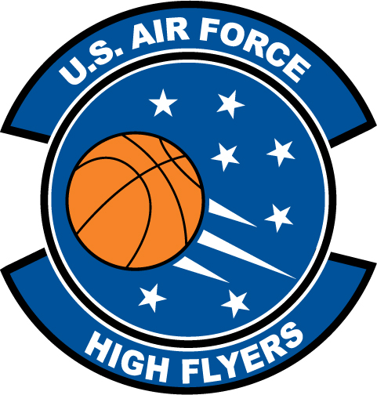

Shivaughn Wiggins – North Mecklenburg
U.S. Air Force High Flyer of the Week – North Carolina

The U.S. Air Force 337th Recruiting Squadron honors North Mecklenburg’s Shivaughn Wiggins as a 2011-2012 U.S. Air Force High Flyer of the Week as the best high school basketball player in North Carolina. Wiggins poured n 30 points, dished out five assists, and recorded two steals in North Mecklenburg’s 72-54 win over Lake Norman. The U.S. Air Force recognizes this exceptional individual performance and the incredible skill, dedication, and teamwork required to accomplish team goals.
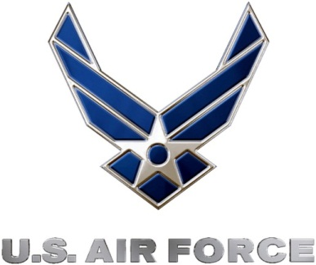 |  | TROY C. KIMBALL, Lieutenant Colonel, USAF  Commander, 337th Recruiting Squadron

