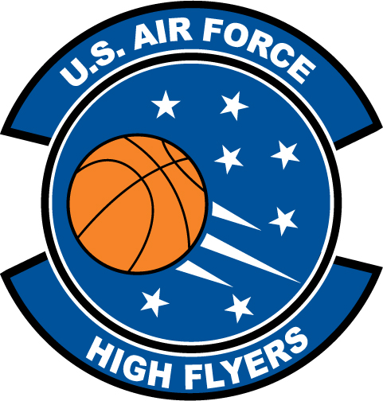

Shelby Wolfe – Northwood High School
U.S. Air Force High Flyer of the Week – North Carolina

The U.S. Air Force 337th Recruiting Squadron honors Northwood High School’s Shelby Wolfe as a 2011-2012 U.S. Air Force High Flyer of the Week as the best high school basketball player in North Carolina. Wolfe’s double-double of 24 points, 11 rebounds led Northwood to a 56-41 win over Granville Central to win the Carolina 12-2A Conference tournament title. The U.S. Air Force recognizes this exceptional individual performance and the incredible skill, dedication, and teamwork required to accomplish team goals.
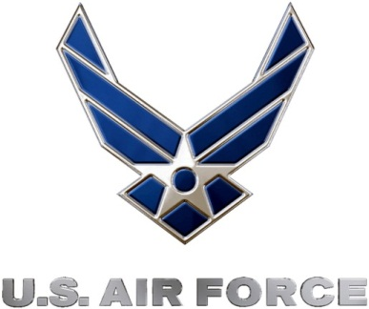 |  | TROY C. KIMBALL, Lieutenant Colonel, USAF  Commander, 337th Recruiting Squadron

