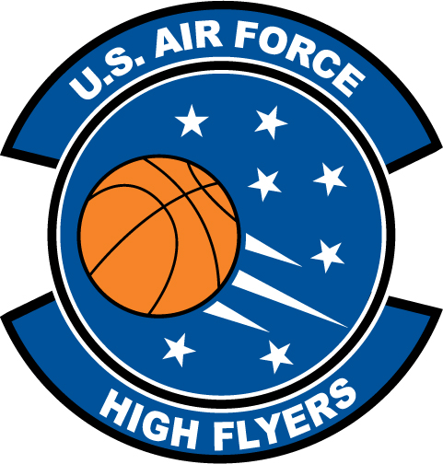

Travonda Haddock - Jones Senior
U.S. Air Force High Flyer of the Week – North Carolina

The U.S. Air Force 337th Recruiting Squadron honors Jones Senior’s Travonda Haddock as a 2011-2012 U.S. Air Force High Flyer of the Week as the best high school basketball player in North Carolina. Haddock scored 21, collected 21 rebounds, blocked nine shots, dished out eight assists, and added seven steals in Jones Senior’s 61-54 win over Southwest Onslow. The U.S. Air Force recognizes this exceptional individual performance and the incredible skill, dedication, and teamwork required to accomplish team goals.
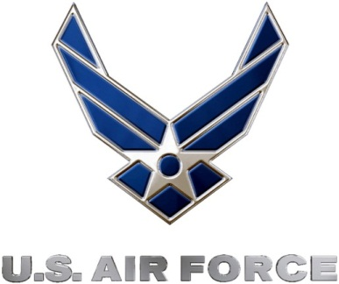 |  | TROY C. KIMBALL, Lieutenant Colonel, USAF  Commander, 337th Recruiting Squadron

