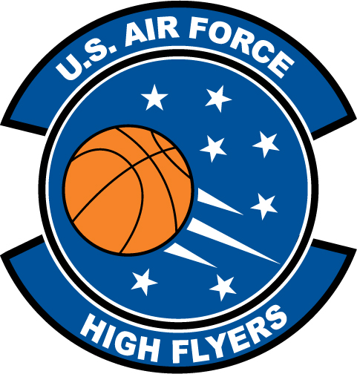

Jevon Patton – Highland Tech
U.S. Air Force High Flyer of the Week – North Carolina

The U.S. Air Force 337th Recruiting Squadron honors Highland Tech’s Jevon Patton as a 2011-2012 U.S. Air Force High Flyer of the Week as the best high school basketball player in North Carolina. Patton stripped the nets for 36 points, collected seven rebounds, dished out eight assists, and recorded seven steals in a 72-56 win over Cherryville. The U.S. Air Force recognizes this exceptional individual performance and the incredible skill, dedication, and teamwork required to accomplish team goals.
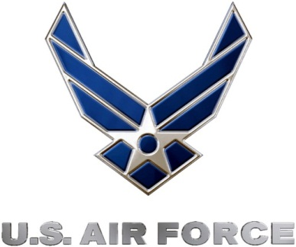 |  | TROY C. KIMBALL, Lieutenant Colonel, USAF  Commander, 337th Recruiting Squadron

