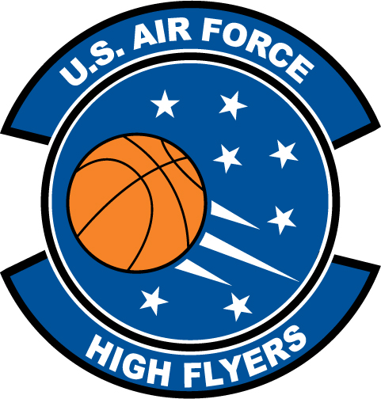

Kristen Gaffney – Green Hope High School
U.S. Air Force High Flyer of the Week – North Carolina

The U.S. Air Force 337th Recruiting Squadron honors Green Hope High School’s Kristen Gaffney as a 2011-2012 U.S. Air Force High Flyer of the Week as the best high school basketball player in North Carolina. Gaffney dropped in 23 points to lead Green Hope to a 73-35 win over Fuquay-Varina. The U.S. Air Force recognizes this exceptional individual performance and the incredible skill, dedication, and teamwork required to accomplish team goals.
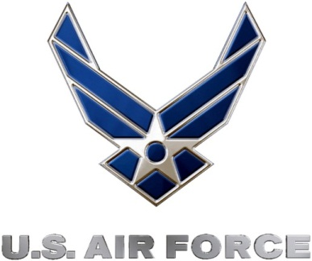 |  | TROY C. KIMBALL, Lieutenant Colonel, USAF  Commander, 337th Recruiting Squadron

