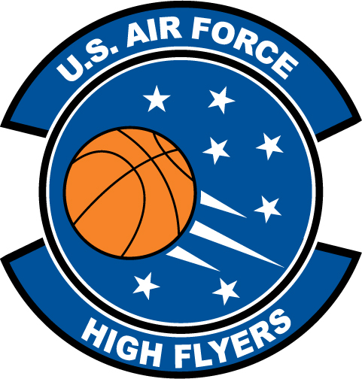

Nate Jones – Davie County High School
U.S. Air Force High Flyer of the Week – North Carolina

The U.S. Air Force 337th Recruiting Squadron honors Davie County’s Nate Jones as a 2011-2012 U.S. Air Force High Flyer of the Week as the best high school basketball player in North Carolina. Jones poured in 40 points to lead Davie County to a 79-64 win over West Forsyth. The U.S. Air Force recognizes this exceptional individual performance and the incredible skill, dedication, and teamwork required to accomplish team goals.
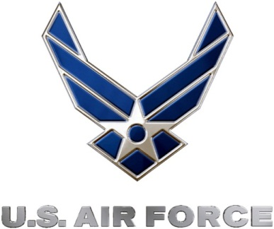 |  | TROY C. KIMBALL, Lieutenant Colonel, USAF  Commander, 337th Recruiting Squadron

