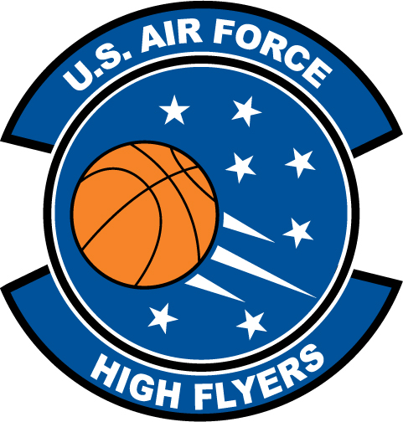

Sidney Cook – South View High School
U.S. Air Force High Flyer of the Week – North Carolina

The U.S. Air Force 337th Recruiting Squadron honors South View High School’s Sidney Cook as a 2011-2012 U.S. Air Force High Flyer of the Week as the best high school basketball player in North Carolina. Cook recorded a double-double with 20 points and a school-record 20 rebounds to lead South View to a 60-38 win over Pine Forest. The U.S. Air Force recognizes this exceptional individual performance and the incredible skill, dedication, and teamwork required to accomplish team goals.
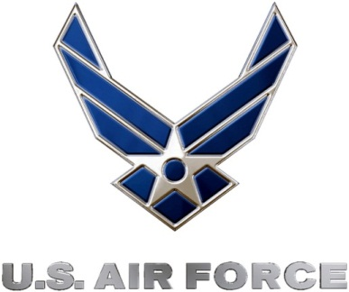 |  | TROY C. KIMBALL, Lieutenant Colonel, USAF  Commander, 337th Recruiting Squadron

